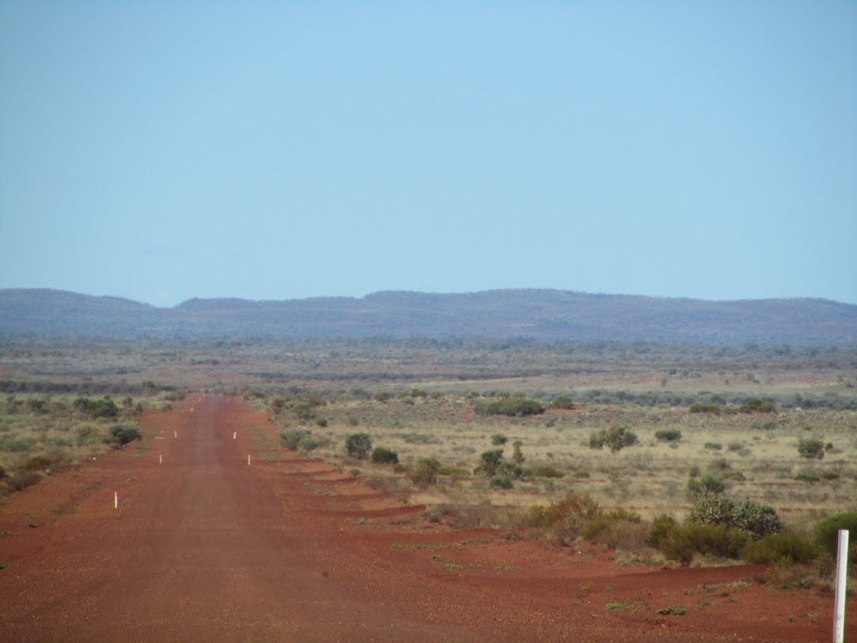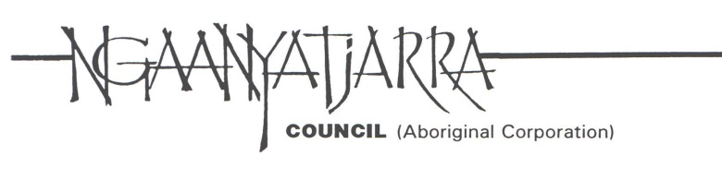

**NGAANYATJARRA COUNCIL (Aboriginal Corporation)**

**Multiple Opportunities Available**

Ngaanyatjarra Council (Aboriginal Corporation) is a dynamic organisation representing the interests of around 2000 Ngaanyatjarra, Pintupi and Pitjantjatjara people living in 12 Communities in the Central Desert region of Western Australia.

Ngaanyatjarra Council currently has multiple vacancies in the following positions available in remote communities on the Ngaanyatjarra Lands in Western Australia.

If you believe you have the skills and experience to positively contribute to the team at Ngaanyatjarra Council we look forward to hearing from you regarding the current vacancies.

**Community Services Manager (CSM)** will work closely with Indigenous participants to provide effective management of staff & CDP activities and will liaise with a wide range of stakeholders in the development of the Community and the use of community resources.

**Case Manager** will provide integrated case management to participants on the Community Development Programme (CDP) so that they can improve their employment and fulfil their activity requirements under CDP (formerly RJCP).

**Municipal Services Officer (MSO)** will work under the directionthe Community Services Manager, the role of the MSO is to coordinate and carry out the delivery of municipal services activities in the Ngaanyatjarra communities.

**Communications & Engagement Officer –** will be responsible for developing and implementing a communications and engagement strategy that brings about improved two-way information flows between the Council, its Communities and Ngaanyatjarra people.

On receipt of expressions of interest further discussion may be held in regard to remuneration and conditions.

Candidates should note that all Communities are ‘dry’ areas and consumption of alcohol is prohibited under the Aboriginal Communities Act.

Applicants **must** address the Selection Criteria and provide at least 3 contactable professional referees. The successful applicants’ employment will be subject to obtaining a Federal Police Clearance and Working with Children check.

For an application package including the Selection Criteria, please see contact details below.

**Linda Robertson, Human Resources Manager, Ngaanyatjarra Council**

**Ph: 08 8950 1719 Fax: 08 8952 1758**

[**linda.robertson@ngcouncil.org.au**](mailto:linda.robertson@ngcouncil.org.au)

(NCAC reserves the right to fill positions as suitable applicants are identified)

** Persons interested in relief work on Ngaanyatjarra Lands are also encouraged to apply.