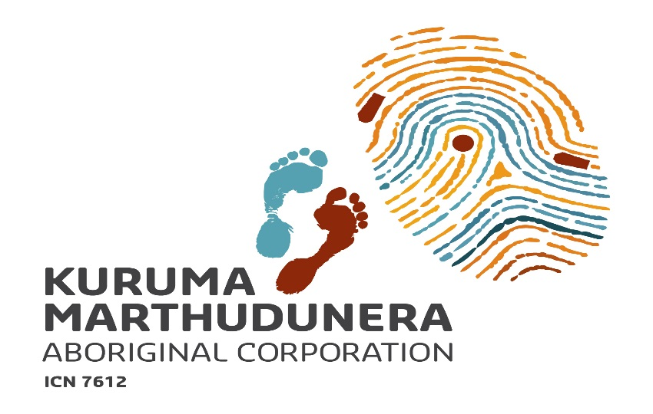
Cultural Heritage Manager
The Kuruma Marthudunera Aboriginal Corporation (KMAC) represents and advances the economic, cultural and social interests of the Kuruma and Marthudunera people (K&M people) in their dealings with the wider community, government and the corporate sector. We are an expanding organisation based in Karratha with responsibility to implement a number of native title agreements.
KMAC has established a very well respected and professional Cultural Heritage Unit which manages cultural heritage services for and on behalf of the K&M people. This includes managing heritage surveys, cultural awareness training, managing compliance with native title agreements, liaising with resource companies and relevant government agencies, and managing the preservation of artefacts and traditional cultural knowledge.
The successful applicant must have extensive cultural management experience, a passion to protect and promote traditional cultural knowledge, situational leadership experience, maturity, excellent sense of humour and patience to lead a dedicated team of K&M people.
Your resumé and application addressing the above criteria should be forwarded to careers@kmac.org.au by no later than Friday, 7 August 2015. If you require a position description, please email a request to careers@kmac.org.au. For further details, please contact Franklin Gaffney on 0400 972 615.

