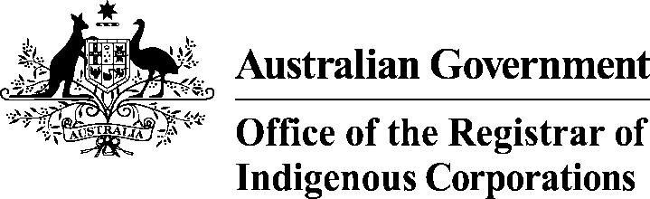 | Notification of a director ID

Name of corporation
Indigenous Corporation Number (ICN)

Director information
You can use this form to notify ORIC of a director ID for one director or multiple directors. You can add more rows if required.

Title | First name | Middle name | Last name | Director ID
Add more rows if required

Declaration | I declare the information provided on this form is correct.
 | Full name |  | Date

