Regulating Indigenous Corporations

Final Report

15 December 2016

Inherent Limitations
COVER IMAGE: Indigenous dancer performing at the opening of KPMG’s new Sydney office in July 2016.
As a firm, KPMG acknowledges Aboriginal and Torres Strait Islander peoples as the First Peoples of Australia and we acknowledge that all of our offices are built on Aboriginal land. Our aim is to build a future where all Australians – Indigenous and non-Indigenous – are united by our shared past, present, future and humanity.
Aboriginal and Torres Strait Islander people are advised that this document may contain images of deceased people.

This report has been prepared as outlined in the Review objective, scope and methodology section. The services provided in connection with this engagement comprise an advisory engagement, which is not subject to assurance or other standards issued by the Australian Auditing and Assurance Standards Board and, consequently no opinions or conclusions intended to convey assurance have been expressed.
The Review has drawn on the experience, expertise and insights of stakeholders through face-to-face and telephone consultation meetings, the online consultation process, submissions from stakeholders and our review of documents and other information provided by ORIC.
No warranty of completeness, accuracy or reliability is given in relation to the statements and representations made by, and the information and documentation provided by, ORIC or PM&C stakeholders consulted as part of the process.
KPMG have indicated within this report the sources of the information provided. We have not sought to independently verify those sources unless otherwise noted within the report.
KPMG is under no obligation in any circumstance to update this report, in either oral or written form, for events occurring after the report has been issued in final form.
The findings in this report have been formed on the above basis.
Third Party Reliance
This report is solely for the purpose set out in the Review objective, scope and methodology section and for PM&C’s information, and is not to be used for any other purpose or distributed to any other party without KPMG’s prior written consent.
This report has been prepared at the request of PM&C in accordance with the terms of KPMG’s contract dated 28 September 2016. Other than our responsibility to PM&C, neither KPMG nor any member or employee of KPMG undertakes responsibility arising in any way from reliance placed by a third party on this report. Any reliance placed is that party’s sole responsibility.
Accessibility
To comply with the Commonwealth Government’s accessibility requirements for publishing on the internet, two versions of this Report are available: a KPMG-branded secure PDF version and an unbranded Microsoft Word version. The KPMG-branded secure PDF version of this Report remains the definitive version of this Report.

Executive summary
Indigenous corporations are vital to the economic and social fabric of the communities they serve. They provide a wide range of essential services, and make important contributions to the cultural life of Indigenous people. Ensuring that Indigenous corporations are well governed is important to meeting the challenge of reducing Indigenous disadvantage.
Successive Australian Governments have supported the incorporation of Indigenous corporations under an Act specifically designed to meet their circumstances and needs. In addition, many Indigenous organisations are incorporated under various state and territory incorporated associations legislation, or the Corporations Act 2001.
The Registrar of Indigenous Corporations and the Office of the Registrar of Indigenous Corporations (ORIC) is charged with supporting better governance by approximately 2,800 corporations registered under the Corporations (Aboriginal and Torres Strait Islander) Act 2006 (CATSI Act), and enforcing compliance with the CATSI Act. It does this with 47 staff across Australia, and an annual budget of $7.9 million, making it a comparatively small Australian Government regulator.
This Review has been initiated to identify opportunities to improve the effectiveness of ORIC, and to enhance the CATSI Act. The CATSI Act and ORIC have their critics, who seem to fall into two groups:
- those who object to separate incorporation requirements for Indigenous corporations, and the associated higher level of scrutiny, and
- those who consider ORIC should provide a higher level of scrutiny and associated enforcement action than currently.
Balancing out these views is the substantial number of stakeholders who value the additional governance support that is available under the CATSI Act and from ORIC, and the additional scrutiny provided by ORIC.
The overall assessment of the Review is that ORIC is doing a good job, in a challenging regulatory environment and in the context of substantial decreases in funding and staffing. The Review’s high level analysis of each of ORIC’s support functions identified many positive features, noting there are also opportunities for these activities to be enhanced in the future. Consultation with funding agencies and co-regulators were also generally positive, again with areas for improvement identified. Online consultation responses were also largely reflective of ORIC’s good work.
However, there are significant opportunities to enhance ORIC’s contribution to better governance in the future as it becomes a more modern, intelligence-led, risk-based regulator. Some of these opportunities will likely require some additional resources, while others may be feasible within existing resource levels if further efficiencies are found following initial work to define ORIC’s regulatory approach and strategic risk framework, as well as assessment of current staffing work level standards within the organisation.
There are also opportunities to improve the CATSI Act, but these represent enhancements rather than a fundamental change in approach.
Key opportunities for improvement identified by the Review included:
- Potential amendments to the CATSI Act to better align with mainstream corporate regulation, streamline or otherwise strengthen and improve the Act;
- Clarification and better articulation of ORIC’s regulatory approach and strategy;
- Working towards a co-regulatory approach with Government agencies and co-regulators;
- Ensuring compliance programs are both more risk-based and well-targeted to ensure the best use of limited resources, and that this risk-based approach is demonstrated to key stakeholders;
- Ensuring decisions are made and work is undertaken at the right levels within ORIC; and
- Ensuring more transparent, stable and certain multi-year funding arrangements.
The Review’s full list of recommendations are set out on the following pages.
KPMG would like to thank the many stakeholders who provided detailed input, including through face-to-face meetings, telephone consultations and through the online consultation process, within constrained timelines during what is a busy time for CATSI registered corporations. We would also like to thank the Registrar, and ORIC management and staff for their openness and willingness to constructively engage with the Review, and for their assistance in the distribution of the details of the online consultation.

Recommendations and options
Section | Ref. | Recommendation
2.1 | 1 | ORIC and PM&C should work collaboratively to consider potential amendments to the CATSI Act to make it more consistent with the Corporations Act, including:  - amending provisions relating to related party financial transactions to mirror those applying to proprietary companies and companies limited by guarantee  - creating a presumption of insolvency where records have not been kept  - introducing fees for late lodgement of reports  - reducing notice periods for the production of information and documents and for attendance to answer questions  - prohibiting the use of specific corporation names unless incorporated under the CATSI Act.  This consideration should also extend to the following potential amendments to strengthen or improve the CATSI Act:  - streamlining the provisions relating to approvals of time extensions for annual general meetings and financial reporting  - including explicit reference to the PBC Regulations (also discussed in section 4.2 of this report)  - additional powers for the Registrar to amend member registers and to amend rule books where the rule books are inconsistent with a native title determination  - allowing corporate membership  - clarification of powers relating to the property of deregistered corporations.  Any proposed amendments to the Act should involve careful policy consideration and appropriate consultation.
 | 2 | ORIC and PM&C should work collaboratively to examine other potential technical, administrative or straight forward amendments to the CATSI Act for consideration by Government.
2.2 | 3 | The Minister for Indigenous Affairs should send an updated Statement of Expectations which articulates Government’s expectations for the role of the Registrar and strategic direction for ORIC, including expectations concerning cooperation with funding agencies and co-regulators.
 | 4 | The Minister should request ORIC to establish an advisory panel (or utilise a suitable existing advisory group) to support and advise it on the development of its regulatory strategy, its plan to implement that strategy, and the associated performance indicators.
3.1 | 5 | ORIC should retain its current decentralised national strategy to provide for increased capacity for proactive contact and face-to-face engagement with Indigenous communities and corporations.
 | 6 | ORIC should ensure that publications such as the Top 500 report, statistics on corporations entering external administration, and the overview of complaints are released with analysis that shows how they are part of ORIC’s work to ensure it understands its regulatory environment, and articulate how each publication informs ORIC’s regulatory approach and planning.
 | 7 | ORIC should work together with:  - the key funding agencies (PM&C, the Department of Health, the Department of Communication and the Arts, and the Attorney-General’s Department) to build better relationships  - key co-regulators (ASIC, the Australian Tax Office and ACNC) to work towards a co-regulatory approach.  It will be critical that agencies and co-regulators support ORIC’s engagement and that, as a first step, each agency should establish a point of contact for this collaboration.  ORIC should encourage the provision and use of information, and analysis of risks, with both funding agencies and other regulators.
3.2 | 8 | ORIC’s regulatory approach, including its compliance and enforcement framework, should be clarified in consultation with key funding agencies (PM&C, Health, Communication and Arts and Attorney-Generals), co-regulators such as the ACNC and the ATO, and Indigenous corporations, and should be communicated in an understandable way to Indigenous corporations and others.
 | 9 | ORIC should undertake work to develop a strategic risk management framework to support the effective management of corporate governance and financial management compliance risks.
 | 10 | ORIC should publish its three year strategic plan, refreshed annually, linked to its regulatory approach so that it explains the existing and emerging issues that it has identified, and how its current priorities and compliance projects are explicitly targeted to addressing those compliance issues.
 | 11 | ORIC should develop a performance reporting framework that demonstrates links between identified specific issues/problems, specific actions implemented to address those issues, and the outcomes achieved (drawing on the Public Governance, Performance and Accountability Act (PGPA) 2013 and Regulator Performance Framework guidance).
 | 12 | ORIC’s performance should be separately reported in the PM&C annual report in a format consistent with the PGPA Act approach.
3.3 | 13 | ORIC should continue to offer corporate governance training to the members, directors and staff of Indigenous corporations, particularly in remote communities.
 | 14 | ORIC and PM&C should work together to enhance coordination, alignment and complementarity of governance training offered by other providers, particularly where it is funded by the Australian Government.
 | 15 | ORIC should update the external facing website to make it clearer and more user-friendly, noting that a complete overhaul would require additional funding.
 | 16 | ORIC should consider the merits of establishing a pro bono accounting service as part of its regulatory approach, based on the LawHelp model, subject to funding.
 | 17 | ORIC should consolidate its various and useful guidance materials in a simple and easy-to-use corporate governance handbook to be available in hardcopy and on the website. This could be undertaken as a discrete project and would require funding.
Section | Ref | Option | Considerations
3.3 | 18 | There is scope to use a wider variety of approaches to releasing guidance material – for example, in the form of a Youtube video (as does the ACNC) or interactive online learning formats (as does the Fair Work Ombudsman) to address particular groups who may have less literacy. | Resourcing may be a challenge. Take up may be low in remote communities with limited internet access.
Section | Ref. | Recommendation
3.4 | 19 | ORIC should review its risk assessment mechanism to ensure that the risk ratings are meaningful and contribute to the targeted allocation of resources.  This should be linked to the activities outlined in Recommendations 7-9 to work more closely with funding agencies and co-regulators, clarify ORIC’s regulatory approach, and develop a strategic risk management framework. There may be benefit in conducting this review together with other agencies.
 | 20 | ORIC should pilot an expanded examinations/audit program to include different types of examinations, for example, examinations with a narrower scope and/or desk-based reviews.  This should be considered in relation to the development of a risk based regulatory plan, and could draw on the expertise of co-regulators (Recommendation 10).
 | 21 | ORIC should communicate more clearly to interested funding agencies about how it risk-profiles corporations, and analyses and acts on information received in financial reports – this can be done through closer working relationships (Recommendation 7) and a better articulated regulatory approach (Recommendation 8), involving funding agencies in the review and revision of its risk assessment mechanism (Recommendation 19).
3.5 | 22 | ORIC should increase its proactive encouragement for funding agencies to provide ongoing intelligence of potential issues, in addition to the more periodic strategic discussions. This intelligence collection may utilise the complaints process. It is acknowledged that intelligence sharing requires the input and participation of organisations outside the control of the Registrar.
 | 23 | ORIC should consider identifying further source data, for example whether complaints are received from funding agencies, police, peak bodies etc., in its complaint recording in order to enable trend analysis.  ORIC should also consider whether the level of analytics skill within ORIC is currently sufficient for undertaking trend analysis and other data analytics. This could be bolstered with appropriately skilled Graduates rotating through ORIC.
 | 24 | ORIC should enhance its proactive approach to regulation through the use of enhanced risk profiling of organisations, including:  - considering the risks presented by key personnel and organisational interrelationships  - consideration of complaints against other similar organisations based on industry or operational similarity.
3.6 | 25 | ORIC should formalise a Case Categorisation and Prioritisation Model to guide a consistent, repeatable range of responses.
3.7 | 26 | ORIC should consider tracking an activity measure, such as number of investigations completed, for investigators in addition to successful litigation statistics to encourage effective use of investigator time.
 | 27 | The staffing profile of the Investigations team should be re-balanced over time to make greater use of more junior staff as corroborating staff. As an illustrative example, the Department of Immigration and Border Protection considers qualified investigators to be APS5 staff, Senior Investigators as APS6 and Investigations Team Leaders as EL1 staff.
3.8 | 28 | ORIC should ensure that it clearly articulates the escalation process for non-compliance and how, for example, failure to lodge an annual report can ultimately result in criminal prosecution.  A clear link between ORIC’s public regulatory approach and decisions to prosecute, and the related communications strategy post-court outcome, will highlight how this activity is intended to drive compliance in ORIC’s priority areas of concern, and also potentially contribute to increased compliance.
3.9 | 29 | ORIC should undertake a review of work level standards of all positions within ORIC to assess capacity and capability of current staff and to ensure that work is undertaken at the commensurate level.  - This should also include consideration of whether delegations are appropriate and decisions are being made at the correct level.  - Such an assessment would inform any case for increased staffing allocation (see Recommendation 37).
 | 30 | ORIC should continue to regionalise client-facing, voluntary compliance support functions where appropriate, while ensuring active management of consistency of advice and guidance for staff and ensuring streamlined communication channels between regional offices and Canberra based staff.
 | 31 | PM&C should ensure that the Registrar and ORIC staff are proactively included and encouraged to participate in broader corporate activities, including senior staff interaction, business planning and reporting, development opportunities for staff, social events, and information exchange, on relevant email distribution lists, as well as ministerial briefings and correspondence where appropriate.  The Registrar should also actively participate and encourage ORIC staff participation in broader departmental corporate citizenship.
 | 32 | PM&C should ensure that ORIC has access to appropriately skilled resources, including junior staff such as Graduates and Indigenous Australian Government Development Programme participants. ORIC can contribute to this by identifying and communicating to PM&C the types of skills required of such junior staff and opportunities available within ORIC for their development.
 | 33 | ORIC should undertake an internal project to improve freedom of information (FOI) business processes. This should include consideration of:  - The principles behind FOI (open government, greater transparency and greater public participation in decision-making) and how to best integrate these into usual business, including ORIC’s approach to handling complaints.  - Approaching the initial processing and preparation of any routine/common aspect of FOI requests as an administrative, rather than legal, activity seeking legal assistance only where necessary, noting that current staffing levels and workload would not allow for staff taking on additional functions related to FOI.  - Consultation with the Office of the Australian Information Commissioner in relation to handling common requests.
3.10 | 34 | PM&C should, subject to the Minster’s approval, reinstate an Indigenous Litigation Fund to ensure accessible funding for major civil and criminal prosecutions, with a review by the Department after five years. The amount of this fund should be based on the analysis of the legal costs associated with the cases that were run in 2012-13 to 2014-15 and taking into account the costs incurred by all parties.
 | 35 | ORIC should continue to be funded under PM&C Outcome 2 but under an explicit program or sub-program for ORIC. This funding approach would provide greater transparency and the opportunity to capture a four year budget profile, therefore providing greater certainty for ORIC. This approach is similar to that adopted for many independent Commonwealth Regulators.  The Registrar should engage PM&C’s chief financial officer directly about how to arrange this.
 | 36 | PM&C should provide one-off funding in 2016-17 for additional discrete, one-off projects identified in this Review with the assistance of PM&C. These should include:  - development of an agreed regulatory approach (Recommendation 8)  - development of a strategic risk management framework (Recommendation 9)  - development of a performance reporting framework (Recommendation 11)  - enhancement of ORIC’s web site (Recommendation 15)  - establishment of a pro bono accounting service in a similar way to LawHelp (Recommendation 16)  - development of a consolidated guidance handbook (Recommendation 17)  - refinement of the regulatory risk model within ERICCA (Recommendation 19)  - reinstating capital funding for database enhancements including for enhancements required as a result of Recommendation 19  - undertaking a work level standards assessment (Recommendation 29).
 | 37 | Following ORIC’s development of the regulatory approach and a new draft strategic plan, the Department and ORIC should work together to assess the case for additional funding, outlining what additional activities and outcomes would be achieved with any proposed increase in funding.  An increase of ORIC’s funding base from 2017-18 is likely to be required to keep abreast of potential increases in demand for services and to enable ORIC to proactively support the prosecution of significant breaches of the Act.
4.1 | 38 | Commonwealth agencies funding Indigenous organisations should include a requirement in their funding agreements that organisations funded over $500,000 report key management personnel remuneration to their respective regulators as a note to their accounts. This clause should apply to both CATSI and non-CATSI registered funded organisations.
 | 39 | ORIC should explore the potential of including senior executive remuneration in corporation risk profiling through the review of the corporation risk assessment mechanism (Recommendation 19).
 | 40 | The Minister’s statement of expectations should require ORIC to:  - conduct research and annually publish remuneration benchmark information relating to key management personnel of Indigenous corporations  - develop guidance materials for boards explaining their responsibilities in terms of oversight of benefits packages  noting that additional funding may be required in order for ORIC to undertake these activities.
Section | Ref. | Options | Considerations
4.1 | 41 | Introduce requirements for large (or potentially medium) sized corporations to disclose the nature and value of remuneration of key management personnel in annual reporting, consistent with the requirements of all listed companies. | This may be too burdensome and inappropriate for a large proportion of CATSI registered corporations.
 | 42 | Provide members of Indigenous corporations with the same powers relating to approval of remuneration reporting, as is available to shareholders in listed companies under the Corporations Act. | This may be too burdensome and inappropriate for a large proportion of CATSI registered corporations.
4.2 | 43 | Investigate the option to include reference to relevant PBC Regulations clauses in the CATSI Act so that regulation of these are explicitly within ORIC’s jurisdiction.  Also consider additional powers for the Registrar to amend member registers, and to amend rule books where the rule books are inconsistent with a native title determination as suggested in Recommendation 1. | - Does ORIC have the capacity and capability to take on this function?  - Challenges involved in changing legislation including time and appropriate consultation.  - Would provide oversight over PBC Regulations, potentially strengthening management of native title entities and reduce complaints and issues.  - Would provide a more accessible avenue for dispute resolution.
 | 44 | Investigate the option to provide funding to Native Title Representative Bodies (NTRBs) to provide support and services post determination for members and PBCs/RNTBCs. |  |  | - Future funding models and availability for the NTRBs to perform this function.  - Could provide more accessible support services to members and PBCs/RNTBCs.  - Would provide a more accessible avenue for dispute resolution.
 | 45 | Increase PBC/RNTBC specific training and support services, including for members.  Explore options for delivery of this through partnerships between PM&C, ORIC, NTRBs and other stakeholders, and ensure that this is resourced appropriately. |  | - Capacity for organisations to deliver training.  - Availability of funding to provide support services.
 | 46 | Consider whether a separate part in the CATSI Act or separate legislation specifically dealing with native title corporates allowing for more flexibility in corporate structures would be more appropriate. |  | - Challenges involved in changing legislation including time and appropriate consultation.  - Could provide a more appropriate structure for native title entities.  - Would require current native title entities to change corporate structures to this model.  - Any broader tax implications.  - If under separate legislation, would need to be regulated by an appropriate body.  - If under the CATSI Act, does ORIC have the capacity and capability to perform the function?
47 |  | Consider introducing public reporting of native title monies, including the use of register of third party consultants or agents, or explore other measures to further increase transparency and accountability.  For example, regulatory guidance around benefit allocation models, to ensure fiduciary responsibility of trustees where they are the native title holders, or mandate the use of a professional trustee. |  | - Identify an appropriate mechanism, e.g. legislative amendments to require native title entities to report publicly.  - Ensure the corporate structures that negotiate agreements and manage funding arrangements are covered by a regulator.  - Challenges involved in changing legislation including time and appropriate consultation.  - Any broader tax implications.  - Establish a regulatory function to oversee reporting obligations and managing complaints or disputes.

Contents
Executive summary ii
Recommendations and options iv
1 Introduction 1
1.1 Previous reviews and reports 1
1.2 Review objective, scope and methodology 1
2 Clarifying ORIC’s role 4
2.1 Separate regulation and a regulator for Indigenous corporations 4
2.2 ORIC’s objectives 12
3 ORIC’s regulatory approach 15
3.1 Understanding the environment 15
3.2 Managing the risks of inadequate governance and financial management 18
3.3 Promoting voluntary compliance 24
3.4 Monitoring compliance 33
3.5 Managing complaints of non-compliance 39
3.6 Case selection and escalation 43
3.7 Investigations into non-compliance 44
3.8 Enforcement actions 46
3.9 Capability 50
3.10 Funding 57
4 Enhancing ORIC’s role 62
4.1 Reasonableness of employee benefits 62
4.2 Regulation of native title entities 63
4.3 Other observations 66
Appendix A : Online consultation 67
Appendix B : Online responses 79

Appendix C : Registrar’s Functions 85
Appendix D : ORIC’s Structure 86

Introduction
The Review of the Office of the Registrar for Indigenous Corporations (ORIC) and the Corporations (Aboriginal and Torres Strait Islander) Act 2006 (CATSI Act or the Act) was commissioned by the Department of Prime Minister and Cabinet (PM&C or the Department) in September 2016. KPMG has been engaged by PM&C to undertake a review of ORIC and the CATSI Act in order to inform considerations of how the Registrar for Indigenous Corporations (the Registrar) can most effectively support the capacity of Indigenous corporations to institute good governance and strong financial management, and intervene when necessary under the CATSI Act, and any amendments to the Act required to meet this objective.
The Minister for Indigenous Affairs is focused on how to best promote economic development in Indigenous communities, and enhancing the contribution of portfolio entities to this objective. It is critical that Indigenous organisations maintain appropriate governance standards given the important role they play in their communities in terms of creating employment, driving economic development and delivering services. However, the governance and financial management challenges faced by Indigenous organisations can often differ to those faced by other for-profit and not-for-profit entities.
As the corporate regulator of many Indigenous owned organisations, ORIC is instrumental in ensuring governance standards are upheld. Going forward, it will be important to ensure that ORIC is focussed and equipped to support Indigenous corporations to contribute to the economic and social development and goals of their communities.

Previous reviews and reports
While conducting the Review of ORIC, KPMG reviewed various different relevant reports that had been commissioned for a variety of purposes. Observations and recommendations of the below reports were considered during the course of the Review.
- Australian Human Rights Commission 2007, Native Title Report 2007
- Australian National Audit Office 2012, Capacity Development for Indigenous Service Delivery, - Audit Report No.26 2011–12
- House of Representatives Committee 2009, Inquiry into Outback Stores
- Corrs Chambers Westgarth Lawyers 2002, A modern statute for Indigenous Corporations: Reforming the Aboriginal Council and Associations Act
- Finance and Public Administration References Committee, Inquiry into Commonwealth Indigenous Advancement Strategy tendering processes
- Chester 2015, Fit for the future: A capability review of the Australian Securities and Investments Commission

Review objective, scope and methodology
The objective of the review of ORIC was to assess the effectiveness of:
- The Registrar’s administration of the Act, with reference to the public’s confidence in the administration of the Act – this is covered in the sections in Chapter 0 of this report.
- ORIC’s staffing profile and current human resources to perform their function – this is covered in section 3.9 of this report.
- The Registrar’s risk-profile in conducting investigations and, in particular, its use of special administrations, examinations and investigations in a way that fulfils the objectives of the Act – this is covered in sections 3.4 to 3.7 of this report.
- ORIC’s engagement with, and support for, Indigenous corporations incorporated under the Act and the outreach programmes – this is covered in section 3.3 of this report.
- ORIC’s dual role as educator and regulator and whether these functions are best performed by a single office – this is covered in section 3.3.1 of this report.
The Review also considered the following systemic issues:
- Whether amendments to the Act are needed to ensure consistency or harmonisation with the other corporate regulations in Australia – this is covered in section 2.1 of this report.
- Whether strengthening the prosecutorial and evidence-gathering powers of the Registrar would encourage more effective management of organisations registered under the Act – this is covered in sections 2.1 and 3.8 of this report.
- Whether individual provisions or structural issues within the Act require strengthening to improve the integrity of the Act and the Registrar’s effectiveness – this is covered in section 2.1 of this report.
- The effectiveness and use of the merits review provisions in Part 15-4 of the Act – consultation did not identify any substantive issues with the operation of these provisions.
- Whether the regulation of native title benefits should be brought within the jurisdiction of the Registrar – this is covered in section 4.2 of this report.
- Whether giving the Registrar the power to review the reasonableness of benefits provided to an employee of an organisation registered under the Act in the course of their employment would encourage more appropriate financial management of those organisations – this is covered in section 4.1 of this report.
- Whether the current resourcing of the Registrar is sufficient to support the Registrar’s ability to prosecute potential breaches of the Act and effectively administer the Act – this is covered in section 3.10 of this report.
The systemic aspects of the Review relating to the Act have been conducted jointly with the Registrar. Staff within each business area of ORIC have been consulted, providing feedback to the Review team on the functions completed as well as any barriers or issues experienced in completing these functions.
In order to reach a conclusion and provide useful insight and recommendations as part of this Review, KPMG assessed:
- Administration of the CATSI Act – activities to map the Registrar’s obligations under the CATSI Act and understand its execution of its regulatory functions. Feedback from the public and regulated parties on ORIC’s administration of the Act was also collated.
- Risk-profiling and Investigations – activities to identify and assess any proactive detection or early warning mechanisms for non-compliance by ORIC-regulated entities, as well as to assess the powers, governance, skills and support (including technology) of the ORIC investigation functions.
- Staffing, capability and engagement – consultations were conducted to understand ORIC’s staffing profile in relation to its functional requirements.
In conducting the Review, KPMG consulted with ORIC, Government funding and policy agencies, and developed an online consultation tool which allowed feedback to be provided by the public and corporations registered with ORIC. Input was sought through emails from ORIC (to all its registered corporations), as well as through PM&C and the Department of Health’s mailing lists to funded agencies and key stakeholder contacts. The online consultation tool input was not from a random sample, but provided a very broad range of responses from 381 respondents. A series of questions were asked in order to identify options to enhance the operation of the Act and the performance of ORIC in completing regulatory and support functions (see online consultation questionnaire at Appendix A and summary of quantitative results at Appendix B).
A Steering Committee was also established to oversee the Review. Membership consisted of PM&C, Australian Securities and Investments Commission (ASIC) and Department of Health representatives. Michael D’Ascenzo, the former Commissioner of Taxation, was a special advisor to the Steering Committee. The Steering Committee was engaged throughout the Review, providing feedback on key deliverables such as the Review project plan and the online consultation tool.

Clarifying ORIC’s role
The Organisation for Economic Co-operation and Development (OECD) noted that:
An effective regulator must have clear objectives, with clear linked functions and the mechanism to coordinate with other relevant bodies to achieve desired regulatory outcomes. (OECD 2014, p.14).
This section of the report examines the objective governments have set for the CATSI Act, the legislation regulating Indigenous corporations, and the regulator charged with supporting compliance and enforcing the Act’s requirements.

Separate regulation and a regulator for Indigenous corporations
Successive Australian Governments have taken the view that a separate legislative framework should be available for the incorporation of Indigenous corporations and that a separate regulator should support and enforce compliance with that legislation.
The original Commonwealth legislation was the Aboriginal Councils and Associations Act 1976 (the 1976 Act), and following a review of that Act in 2006, it was replaced by the Corporations (Aboriginal and Torres Strait Islander) Act 2006 (CATSI Act). Among other points, the Review of the 1976 Act noted that:
- Indigenous people possess a range of socio–economic and cultural characteristics which differ from those of other Australians. These characteristics may disadvantage Indigenous people using statutes of general incorporation such as the Corporations Act 2001 (Corporations Act) or the State and Territory associations’ incorporation legislation. If these disadvantages are to be relieved, the review argued that the special needs of Indigenous people in the context of incorporation and corporate regulation must be accommodated.
- The CATSI Act should distinguish itself from the Corporations Act by providing something the Corporations Act cannot provide. It must provide Indigenous people with special forms of regulatory assistance that would enable them to use corporations more effectively and in accordance with contemporary standards of good corporate governance (paraphrased from p. 2).
The challenges faced by Indigenous corporations have also been detailed within a number of other reviews. The Australian Human Rights Commission noted that statutory reporting is, and will continue to be, a burden on Indigenous corporations. The Human Rights Commission also noted that the CATSI Act is lengthy and presents the challenge of delivering education resources in a timely and linguistically and culturally appropriate way. The impact of financial management and governance has also been identified as the most common risk to the performance of an Indigenous organisation by the Australian National Audit Office (ANAO).
Some individuals in the Indigenous community, including some participants in this Review, have argued that Indigenous corporations should only be able to incorporate under the legislation available to non-Indigenous organisations, namely state and territory incorporated associations’ legislation or the Corporations Act. They have argued that there should not be a CATSI Act, nor ORIC to support and enforce compliance.

The CATSI Act
The CATSI Act largely mirrors the Corporations Act with some important differences, including:
- there must be at least five members of the corporation, all of whom must be Aboriginal or Torres Strait Islander and older than 15 years of age (a Corporations Act company can have only one member, and there are no restrictions on age or ethnicity)
- there is no limit on the number of members (a private, unlisted Corporations Act company can have no more than 50 members)
- the majority of directors of a corporation must be members, Aboriginal or Torres Strait Islanders, and not be employees of the corporation. There can be a minimum of three directors, and generally no more than 12 (a Corporations Act company does not have restrictions on directors)
- there are restrictions on related party financial benefits applying to all types and size of CATSI corporations (the equivalent provisions in the Corporations Act only apply to public companies)
- the regulator (the Registrar) can appoint an examiner to review a corporation’s business to identify any financial or governance problems (no similar provision is in the Corporations Act)
- the regulator can appoint a special administrator, who must act in the interests of the corporation, rather than in the interests of creditors, which is the case for an administrator under the Corporations Act (under the Corporations Act, administrators are appointed by the directors)
- the regulator can change a corporation’s rule book (equivalent to a Corporations Act constitution) or call a general meeting or an annual general meeting or act for members in certain circumstances (no similar provision exists in the Corporations Act).
During the course of the Review, both ORIC and other interested parties were asked if there were ways in which the CATSI Act could be amended to better achieve its objectives.
Key overarching emerging themes from stakeholder consultation included:
The CATSI Act, at almost 600 pages, is long and complicated
- While a few interviewees from funding agencies, as well as a handful of online consultation respondents, noted that the CATSI Act seems unnecessarily complicated and long, this is probably inevitable considering that the CATSI Act mirrors the Corporations Act, itself a very long and complex piece of legislation, and includes a number of additional provisions in recognition of the circumstances and incorporation needs of Indigenous corporations. However, 75 per cent of online respondents suggested that reporting rules under the CATSI Act are easily applied. No specific options for addressing the concerns regarding the length and complexity of the Act were provided.
Whether separate and discriminatory legislation for Indigenous corporations is needed
- Online respondents, as well as a representative from an Indigenous peak body that was interviewed, questioned the need for separate legislation. Twenty online consultation respondents (around nine per cent of respondents addressing that part of the consultation) made comments along the lines of “one law for all”, suggesting that governance and reporting requirements should be the same as for mainstream corporations. A few comments received also pointed to a perception that the CATSI Act is racially discriminatory. The Review notes that under the CATSI Act registration as an Indigenous corporation is voluntary for all but native title bodies. The Indigenous Advancement Strategy made it mandatory for Indigenous organisations receiving more than $500,000 from PM&C to incorporate under the CATSI Act, but this was a funding policy decision, and not a decision by ORIC under the CATSI Act. The Review considered this issue was outside its terms of reference.

Alignment with the Corporations Act
The terms of reference of the Review specifically asked whether amendments might be needed to ensure consistency or harmonisation with other corporate regulation. Specific issues identified to align the CATSI Act more closely with the Corporations Act included:
- ‘Related parties’ provisions
- ORIC suggested that the current CATSI Act provisions are unnecessarily complicated, arguably unsuitable for Indigenous corporations where there are extensive family relationships, and poorly understood by some directors. The current provisions are modelled on those applying to public companies under the Corporations Act, and are more complex than the requirements placed on other corporations. ORIC noted that addressing poor decisions to pay related party benefits might be better dealt with under the director’s duties or by providing greater clarity around exempted transactions. The Review supports progressing this potential change.
- Better reporting of remuneration
- ORIC suggested that annual directors’ reports or financial statements should be required to include reporting on the remuneration of key management personnel. This could be along the lines of what is required by the Corporations Act. Some, but not all, corporations already report this information as registered charities regulated by the Australian Charities and Not-for-Profits Commission (ACNC). The Review supports better public reporting of remuneration, particularly for government-funded organisations. However, the Review considers that it would be preferable to mandate such annual reporting disclosure requirements through funding agreements, and that the requirement could apply to entities of various corporate types. This is covered in more detail in section 4.1 of this report.
- Create a presumption of insolvency where records have not been kept
- ORIC suggested that for the purpose of establishing that there are grounds under which to place a corporation into special administration, a corporation should be presumed to have been operating at a loss where financial records have not been kept. This would be somewhat similar to the provisions relating to those available to liquidators under section 588E of the Corporations Act. The Review supports progressing this potential change.
- Establish fees for late lodgement of reports
- ORIC suggested that consideration of provisions for late fees would reduce the need to pursue criminal prosecutions for non-lodgement of reports. ASIC charges a late fee of $76 for lodgement up to one month late, and $316 for lodgement over one month late. The Review supports progressing this potential change.
- Strengthen investigative powers
- ORIC suggested that the requirement to give no less than 14 days’ notice to people who are formally requested to provide information, produce the documents or appear to answer questions, creates a situation where evidence can be destroyed before it can be secured for investigative purposes. In contrast, ASIC can specify what it considers to be a reasonable time from the date of service of the notice, taking into account the documents required, and the type of inquiry, noting that in some cases it may be appropriate to require documents to be provided immediately. ORIC suggested amending the CATSI Act to provide equivalent and more practical notice periods. The Review supports progressing this potential change.

- Prohibiting names required under the CATSI Act
- ORIC suggested prohibiting an entity that is not registered under the CATSI Act from using the words required by the CATSI Act to be part of the name of a corporation, such as “Aboriginal Corporation”, “Torres Strait Islander Corporation”, “Indigenous Corporation” or “Aboriginal and Torres Strait Islander Corporation”. This would reduce confusion amongst third parties as to the incorporating legislation of entities, and is in line with similar prohibitions in the Corporations Act regarding words such as “Proprietary Limited” or “Limited”. The Review supports progressing this potential change.
- Other minor amendments to align the CATSI Act with the Corporations Act
- In addition to the issues outlined in points 1-6 above, other opportunities for minor amendments to better align the CATSI Act with mainstream incorporation legislation included:
- aligning an administrator’s power to call creditors’ meetings with the related provisions in the Corporations Act
- specifically providing for a qualified privilege for auditors
- simplification of corporation size categories (from three to two), as well as minor distinctions between corporation sizes such as those for the contact person/secretary and registered office and document address.

Other improvements to the CATSI Act
The terms of reference of the Review specifically queried whether amendments are needed to improve the integrity of the Act and the Registrar’s effectiveness. Further areas identified by the Review where there may be opportunities to improve the Act included:
- Streamlining provisions relating to extensions of time for annual meetings
- One interviewee from PM&C suggested that the number of approved extensions of time for annual general meetings (AGMs) of corporations each year is an indicator that the current meeting requirements are overly rigid. In 2015-16, 236 extensions were granted, accounting for approximately 8.5 per cent of CATSI corporations. ORIC suggested the provisions could be streamlined by retaining the power of 10 per cent of members to request a general meeting but: repealing the mandatory requirement for small corporations to hold an AGM; providing for members of medium and large corporations to have the power to pass a resolution to not require an AGM for up to three years; and introducing a power for the Registrar to direct a corporation to hold a general meeting if issues were identified. Where members of a medium or large corporation still sought an AGM, the corporation could be required to notify (but not seek approval from) ORIC if the meeting needed to be held after 30 November, outlining the reasons for the delay. The Review supports progressing this potential streamlining opportunity.
- Streamlining provisions relating to extensions of time for financial reports
- Medium and large corporations are required to lodge financial reports by 31 December, and ORIC advised that 190 extensions were approved in 2015-16. ORIC noted that if the delays are caused by factors such as a death in the community, natural disaster, cultural activity, or a delay in audit, ORIC routinely approves 30 day extensions. A streamlining option would be to amend the CATSI Act to allow a corporation to simply notify ORIC that the deadline would not be met and to outline the reasons for a delay, on the condition that financial reports would be lodged within 30 days of the original deadline. Formal approval would still be required where there are likely to be delays of more than 30 days. The Review supports progressing this potential streamlining opportunity.
- Reference to the Native Title (Prescribed Bodies Corporate) Regulations 1999 (PBC Regulations)
- Representatives from PM&C and the Attorney-General’s Department who were consulted supported the option to include reference to relevant PBC Regulations clauses in the CATSI Act so that compliance with the PBC Regulations would be explicitly within ORIC’s jurisdiction. This would provide oversight of the PBC Regulations, potentially strengthening management of native title entities and reducing complaints and issues. There would seem to be merit in this proposal, but it is potentially more controversial than some of the other proposals, and therefore should be subject to additional policy analysis and appropriate consultation. There is additional analysis of issues associated with registered native title body corporations in section 4.2 of this report.
- Power to amend a register of members
- ORIC suggested amending the CATSI Act to give the Registrar the power to amend a register of members or the specific power to direct a corporation to amend the register. ORIC reports that many disputes within corporations arise as a result of the removal of members or a refusal to admit a member to a corporation, particularly within native title bodies. ORIC considers that such disputes could be minimised if the Registrar had the power to direct a corporation to re-admit or admit a member and/or amend the register of members if it was just and equitable to do so. This would seem a reasonable amendment but is potentially more controversial than some of the other proposals, and therefore should be subject to additional policy analysis and appropriate consultation, particularly regarding the circumstances when such a power could be exercised. There is additional analysis of issues associated with registered native title body corporates in section 4.2 of this report.
- Power to amend rule books
- ORIC suggested that Divisions 66 and 69 of the CATSI Act should be amended to provide the Registrar with the specific power to refuse to register a rule book or to amend a rule book if its terms are not consistent with a native title determination. ORIC argues that this would reduce disputation regarding eligibility for membership of a registered native title body corporate. This would seem a reasonable amendment but is potentially more controversial than some of the other proposals, and therefore should be subject to additional policy analysis and appropriate consultation, particularly regarding the circumstances when such a power could be exercised. There is additional analysis of issues associated with registered native title body corporates in section 4.2 of this report.
- Power to exempt compliance with a provision of a rule book
- ORIC suggested introducing a provision to enable the Registrar to exempt a corporation, or its members and directors, from provisions of its rule book. This could be subject to conditions, such as proposing amendments to the rule book at the next general meeting of members. According to ORIC, circumstances often arise that are not envisaged at the time a corporation’s members approve a rule book; however, amendment to the rule book requires at least 21 days’ notice and a special resolution. An exemption provision would increase flexibility and certainty for the corporation in these circumstances. The Review supports progressing this potential change.
- Allowing for corporate memberships
- Currently, a corporation registered under the CATSI Act must have individual members. It cannot have bodies corporate as its only members. ORIC noted that this limits the ability of Indigenous bodies corporate to incorporate wholly owned subsidiaries under the CATSI Act. Amending the Act to provide greater flexibility for Indigenous people and bodies corporate when establishing corporate structures would allow for risk minimisation in economic ventures, and ORIC argued could potentially contribute to economic development objectives. The Review supports progressing this potential change.
- Property of deregistered corporations
- ORIC suggested that the provisions of the CATSI Act relating to the property of deregistered corporations should be amended to clarify the powers of the Registrar. The Review supports progressing this potential change.
- Technical, administrative or straightforward amendments
- ORIC suggested a number of areas for amendment that seem to be technical, administrative or relatively straightforward that would improve the operation of the Act. These include issues such as removing the requirement to advertise in newspapers, updating the legal name of the Registrar and ORIC, allowing corporations to be placed into special administration without following the show cause process where all directors make a request, and allowing corporations to be voluntarily deregistered even if they have outstanding liabilities, fees, penalties or fines. The Review supports these changes.
If it is intended to amend the Act to address any of the Review’s recommendations, it will be important for ORIC and the Department to work together collaboratively to test more fully the relevant policy issues, and jointly develop proposed amendments for consideration by Government and ultimately consultation with affected stakeholders.

Recommendations
Ref. | Recommendation
1 | ORIC and PM&C should work collaboratively to consider potential amendments to the CATSI Act to make it more consistent with the Corporations Act, including:  - amending provisions relating to related party financial transactions to mirror those applying to proprietary companies and companies limited by guarantee  - creating a presumption of insolvency where records have not been kept  - introducing fees for late lodgement of reports  - reducing notice periods for the production of information and documents and for attendance to answer questions  - prohibiting the use of specific corporation names unless incorporated under the CATSI Act.  This consideration should also extend to the following potential amendments to strengthen or improve the CATSI Act:  - streamlining the provisions relating to approvals of time extensions for annual general meetings and financial reporting  - including explicit reference to the PBC Regulations (also discussed in section 4.2 of this report)  - additional powers for the Registrar to amend member registers and to amend rule books where the rule books are inconsistent with a native title determination  - allowing corporate membership  - clarification of powers relating to the property of deregistered corporations.  Any proposed amendments to the Act should involve careful policy consideration and appropriate consultation.
2 | ORIC and PM&C should work collaboratively to examine other potential technical, administrative or straight forward amendments to the CATSI Act for consideration by Government.

ORIC’s performance as a regulator of Indigenous corporations
Successive governments have funded ORIC so that it has the capacity to support and enforce compliance with good governance and financial management by each registered corporation at a level far higher per entity than would be feasible if the corporations were supported by ASIC. Unlike Corporations Act companies, CATSI Act corporations are not subject to fees associated with registration, nor does ORIC charge fees for the support or services that it offers.
ORIC has its critics, who seem to fall into two groups. First, there are those who object to the policy decision of successive governments to provide for separate incorporation requirements that are only available to Indigenous corporations (discussed earlier), and the associated higher level of scrutiny than would apply if these corporations were subject to the general Commonwealth requirements. These objections have been heightened by the Australian Government’s relatively recent decision that some funded Indigenous corporations must be subject to these requirements. Second, there are those that consider that ORIC should provide a higher level of scrutiny and associated enforcement action than currently. This is not withstanding that ORIC is a comparatively small regulator that covers a wide range of corporations, many in regional and remote areas. These corporations often face significant governance, skills and capability challenges, and so substantial effort needs to go into supporting many of them to achieve better governance and financial management, as well as ensuring there are the resources to take enforcement action where warranted. Balancing out these views are the stakeholders who value the additional governance support that is available under the CATSI Act and from ORIC, and the additional scrutiny provided by ORIC.
The focus of the CATSI Act and ORIC on corporate governance capacity building also reflects the importance of many of these corporations for their communities as key service providers delivering health, employment, education and other important community services. The failure of these organisations in many cases would have major consequences for the delivery of valuable services in these communities, not to mention issues associated with the mismanagement of government funding for these services.
The overall assessment of the Review is that ORIC is doing a good job, in a challenging regulatory environment. The Review’s high level analysis of each of its support functions identified many positive features, noting there are also opportunities for these activities to be enhanced in the future. Consultation with funding agencies and co-regulators were also generally positive, again with areas for improvement identified. Moreover, 55 per cent of respondents to the online consultation undertaken for the Review who assessed ORIC’s performance as a corporate regulator of Indigenous corporations rated it as good/excellent, while only 20 per cent rated it as poor/very poor (see figure below). To put this into context, when a similar question was asked of ASIC’s stakeholders in 2015, 43 per cent indicated ASIC’s performance was good/excellent, and 15 per cent indicated it was poor/very poor.
Figure 2.1: Respondent’s ratings of ORIC’s performance
Source: KPMG online consultation, 2016
More objective measures of ORIC’s performance are difficult to identify. The number of corporations entering special administration has remained relatively stable at between nine and 11 corporations annually over the last three years. The number of disputes that ORIC has finalised annually has fallen from a high of 102 in 2011-12, to 34 in 2015-16. Of the 28 online respondents who participated in the mediation or dispute resolution service, 57 per cent were very satisfied or satisfied, compared to 21 per cent who were very unsatisfied or unsatisfied.
Complaints about corporations have increased from 340 in 2009-10 to nearly 750 in 2015-16. This could indicate increasing problems with the governance of corporations or alternatively greater confidence by complainants that the complaint will achieve a positive outcome. The reasons the Registrar has identified as potentially driving this increase include:
- an increase in the number of corporations, particularly prescribed bodies corporate (PBC), where members have high expectations of their corporations
- an increased awareness:
- of the Registrar’s role, regulatory services and the complaints assistance
- of the Registrar’s activities, particularly prosecution action against wrongdoers
- by members of their rights
- an increased understanding of how corporate governance should operate.
The feedback from the online consultation regarding the handling of complaints was less positive than other aspects of ORIC’s activities. Of the 97 respondents who rated how effective ORIC’s performance was in assessing their complaint, 30 per cent rated it as extremely effective or very effective, while 53 per cent rated it as not very effective or not effective at all. However, this may reflect the fact that most respondents were linked to a corporation, and were thus the subject of the complaint rather than the person making the complaint. The management of complaints is discussed further in section 3.5.
ORIC devotes substantial resources to support incorporation and ongoing reporting. When asked how effective ORIC was in supporting their corporation going through the registration process, it was described as extremely effective or very effective by 64 per cent of the 113 online respondents who answered this question, and not very effective or not effective at all by 10 per cent. Respondents noted the support provided by regional offices, ORIC’s hands-on approach, and the quick, detailed and culturally appropriate responses to queries.
Compliance with annual reporting requirements have remained at a high level since first achieving 96 per cent compliance in 2009-10. Of the 267 online respondents, 75 per cent agreed that ORIC’s financial reporting rules for Indigenous corporations were easy to apply.
A theme that emerged from the consultations with funding agencies and co-regulators was that ORIC’s practical support to assist Indigenous corporations register and comply with corporate governance and financial management standards was critical. The feedback received through the online consultation on ORIC’s support of CATSI corporations was generally positive. For example, 60 per cent of respondents agreed that ORIC had assisted their corporation to improve financial management and corporate governance. An overwhelming majority (92 per cent) of the 148 respondents who had participated in ORIC’s corporate governance training found the training useful.

ORIC’s objectives
The CATSI Act sets out that:
The Registrar, in performing his or her functions and exercising his or her powers, must have the following aims:
    - to facilitate and improve the effectiveness, efficiency, sustainability and accountability of Aboriginal and Torres Strait Islander corporations; and
    - to provide certainty:
      - for the members, officers and employees of an Aboriginal and Torres Strait Islander corporation in their dealings with the corporation and with each other; and
      - for persons outside Aboriginal and Torres Strait Islander corporations in their dealings with those corporations; and
    - to have regard to Aboriginal and Torres Strait Islander tradition and circumstances; and
    - to administer the laws of the Commonwealth that confer functions and powers on the Registrar effectively and with a minimum of procedural requirements; and
    - to ensure that information is available as soon as practicable for access by the public. (section 658.5)
These broad aims provide the Registrar with high-level guidance. However, as US regulatory academic Cary Coglianese notes, criteria such as effectiveness and efficiency “are often used to guide policy decision-making, but to use them in making a concrete decision necessarily requires filling in the details — or making them operational.” As an example, he used ‘effectiveness’ noting that this needs to be stated in terms of being effective in achieving a specific outcome so that it can be used to guide decision-making.
Following the Australian Government’s release of the Uhrig report in 2003, it has been common, but not universal, practice for Ministers to issue Statements of Expectations to provide more guidance to regulators as to specific outcomes sought, and how the regulator might independently exercise their often broadly defined functions and powers. For example, nine of Treasury’s portfolio agencies were issued with updated Statements of Expectations in 2014, and each has subsequently provided a Statement of Intent which informs their Ministers of how they intend to meet these expectations.
The ANAO has also indicated that Statement of Expectations can be useful for clarifying regulatory outcomes sought and administrative priorities. The Registrar advised that he was last issued with a Statement of Expectations by the then Minister in 2008 (Macklin 2008). As there has been no subsequent formal guidance from Government, the Registrar noted that he has continued to use the 2008 Statement to inform the development of ORIC’s strategic plan (ORIC 2014), and subsequently when determining how the organisation’s resources are deployed.
One aspect of the 2008 Statement of Expectations that does not seem to be reflected in the current strategic plan is an explicit focus on ‘Regulatory Cooperation’. This highlighted the importance of collaborative working relationships with other Commonwealth and state bodies working in Indigenous affairs and corporate governance and regulation. During the course of the Review, consultations with other Commonwealth regulators and funding agencies working in Indigenous affairs indicated that most, but not all, had a less effective working relationship with ORIC than is common between other agencies. Conversely, the Registrar noted that ORIC’s interaction with the Department had substantially declined since the machinery of Government changes led to it moving to the Department of the Prime Minister and Cabinet.
During the course of the Review, it became apparent that those interviewed were unclear as to how Government and ORIC defined its role in terms of specific measurable outcomes. One benefit of a refreshed Statement of Expectations is that it could clarify the Government’s expectations, and provide guidance as to how ORIC should seem to meet those expectations. For example, the Statement could address matters such as:
- What specific outcomes would demonstrate that ORIC is contributing to corporations becoming more sustainable? For example, ORIC reports regularly on the number of corporations entering external administration, their size, sector and the reasons why they found themselves in this position. However, does the Government consider this should be a performance indicator, and if so, how should ORIC prioritise its efforts and demonstrate its impact?
- What would Government expect to see if ORIC was providing greater certainty for people both within and outside corporations? Would it expect to see a reduction in disputes about specific matters or fewer complaints, or fewer of particular types of complaints?
- To what extent should ORIC seek to be more intelligence-led, and risk-based, and consequently more proactive/strategic, in its operations, and seek to demonstrate that it is applying this approach to those it regulates? If this is sought, then an appropriate regulatory strategy and an estimate of any required funding could be developed (discussed further in section 3.9 on funding).
- What role should ORIC play in improving the extent to which corporations are accountable, specifically for the benefits they pay to key management personnel? ORIC released a report in 2013 that benchmarked the salaries of Indigenous corporations it regulated, based on data that was requested under a general power to seek information. However, the Registrar advised that this proved to be very contentious for some regulated corporations that queried the intent, even though information about individuals or individual corporations was not published. Clarity from the Minister regarding the importance of activity in this area, and the extent to which specific information should be public, would support continued effort in this area (discussed further in section 4.1 on reasonableness of benefits).
- What role should ORIC play in both delivering governance training, and coordinating the provision of governance training funded by other parts of Government?
Every regulator has to define and refine its specific roles over time, and as circumstances and priorities change. Across Government, many larger regulators are structured with Commissions or Boards that are not involved in the day-to-day management of the organisation. These governance bodies are responsible for regularly revisiting the specific role of the regulator to ensure it continues to create the most public value, approving the strategy to deliver against that role description, and monitoring performance at delivering against the strategy. Examples of regulators with multi-member Commissions or Boards include ASIC, the Clean Energy Regulator and the Civil Aviation Safety Authority (CASA). Smaller regulators, such as ORIC, the ACNC or the Australian Skills and Quality Authority (ASQA), are often structured with a smaller number of statutory appointments who typically have both governance and management responsibilities, but that can have an advisory body or panel that provides support and advice. Such an advisory panel can be skills-based (for example, with knowledge of accounting, the sector being regulated, or legal issues) and provide useful external governance oversight and support to the organisation. Examples include the ACNC and the National Offshore Petroleum Safety and Environmental Management Authority advisory boards.
One option for the Registrar would be to use an existing advisory group, to test its regulatory approach in response to an updated Statement of Expectations, rather than establish a separate advisory body for ORIC. Since coming to office in 2013, the current Australian Government has been reviewing government bodies, including advisory bodies, as part of its Smaller and More Rational Government Agenda. As a result, a number of advisory bodies were abolished. Using the existing ministerial advisory council would be consistent with the Government’s Regulatory Performance Framework which suggests stakeholder consultation via the relevant Ministerial Council in the development of performance indicators.

Recommendations
Ref. | Recommendation
3 | The Minister for Indigenous Affairs should send an updated Statement of Expectations which articulates Government’s expectations for the role of the Registrar and strategic direction for ORIC, including expectations concerning cooperation with funding agencies and co-regulators.
4 | The Minister should request ORIC to establish an advisory panel (or utilise a suitable existing advisory group) to support and advise it on the development of its regulatory strategy, its plan to implement that strategy, and the associated performance indicators.

ORIC’s regulatory approach

Understanding the environment
The effective administration of the Act and its enhanced regulatory outcomes requires a detailed understanding of the environment within which Indigenous corporations operate and the challenges they face in achieving high standards of governance and financial viability.
It is difficult for external parties to assess whether a regulator has a good understanding of the regulatory environment, but it is still useful to understand their perceptions. The online consultation indicated that respondents consider that ORIC largely has a well-developed understanding of Indigenous corporations, the environment in which they operate and their challenges – 40 per cent of online respondents agreed with this statement, while 34 per cent disagreed. To put this into context, a survey of ASIC’s stakeholders for its 2015 capability review found that 45 per cent of respondents considered ASIC ‘understands the industries and markets it regulates’, while 20 per cent disagreed.
During consultation around the effectiveness of the Registrar in supporting the capacity of Indigenous corporations to institute good governance and strong financial management, representatives of co-regulator, ACNC, remarked that ORIC’s support functions show corporations what good governance looks like. The ACNC would not have the resources or relevant expertise to conduct support activities for this specialised group. As ORIC outlines, its model allows for intensive, individual corporation support – both when initially incorporating, and over time – to accommodate the special incorporation needs of Indigenous people. Other individuals consulted as part of the Review supported ORIC as being well placed to provide support services that are culturally appropriate and that address the challenges faced by Indigenous corporations.

Understanding through research
Research activities are conducted by ORIC and provide context and insight into the environment within which Indigenous corporations operate. The sixth edition of the Top 500 Corporations Report was published last year. The ‘At the heart of art – a snapshot of Aboriginal and Torres Strait corporations in the visual arts sector’ report published in 2011-12 provides useful information on CATSI Act corporations operating in this area, and documents aspects of their governance. Representatives from the Department of Communications and the Arts reported that they found this publication very useful, and it would be very helpful if this kind of sector publication was produced every four years or so.
Other research activities that have been more targeted at specific areas of governance concerns were ‘Analysing key characteristics in Indigenous corporate failure‘ – published in 2010, and ‘Remuneration – a report benchmarking the salaries of Aboriginal and Torres Strait Islander corporations’ published in 2012-13. The analysis of corporate failure informed ORIC’s regulatory approach, with its strong focus on timely submission of annual reports, while the remuneration analysis has supported corporations to make one of their most important governance decisions, that of recruiting senior staff.
ORIC also demonstrates its understanding of the regulatory environment through its regular publication of overviews of activity in the ‘Aboriginal and Torres Strait Islander corporations entering external administration’ and ‘Complaints involving Aboriginal and Torres Strait Islander corporations’ publications. The information in these publications can assist the community understand both the regulatory environment, and ORIC’s activities, but could be enhanced by additional contextual information. For example, ORIC reported there were 13 external administration appointments in 2015-16, while separately it reported there were 2,781 registered corporations in the same year, and thus a rate of about 0.46 per cent entering administration. While not directly comparable, it would be useful if this was reported with the equivalent Corporations Act proportions, which was 0.42 per cent in the same year.
The amount of research that ORIC has been able to produce to enhance its understanding of the regulatory environment, inform its regulatory approach and plans, and to inform the broader community, has declined in recent years as its funding has fallen in real terms.

Understanding through intelligence
ORIC is also able to gain intelligence about developments through its 10 regional office staff located in eight regional office locations nationally. These officers travel extensively throughout regions to provide support to new organisations or transferring organisations to register, assist corporations to meet their compliance obligations including reporting and holding AGMs, and to deliver Introduction to Corporate Governance Training and Corporation Specific Training which is tailored to the needs of Indigenous corporations. However, these regional officers are quite stretched, for example, there is currently only one officer in the Darwin office (supported by the Broome manager) who covers the entire northern part of the Northern Territory. There are two officers who cover Queensland, and the Cairns-based officer also covers the Torres Strait. The Review understands that, while the focus of the regional officers is local engagement, they do not necessarily have the capacity required to proactively visit as many corporations as needed due to resourcing limitations. This means that relationship building tends to be reactive and undertaken on the basis of there being an issue.

Communication and publications
ORIC is able to demonstrate its understanding of the regulatory environment through its communication activities targeted at regulated entities and the broader community. It does this through media releases (29 to date this calendar year) largely relating to its compliance and enforcement activity, regular interviews with local media, and speeches. In addition, ORIC produces an annual Top 500 report and an annual review of the PBC sector for the Native Title Conference, both of which are generated from annual reporting data, as well as releasing bi-annual complaints and external administration statistics publications. ORIC has also commissioned substantive research, but the latest research publication was released 2013, with ORIC advising that this activity has had to cease due to funding constraints.
The Review noted that these publications were helpful in informing the broader community of issues associated with Indigenous corporations. However, it was unclear from reviewing these various publications how the data captured and the analysis undertaken informed ORIC’s regulatory strategy. Further discussions with ORIC staff indicated that the data and analysis in these publications had informed decisions on where to focus examinations, to prioritise improving compliance with reporting requirements, the design and targeting of training effort, and a range of other regulatory decisions.
Making the regulatory purpose more apparent in the communication outputs or in the presentation of ORIC’s regulatory strategy may contribute to addressing the widespread comments from funding agencies and co-regulators that ORIC did not seem to be very targeted, risk-based or strategic in its regulatory activity. Moreover, a refreshed regulatory approach (discussed in section 3.2.4) and the strategic plan that highlight how research informs the strategy, would also contribute to ORIC’s evidence base for its approach being better understood.

Information sharing across governments
The Review was advised by most representatives interviewed from funding agencies and regulators that there are currently no formal or informal mechanisms that support information sharing between ORIC, key funding agencies, and other Commonwealth and state/territory regulators that work with Indigenous corporations, about developments in the regulatory environment.
In contrast, regular formal and informal mechanisms are in place nationally in other areas of regulation, such as the consumer law, workplace health and safety, environmental protection, revenue agencies and charities. This allows those regulators to improve their understanding of emerging risks to regulatory outcomes, and the issues associated with managing those risks and existing risks.
The Registrar advised that informal arrangements exist for sharing of information with fraud, compliance and investigation units within Commonwealth agencies, including PM&C, the Department of Social Services, the Australian Federal Police and state and territory police, and that these arrangements are in the process of being formalised with an additional three memoranda of understanding (MOU) prioritised for execution in 2016-17.
Improving linkages across governments can contribute in a range of ways, therefore this issue is also discussed further later in this report (see sections 3.2 and 3.5).

Recommendations
Ref. | Recommendation
5 | ORIC should retain its current decentralised national strategy to provide for increased capacity for proactive contact and face-to-face engagement with Indigenous communities and corporations.
6 | ORIC should ensure that publications such as the Top 500 report, statistics on corporations entering external administration, and the overview of complaints are released with analysis that shows how they are part of ORIC’s work to ensure it understands its regulatory environment, and articulate how each publication informs ORIC’s regulatory approach and planning.
7 | ORIC should work together with:  - the key funding agencies (PM&C, the Department of Health, the Department of Communication and the Arts, and the Attorney-General’s Department) to build better relationships  - key co-regulators (ASIC, the Australian Tax Office and ACNC) to work towards a co-regulatory approach.  It will be critical that agencies and co-regulators support ORIC’s engagement and that, as a first step, each agency should establish a point of contact for this collaboration.  ORIC should encourage the provision and use of information, and analysis of risks, with both funding agencies and other regulators.

Managing the risks of inadequate governance and financial management
The ANAO (2014) notes:
Well-functioning regulators have a clear understanding of the regulatory outcomes being sought, apply a risk-based approach to regulatory administration, effectively engage with stakeholders to share and collect information, use information as a source of intelligence to guide regulatory activity, are transparent in their approach, accountable for their actions and decisions, and monitor and report on their performance and the effectiveness of the regulatory regime. (p.13)

Defining regulatory outcomes
Defining regulatory outcomes in a way that is clear both internally and externally can be challenging for a regulator but is critical to achieving high performance. The Review examined ORIC’s most recent strategic plan to identify the specific regulatory outcomes being sought. At the highest level, the regulatory outcomes sought could be framed as:
CATSI corporations operate in a way that is:
- Effective and efficient – that is, they are governed to achieve their corporate purposes by directors who fulfill their duty of care, of honesty, to avoid conflicts of interest and of disclosure and to not trade while insolvent.
- Sustainable – that is, they are financial viable, manage non-financial risks to the corporation achieving its purpose, and are free of substantive disputes between members, and with other key stakeholders in the corporation.
- Accountable – that is, they report both to their members and local community (through annual reporting, the holding of annual general meetings and the like), and the public (through the release of information on ORIC’s public register).
In addition to ‘what’ outcomes ORIC seeks to achieve, it is also critical to be clear about ‘how’. ORIC’s strategic plan identifies that it aims to:
- be internally efficient and effective
- reduce the burden on corporations
- support certainty, both within corporations and in those corporations’ dealings with people outside corporations, through its actions. For example, by providing guidance on practices in which corporations should engage, it can contribute to fewer disputes between parties
- identify corporate wrongdoing and to take appropriate action.
ORIC aims to do this while taking Aboriginal and Torres Strait Islander tradition and circumstances into consideration.
Framing the regulatory outcomes in terms of contributing to more ‘efficient and effective’, ‘sustainable’ and ‘accountable’ corporations allows risks to these outcomes to be identified, assessed, and then measures put in place to control these risks, to the extent feasible with the Regulator’s available tools and level of resourcing (the resourcing issues are discussed further in section 3.9). The three broad regulatory outcomes outlined above may not fully capture what Government, and the broader community is seeking from the CATSI Act and its administration by ORIC. Settling additional outcomes would require the organisation to engage in more dialogue, both within and outside ORIC, to develop a shared understanding of the specific outcomes that ORIC should affect.
As part of clarifying ORIC’s regulatory outcomes, it will also be important for ORIC to define its risk appetite or risk tolerance, as a key input into its regulatory strategy. Ideally, this should be done in a workshop with its advisory board, representatives from PM&C and other funding/policy agencies, and potentially the Minister’s office. Through discussion, it can be ensured that everyone understands the resource trade-off decisions needed to be made to determine where ORIC will focus its activities. The value of such a workshop will come from the conversation. It may also help with perception and expectation differences, and also provide a case for establishing funding levels.
Other regulators look at risk from a systematic as well as an individual regulated entity perspective. During the course of the Review, we did not find evidence of a structured strategic risk assessment process or risk management strategy currently in place for ORIC, in contrast to the well-developed system in place to assess the risk of each corporation which is embedded in the system that captures all the information from the Register of Indigenous Corporations. ORIC Communications staff advised that “the risk management function sits within PM&C” and that no separate organisational level risk strategy exists for ORIC. However, PM&C’s high level risk documentation does not refer specifically to ORIC or the Registrar, or their activities, and in any event, this would be at too high a level to inform ORIC’s regulatory approach and strategy.

Intelligence-led, risk-based regulation
In recent years, there has been considerable focus on regulators taking a risk-based approach to achieving better outcomes. As part of this approach, a strategic risk management process is put in place to systematically seek to understand current and emerging risks to achieving regulatory outcomes. It involves collecting information about hazards (potential sources of harm), and assesses the likelihood (chance of the hazard eventuating) and the consequence (amount of harm should the hazard occur). This process can be used to inform both areas where the Regulator might focus as part of its regulatory strategy: for example, on corporations in a particular sector where a specific problem has been observed; and to guide its more tactical work through the risk rating of complaints and/or individual regulated corporations.
There are examples of ORIC explicitly taking a risk-based approach to its work. The 2010 report on the causes of failures of Indigenous corporations provided the evidence to support a strong focus on improving the timeliness and completeness of corporations’ reporting. ORIC has been very successful in achieving much higher reporting compliance as a consequence of this focus, noting in its yearbook that compliance has risen from 24 per cent of corporations in 2001-02 to 97.1 per cent in 2014-15. This has been framed in documents such as the ORIC Yearbook in terms of achieving higher levels of accountability. However, the information in annual reports are key inputs into the other compliance activity of ORIC, therefore the focus on this area of compliance actually contributes to achieving ‘efficiency and effectiveness’ and ‘sustainability’ outcomes.
More recently, ORIC’s 2014-15 Yearbook noted the identification of a hazard in the form of an accounting treatment of unexpended grants in some corporations’ accounts which could lead to mis-statements of the corporation’s financial position. Presumably, the consequence is that this could lead to decisions that affected the regulatory outcome of improving sustainability of corporations. The Yearbook noted that in response, the Registrar had issued guidance on the preferred accounting treatment. In contrast, as noted earlier, the other analysis in ORIC publications, such as the Yearbook, and strategic plan, do not explicitly explain the key risks to regulatory outcomes that ORIC has identified, and how its activities are targeted at those risks.
Based on the Review’s examination of ORIC compliance processes, much of the activity appears to be responding to specific complaints and referrals. ORIC attends AGMs and delivers training programs targeted at specific corporations, but it was unclear how risk profiling drives the decisions about how to deploy these resources. ORIC’s expanded presence in regional areas means that it has staff closer to those it regulates which has helped it provide better compliance support. ORIC advised that the information gathered through these interactions, and from complaints and disputes, contributes to the formal risk-profiling of every organisation in ORIC’s system, the Electronic Register of Indigenous Corporations under the CATSI Act (ERICCA). However, while this sophisticated system has the capacity to capture this information, it was unclear to the Review how ORIC has implemented this to achieve more active intelligence gathering and thus risk profiling of organisations likely to require more active compliance/enforcement attention.
The process of initiating examinations provides an example of how ORIC could be more risk-based in the future. Given the cost of examinations, to both ORIC and in terms of disruption to corporations, the aim should be to tightly target these activities. Currently, ORIC advised that the mix of corporations identified for examinations at the commencement of each annual cycle includes some which are rated ‘extreme’, some ‘high’ but also some rated based on the ERICCA analysis as ‘low’.
A risk-based approach by those corporations would most likely be both non-compliant and/or in need of support, and where a compliance failure would have the most adverse impact on the outcomes sought by the Regulator. Ideally, over time, a higher proportion of ORIC’s examinations would identify issues requiring compliance or show cause notices, and fewer would result in management letters indicating that the corporation is operating well and requires no further action.
During the course of the Review, ORIC noted that declining budgets have meant that it has been able to initiate fewer examinations. In the four years to 2014-15, it had been completing between 46 and 61 examinations annually, whereas in the prior four years, it had undertaken between 60 and 81 examinations. In addition, comparing these four year periods, the proportion of examinations resulting in a compliance or show cause notice fell from 72 per cent to 66 per cent, with a commensurate increase in those where only a management letter was provided. There are a range of possible explanations for these results, and the outcomes of examinations vary substantially year-to-year (for example, there was a significant drop in the proportion of examinations resulting in management letters issued in 2015-16), but this suggests that there is scope to better target this activity, particularly if additional funding was to be provided to increase this potentially proactive regulatory activity (this is discussed further in section 3.4.2).
Table 3.1: Examinations
Examination outcome | 2007-08 | 2008-09 | 2009-10 | 2010–11 | 2011–12 | 2012–13 | 2013–14 | 2014-15 | 2015-16
Management letters | 19% | 22% | 17% | 40% | 31% | 43% | 26% | 26% | 15%
Compliance notices | 70% | 62% | 73% | 47% | 51% | 51% | 57% | 57% | 69%
Show cause notices | 9% | 14% | 4% | 10% | 15% | 2% | 15% | 15% | 10%
Other | 2% | 3% | 6% | 3% | 3% | 4% | 2% | 2% | 5%
Total | 60 | 81 | 77 | 72 | 61 | 51 | 46 | 59 | 39
Sources: ORIC Yearbooks 2011-12, 2014-15, and 2015-16
In future, ORIC strategic risk management processes could build on both making more use of the existing data that ORIC captures, and more systematically capturing intelligence it receives from stakeholders, co-regulators and funding agencies. This process could involve analysis of the data underlying the existing reports on external administration and complaints, as well as data captured through the annual reporting cycle. The resulting analysis could be used to guide specific proactive regulatory initiatives, while as noted earlier, in future the existing standard publications could be updated to better explain why ORIC is targeting particular areas, forms of non-compliance, or types of corporations.
Almost all the representatives of funding agencies that the Review consulted, while generally being very positive about ORIC and its activities, suggested that it should be more proactive in its enforcement and compliance approach in the future.

Engaging stakeholders
The ANAO notes that well-functioning regulators effectively engage with stakeholders to share and collect information. It defines stakeholders as “The wide range of groups and individuals with which a regulator interacts, including regulated entities, other regulators, the community and peak industry groups.” The ANAO also notes that “Effective stakeholder interactions and relationships rely on a regulator identifying key stakeholders, the value of engagement and how best to undertake engagement activities.”
ORIC’s website outlines its key clients (see below), which include the Minister and agencies supporting the Minister as well as the Australian Government, agencies with interests in funds, and Indigenous peak bodies in critical sectors.

Our key clients
We are focused on serving:
- Indigenous individuals, groups and corporations
- people accessing the public registers under the CATSI Act—public Register of Aboriginal and Torres Strait Islander Corporations, and Register of Disqualifed Directors
- the minister and agencies supporting the minister
- the Australian Government and state and territory governments
- agencies with interests in funds and/or assets controlled by Aboriginal and Torres Strait Islander corporations
- other agencies regulating the Indigenous corporate sector.
The use of terms such as ‘clients’ and ‘customers’ have proved challenging for many regulators, who will ultimately have to prosecute or impose other sanctions on some of those they regulate. Ultimately, the key clients are Indigenous communities, but day-to-day, ORIC needs to have a customer focus in its dealings with the corporations it regulates to assist them implement better governance and financial management.
The Review considers that in addition to regulated parties, it is important to also identify those organisations that have a shared stake in achieving the same or similar objectives as ORIC of enhancing the corporate governance and financial management of Indigenous corporations, and to actively engage those stakeholders. The Review considers that these include funding agencies, and other agencies that regulate the Indigenous corporate sector, as well as peak bodies that represent and support sectoral groups of corporations that ORIC regulates. Other organisations that are working to improve corporate governance and financial management of Indigenous corporations, and thus share ORIC’s objectives, are also in the Review’s view, ORIC stakeholders.
During the course of the Review, ORIC advised that it had proved very challenging to constructively engage with some peak bodies. These include those bodies that represent a significant number (although not all) of the corporations in critical sectors. ORIC considers that the resources that had been devoted to this activity are better deployed on other activities to directly support and engage with individual corporations. ORIC also argued that some of these bodies should not be considered ORIC stakeholders, as the bodies themselves are not corporations registered with ORIC, and they represent in some cases only a proportion of the corporations in their sector.
The Review considers that the groups ORIC identified above, peak bodies and other organisations working to improve corporate governance and financial management of Indigenous corporations, should all be considered key stakeholders, and that ORIC should continue to provide them with the opportunity to contribute to ORIC’s work.

ORIC’s regulatory approach
Increasingly, regulators are striving to be transparent about their broader regulatory approach, and to develop their various compliance initiatives in consultation with co-regulators and stakeholders. ORIC already publishes a suite of 27 policy statements on its website, covering a wide range of matters, and so is more transparent than many regulators. These policies each outline: how the Registrar interprets the CATSI Act and associated legislation; the principles underlying the Registrar's approach; and how the Registrar will exercise specific powers under the CATSI Act. However, these documents are formulated as formal, internal policy documents, and do not give external parties and the staff of ORIC a broad understanding of how the organisation approaches the challenge of promoting compliance.
A more accessible published regulatory approach, and more specific regulatory strategy or plan, would both help to demonstrate that ORIC is being proactive, within its resource constraints, while also highlighting to corporations and their officers where it will focus on non-compliance. Examples of such documents include: the ACNC’s Regulatory Approach Statement (2015); the Australian Skills Quality Authority Corporate Plan 2016–20; and the Australian Tax Office’s Developing effective compliance strategies (2009).
There is evidence that ORIC is actively engaging with some funding agencies, has formal MOUs with some co-regulators, and is involved in the Commonwealth Fraud Network. However, the Review’s consultations suggest that it does not work as closely with relevant co-regulators, and other partners, such as funding agencies, governance groups, etc. as do other regulators. ORIC’s Strategic Plan, Yearbook and reporting of complaints does not highlight how it works specifically with co-regulators, funding bodies and others. That said, consultation with the Department of Communications and Arts highlighted the strong and productive relationship that ORIC’s senior management has with that funding agency, although they too noted room for improvement in terms of officer level contacts.
The Registrar noted that there was more regular sharing of intelligence and risk profiles in the past when ORIC was within the then the Department of Families, Housing, Community Services and Indigenous Affairs (FaHCSIA), and more integrated into the Department at an executive and operational level, and that had been productive for both ORIC and those with responsibility for funding programs and associated policy changes.
As a result, there appears to be substantial room to better activate these MOUs and to develop improved working relationships, particularly to share intelligence or to develop risk profiles with funding agencies including the Department of the Communication and the Arts, PM&C, the Department of Health, and the Attorney-General’s Department, and other co-regulators.

Performance reporting
The OECD notes that “The regulator should report against a comprehensive set of meaningful performance indicators, set with reference to the goals it is expected to achieve. The regulator’s goals should also be linked to the broader policy goals it is expected to achieve.” The OECD also noted that performance evaluation should draw on peer expertise.
It is difficult to develop and report on the impact of a regulator, as typically a whole range of factors affect the outcomes that the regulator is seeking to influence.
As noted earlier, ORIC releases a considerable amount of information about its activities, and developments relating to the Indigenous corporations it regulates, particularly given that it is a comparatively small regulator. The Snapshot of the Registrar of Indigenous Corporations provides a range of indicators, while the Yearbook and regular publications of complaints and external administration provides useful information on activities. This provides a high degree of transparency about ORIC’s activities and processes. ORIC commissioned client surveys in 2011, 2012 and 2013 which provided additional information on how clients experienced those activities and processes, but ORIC advised that these surveys have been discontinued due to funding constraints.
There is scope to further develop ORIC annual reporting to more clearly align the information released to the regulatory outcomes it is seeking to achieve, in addition to the current reporting of activities. This would complement the recommendation to more clearly articulate ORIC’s regulatory approach. The ACNC and ASQA provide models that could be drawn on in developing a stronger performance reporting framework, as they clearly outline the outcomes they are seeking to achieve and which information they will be releasing to allow others to assess their performance. A refreshed performance reporting framework would also benefit from reinstating client surveys, although, to reduce the cost, a survey need only be undertaken every two to three years.

Recommendations
Ref. | Recommendation
8 | ORIC’s regulatory approach, including its compliance and enforcement framework, should be clarified in consultation with key funding agencies (PM&C, Health, Communication and Arts and Attorney Generals), co-regulators such as the ACNC and the ATO, and Indigenous corporations, and should be communicated in an understandable way to Indigenous corporations and others.
9 | ORIC should undertake work to develop a strategic risk management framework to support the effective management of corporate governance and financial management compliance risks.
10 | ORIC should publish its three year strategic plan, refreshed annually, linked to its regulatory approach so that it explains the existing and emerging issues that it has identified, and how its current priorities and compliance projects are explicitly targeted to addressing those compliance issues.
11 | ORIC should develop a performance reporting framework that demonstrates links between identified specific issues/problems, specific actions implemented to address those issues, and the outcomes achieved (drawing on the Public Governance, Performance and Accountability Act (PGPA) 2013 and Regulator Performance Framework guidance).
12 | ORIC’s performance should be separately reported in the PM&C annual report in a format consistent with the PGPA Act approach.

Promoting voluntary compliance

ORIC’s “dual role” as educator and regulator
The CATSI Act explicitly stipulates one of the functions of the Registrar as being “to conduct public education programs on the operation of the Act and on the governance of Aboriginal and Torres Strait Islander corporations”.
From the point of view of the majority of those people consulted during the Review, there is no question that ORIC should have an educative role in addition to its regulatory enforcement role. This dual role in both compliance and capacity building was also identified as a key component of ORIC’s value proposition by an external organisational review undertaken in 2012 (JRCS 2012). This, and ORIC’s singular focus on Indigenous corporations, “work together to heighten ORIC’s ability to both communicate effectively with and understand the needs and nature of the corporations they work with” (JRCS 2012).
During consultation around the effectiveness of the Registrar in supporting the capacity of Indigenous corporations to institute good governance and strong financial management, representatives of co-regulator, ACNC, remarked that ORIC’s support functions are useful in providing practical advice to corporations on what good governance looks like. The ACNC would not have the resources or relevant expertise to conduct support activities for this specialised group. The ORIC model allows for intensive, individual corporation support, accommodating the special incorporation needs of Indigenous people. Other people consulted as part of the Review supported ORIC as being well placed to provide support services that are culturally appropriate and to address the challenges faced by Indigenous corporations.
Indeed, all regulators have an educative role to some degree, at least in terms of promoting voluntary compliance by providing information, advice and guidance to regulated populations so that they understand and meet their obligations. Clearly, ORIC’s educative role is much more pronounced than some other regulators, such as ASIC. This is reflective of an assessment that there is a higher level of need and generally a lower level of knowledge and understanding of governance issues in a large proportion of Indigenous corporations, and even potential clashes with traditional concepts, of some of the most basic foundations of corporate governance such as conflict of interest, confidentiality and privacy. However, providing training regarding compliance to regulated parties is not unique to ORIC. Some other regulators, such as CASA, have an active role in funding and delivering training for the industry they regulate.
ORIC’s focus on corporate governance capacity building also reflects the importance of many of these corporations for their communities as key service providers delivering health, employment, education and other important community services. The failure of these organisations in many cases would have major consequences for the delivery of valuable services in these communities, not to mention issues associated with the mismanagement of government funding for these services.
Respondents to the online consultation tool also felt strongly about ORIC’s dual role, with a combined total of 389 comments received about the advantages and disadvantages of ORIC being both the educator on governance and financial management and the corporate regulator. 206 comments were received about the advantages. Key advantages identified included that this:
- means that corporations have a ‘One-Stop-Shop’, ‘central point of contact’, or ‘single source of truth;’ a simpler arrangement that saves time and effort rather than having complementary functions divided between different parts of a complicated bureaucracy – this advantage was identified by 18 respondents
- ensures consistency between training and regulation, noting that ORIC has a detailed understanding of the legislation and compliance requirements for corporations under the Act and is well-placed to provide training that is tailored to the audience as well as practical examples – this was highlighted by 15 respondents
- contributes to and capitalises on ORIC’s understanding of Indigenous culture and its awareness of the challenges facing Indigenous corporations, allowing for more targeted training – this was identified by 11 respondents
- is more cost-effective than having the functions separate – noted by five respondents.
183 comments were received within the online consultation on the disadvantages of ORIC being both the educator and regulator. The main disadvantages identified by respondents included:
- a potential conflict of interest or conflict in objectives between the two roles, role confusion, and challenges associated with ensuring independence and transparency – comments provided by 11 respondents
- a lack of resources within ORIC to be able to effectively perform both roles and concerns that resources are being diverted away from its core business, or concern that training is directed more towards corporations that are experiencing difficulty rather than assisting new/developing corporations – noted by nine respondents
- the reluctance of corporations to seek assistance when they are having difficulty, to attend training and be open and honest about issues they are experiencing for fear that they are informing their regulator of possible non-compliance – identified by 10 respondents
- issues of self-review, and ORIC not recognising when training is not working as intended, and losing important opportunity for improvements that alternative perspectives might bring – noted by two respondents.
Based on the positive feedback provided in consultations, including the online consultation, regarding ORIC’s dual role as educator and regulator, ORIC’s performance as a regulator (see section 2.1.2) and its corporate governance training (see section 3.3.2), the Review considers that it would be beneficial for ORIC to continue to fulfil both of these roles, including the continued delivery of training.
It will be important, however, to ensure that there is sufficient separation between compliance and enforcement functions to avoid regulatory capture, particularly in the regional offices.
As discussed earlier, ORIC advised that its regional officers largely deliver support and assistance, including training. While they can be a source of local intelligence regarding issues, they do not undertake investigations of non-compliance. This is a prudent approach to avoiding the risk of regulatory capture, whereby supportive engagement with individual providers and other engagement with peak groups is separated from registration decisions and enforcement functions (ANAO 2014, p. 17).

Corporate governance training
ORIC’s training programs are designed to “support the Registrar’s commitment to increase corporate governance knowledge, skills efficiency and accountability within corporations”. A range of non-accredited and accredited courses are developed and delivered. The ORIC Training team and regional office staff deliver non-accredited training (the Training team reported that wherever possible, regional staff deliver training), while registered training organisations are also engaged to deliver both non-accredited and accredited courses.
Pathways into training include corporations being directed to attend training by the Registrar post-administration or after an examination has uncovered non-compliance, and corporations requesting training. The Review team understands that some funding agencies also direct corporations to undertake ORIC training as a condition of their funding (and at times will withhold funding until training has been attended).
Introduction to Corporate Governance training is provided via a three-day workshop where directors and members of Indigenous corporations are provided an introduction to the key aspects of running a corporation well, including corporate structure, principles of good governance, roles and responsibilities of directors, members and staff, the rule book and financial management.
A two-day, condensed version of this training was also recently developed and rolled out which does not involve as much time away from home and is more accessible to those who cannot be away from their community for a full three days.
ORIC’s corporate governance training is highly regarded by interviewees and online respondents alike.
Training materials are culturally appropriate and well designed.
There is a graduated pathway of training from introductory through to more advanced accredited training.

Both the two and three day workshops are typically held in central or regional locations, for example capital cities such as Brisbane or regional centres such as Cairns, Broome or Alice Springs. ORIC funds the travel and accommodation expenses of participants.
Participants who have completed the Introduction to Corporate Governance training can apply to undertake a Certificate IV in Business (Governance). The Certificate IV training runs for 20 days, which is broken up into four, one-week blocks. Participants who have completed the Certificate IV may be eligible for the Diploma in Business (Governance), which is undertaken over 25 days in five, one-week blocks. These courses are part of a nationally accredited training package developed specifically for Aboriginal and Torres Strait Islander people to improve their corporate governance and management skills.
Corporation-specific training is tailored to meet the individual requirements of the group or corporation requesting it and is provided using culturally appropriate training aids. Workshops can be held anywhere in Australia, usually at a corporation’s premises or within their community. Regional office staff usually deliver Corporation Specific Training, and the range of workshops include:
- pre-incorporation doorway training
- rules design and re-design workshop
- post-administration governance training
- other support and mentoring
- training developed specifically for native title corporations.
In 2014-15, a total of 877 participants from 202 corporations participated in training, as outlined below:
- Introduction to Corporate Governance workshops (234 participants from 93 corporations at an average cost of $1,275 per participant)
corporation-specific training (75 workshops for 629 participants from 92 corporations at an average cost of $197 per participant)
- accredited training (14 participants from 17 corporations at an average cost of $15,535).
The total number of participants and corporations that received training in 2015-16 was similar to the previous year at 865 participants from 208 different corporations.
Training planned for 2016-17 includes six Introduction to Corporate Governance workshops, 65 corporation-specific training workshops, 10 two-day workshops and one Certificate IV program over four blocks. The total cost for this planned training is expected to be just under $540,000.
While there are approximately 2,800 corporations and demand for training appears to be increasing, the number of courses provided is limited by funds and trainers available.
Support and monitoring is offered to corporations post training for a six or nine month period; however, ORIC’s Training team reported take up of this has been low since it was introduced three years ago. Also, the Training team mentioned that current resourcing levels limit the ability to provide this follow up and support to corporations, although regional office staff undertake follow up with corporations in their respective regions.

Quality and relevance of training
The corporate governance training delivered by ORIC appears to be of a very high quality. The Review sighted key materials used, and these appear to be appropriately tailored to the target audience and also use practical approaches to explaining governance concepts. Training is in high demand and over-subscribed, for example, at the time of report drafting, there were 50 expressions of interest for the Certificate IV course, but only 16 places available for the year.
Funding agencies and others interviewed by the Review generally agreed that ORIC’s training is high quality, relevant and that more should be offered. A smaller number questioned whether attending a one-off training course is sufficient to impart an understanding of the core concepts of corporate governance. Another interviewee, who has experience in delivering governance training to the broader community as well as to Indigenous corporations, and a small number of respondents to the online consultation noted there is a need for regular and ongoing contact to instil and reinforce the fundamental building blocks and knowledge of corporate governance, especially where capacity is very low to begin with. ORIC’s regional office staff are tasked with undertaking this kind of regular and ongoing contact with corporations.
An ORIC regional staff member, who is involved in delivery of the Introduction to Corporate Governance training workshops and Corporation Specific Training, reported that, overall, directors found the training very useful, but also mentioned that some of the larger corporations in particular found the level of these programs rather introductory, and had expressed that more advanced training might be more relevant to their situation. ORIC’s accredited training programs offer more advanced coverage of a broader range of governance and management related topics; however spaces are much more limited than the non-accredited training, and they involve being away from the community and corporation for up to five weeks throughout the year.
ORIC’s internal training report for 2015-16 shows that a very high rate of participants report a significant or very significant improvement in their corporate governance understanding as a result of the training (just under 90 per cent in 2015-16 and 90 per cent or just over 90 per cent in the three years before). Responses to the Review’s online consultation corroborated these figures; of the 148 respondents who rated the usefulness of ORIC’s training, 92 per cent found ORIC’s governance training useful, and 73 per cent found it very useful or extremely useful.
Overall, comments received on training from the online consultation were positive. Key themes emerging from these comments centred on:
- outcomes and effectiveness of the training, including that it has enhanced understanding of corporate governance (18 respondents) and improved understanding of the roles and responsibilities of directors, members and staff of corporations (16 respondents)
- the training being culturally appropriate and relevant to Indigenous corporations (nine respondents) including for native title corporations (six respondents)
- the training being available at no cost to Indigenous corporations (five respondents).
While comments were largely positive, some suggestions for improvement were made. These included:
- more proactive follow up with corporations post-training to offer further assistance or clarify any questions that arise in practical application of concepts learned
- more proactive offering of training to corporations that are struggling
- tailoring training more to specific corporations and sectors
- more training delivered each year in regional and remote areas
- different lengths of time of training and course structures to enable more people to attend
- development of more advanced training, for example in financial management
- making training more widely available in other mediums, for example online and as videos that corporations can themselves use to train.
As discussed in section 3.3.1 regarding ORIC’s dual role, the Review supports ORIC’s continued delivery of governance training. Reflecting on the comments provided, the quality of the training is high, but the extent of training is limited by the amount of funds and resources available more generally (discussed further in section 3.9 on capability).

Training partnerships
ORIC entered into a MOU with the Australian Indigenous Leadership Centre (AILC) in 2013 that enables the AILC to use ORIC’s learning resources and materials in the delivery of corporate governance training including for the delivery of the Certificate IV in Business (Governance); however, it appears to have technically expired in 2015. The Registrar also reported having similar agreements with a number of state governments, which are not publicly available.
In the past, ORIC jointly delivered Building Strong Stores training for store management committees and directors with PM&C’s Northern Territory Community Stores Licensing team. PM&C’s Stores Licensing team reported that this training was very effective and assisted greatly in improving the corporate governance understanding and skills of store committee members and directors. They also reported that the program achieved a good level of coverage with around 100 store committee members/directors being trained. Due to funding constraints, this has not been delivered since 2012-13.
PM&C and other government agencies also fund or deliver corporate governance training, for example PM&C has contracted a private provider to deliver governance training to native title corporations. ORIC staff also reported that they often receive requests from a number of different providers for access to ORIC’s learning materials and resources so that they can deliver training to Indigenous organisations. The Registrar expressed concern that there is a lack of coordination of corporate governance training funded by various Commonwealth programs. There may be opportunity for an enhanced role for ORIC in ensuring the coordination, quality and consistency of government funded corporate governance training.

Information, guidance and advice

Registers
Under the CATSI Act, the Registrar is charged with maintaining appropriate public registers. Currently, the Registrar maintains a Register of Indigenous Corporations and a Register of Disqualified Officers.

Register of Indigenous Corporations
This public register contains information on all registered corporations. The register can be searched by the name or Indigenous corporation number (ICN) of the corporation. Comprehensive information is published against each corporation under the register, including: registration status, contact officer or secretary, address, corporation size, and documents, such as financial and general reports, member lists (including names and addresses of members), rule books, notifications of changes, exemptions, show cause letters, notifications of examinations and special administrations, certificates of non-compliance, special administration newsletters and meeting notices, prosecution reports, and any relevant ORIC media releases. A corporation extract can be downloaded which includes a summary of the corporation, including documents lodged and annual report status.
Funding agency staff interviewed expressed that the register is a very important source of information on the corporations it funds as it details the historical information of a corporation.

Register of Disqualified Officers
This register provides information on officers and persons who have been disqualified from being a director or managing a corporation either by the court or by the Registrar. The information is presented in a table which includes the disqualified person’s name, address, and date of birth, disqualification period, reasons for disqualification, and any applicable exemptions to the disqualification. Compared to ASIC’s Banned and Disqualified Register, which can only be searched by first and last name, this register is more user friendly and makes it clearer to the community who is currently disqualified.
There are currently 15 people on the register – people only appear during the disqualification period. None of the currently disqualified officers’ names appeared in searches of ASIC’s banned and disqualified register. The location of this register on ORIC’s website is not very prominent – one must first click on the CATSI Act section of the website for any indication that such a register exists.

Guidance materials
ORIC produces a broad range of high quality guidance materials, which are available online on its website and some of which are also distributed in hardcopy when ORIC staff make site visits. Eighty-five per cent of respondents to the online consultation indicated they had accessed ORIC educational materials and guides, and 97 per cent had found them useful (64 per cent indicated the guidance materials are very/extremely useful, while 33 per cent considered them moderately useful).
These materials include policy statements, factsheets, guides, and templates. ORIC’s newsletter, The ORIC Oracle, which is also emailed to corporations, and postcard flyers also offer useful practical advice and tips on topical issues, which are identified throughout the year, for example through complaints about corporations received, and decisions made on which topics to address during organisational business planning undertaken in May each year.
There is a wide range of Factsheets on ORIC’s website, including:
- Amalgamation – information for existing corporations
- Complaints involving corporations
- Contact persons and secretaries
- Corporation size and reporting
- Dispute resolution
- Disqualification from managing corporations under the CATSI Act
- Duties of directors and other officers
- Information sheet for PBCs
- Lodge online
- Meetings
- Members’ rights
- Related party financial benefits
- Special administrations: what funding agencies, creditors and employees should know
- The CATSI Act and the Corporations Act – some differences
- What the CATSI Act means for funding bodies
- What’s in the corporation’s rule book?
Templates include:
- membership application forms
- meeting notices and request by members
- meeting minutes
- consent to become a director
- rule book templates including:
- a condensed rules template
- example condensed rule book
- rule book info kit
- a guide to writing good governance rules for PBCs and RNTBCs
- a pictorial rule book.
Other guides include:
- Corporation reporting guide for auditors and accountants
- Get in on the Act – a short guide to the CATSI Act.
A range of recruitment specific guidance materials are also available in the ORIC Recruitment Assistance (ORA) part of the website, including:
- example advertisements and selection criteria for key positions
- guides for recruitment including for:
- Corporations: The recruitment process, How to draft a successful job ad, How to draft selection criteria, Checklist for suitable applicants, Sample interview questions, Top 10 must-dos to help you look for a new employee
- Job seekers: Applying for a job in an Aboriginal and Torres Strait Islander corporation, Working in remote communities
- employment guides: Managing performance, Grievance and dispute resolution, Termination of employment – small business employers, and Termination of employment – larger employers
- template employment contracts for key positions such as CEOs, bookkeepers, store managers, health service related work and social and community services related work etc.
Interestingly, five online respondents suggested that ORIC should produce detailed recruitment and human resources related guidance, which it already has developed and has made freely available on the website. Furthermore, other interviewees and online respondents made some suggestions for guidance that already exists, such as guidance developed specifically for native title corporations. Additional guidance resources being made available and/or more detailed resources was suggested by 15 respondents to the online consultation.
There are also some very good simple guidance materials on ORIC’s website, such as the INFOsheet: Top 10 practical tips for good corporate governance, which condenses the essence of ‘what good looks like’ for Indigenous corporations, however these are not particularly prominent or easy to locate.
ORIC call centre staff refer people with queries to the relevant guidance materials on the website, and these are also referred to in ORIC’s Yearbook and other publications such as The ORIC Oracle newsletter. However, based on some of the feedback received, it may be that some corporations and other interested parties are not fully aware of the full range of useful and relevant guidance available on ORIC’s website. The Review team spent some time reviewing ORIC’s website and found that, in general, it was not particularly easy to navigate or locate certain information. There may be an opportunity to refresh and improve on the website’s design and usability.
There may be opportunity to consolidate all of the various and useful guidance materials in a simple and easy to use corporate governance handbook to be available in hardcopy and on the website. This could be undertaken as a discrete project; however, it would require funding.
ORIC endeavours to ensure guidance materials are as appropriate and relevant to the target audience as possible. However, the Communications team indicated that for many people, especially in the most remote communities, these are only useful if delivered in hardcopy and accompanied by a verbal, face-to-face explanation from a member of ORIC’s staff. Communications staff noted that it is very challenging to craft communications materials that both resonate with the intended audience and are also legally accurate.
Some of the resources available online, such as ORIC’s policy statements or the guide to writing good rules for PBCs and RNTBCs, do not appear to be targeted at communicating to the regulated population. They are very legalistic and most likely would only be fully understood by people with legal backgrounds.
Corporation rulebooks also do not appear to be very user friendly. Again, these by their nature are very legalistic and potentially difficult for less educated people to digest. The Review notes that ORIC also provides a Rule Book Info Kit to assist in drawing up of rule books and a pictorial rule book guide that corporations can use to better operationalise and translate some of the key elements of the rulebook in a way that is understandable for directors and members. Another good example of this kind of practical guide is the Central Land Council’s Guide to Being a Council Member, which very simply and clearly outlines the CLC’s structure, code of conduct and rules for meetings for its 90 Aboriginal council members.
85 per cent of respondents to the online consultation indicated they had accessed ORIC educational materials and guides and 97 per cent had found them useful.
Half of the online respondents agreed that communication from ORIC was clear, targeted and effective, while only 20 per cent disagreed.

ORIC is currently undertaking a project to review corporation rule books to correct errors and identify improvements (800 rule books were reviewed in August – September 2016).
ORIC’s guidance materials are not released in other formats such as video, webinar, podcast or interactive online learning formats that could assist particular groups with less literacy. Other regulators are using a range of formats to communicate with their regulated populations, for example the ACNC uses YouTube videos and live and recorded webinars and the Fair Work Ombudsman uses short film clips and an interactive online learning format to communicate messages. While the Review acknowledges that electronic delivery will not be suitable for some of ORIC’s more remote corporations, the 2013 ORIC customer survey indicated that most respondents prefer to receive information electronically (30 per cent preferred web-based and 67 per cent email, while 30 per cent preferred mail). That said, ORIC staff reported that producing videos or other media would not be a best allocation of resources as in their view “people in remote communities don’t use YouTube or DVDs to watch government materials”. Two online respondents suggested that training and educational videos be made available.

Call centre
ORIC also operates a free call number for people with questions or issues to receive verbal advice. Approximately 10,000 calls are received each year. Most teams across ORIC are regularly rostered on to answer telephones, and this includes senior staff.
175 online respondents (46 per cent of all respondents) indicated they had accessed the call centre. 90 per cent of the 99 respondents who provided a rating indicated that they found the call centre advice useful (62 per cent found it very useful / extremely useful). Respondents’ comments on the ORIC call centre were largely positive, with remarks around the speed and quality of advice, and staff being helpful, polite and patient and having good knowledge and understanding of the regions. “Indigenous staff are from where you are from” was one comment received in relation to call centre staff.
A small number of online respondents expressed doubts about the level of expertise of call centre staff, and that the quality of advice depended on the staff member answering the call, and their level of expertise to deal with the complexities of the CATSI Act. One interviewee who deals extensively with Indigenous corporations expressed that they thought that there were issues with the consistency of advice received through ORIC’s call centre, including between Canberra and regional offices. Three interviewees, who deal extensively with Indigenous corporations on the ground, illustrated examples of where verbal advice provided through ORIC’s call centre had caused problems in communities in the past. This is not necessarily because the advice was incorrect or inconsistent, but potentially due to the understanding of the receivers of the advice.
It is understood that more complex issues are followed up with written advice from ORIC, which is a recommended practice to ensure that advice is properly understood and not misconstrued. ORIC has procedures in place to ensure consistency in advice, including between Canberra office and regional staff. This includes the detailed documentation in ERICCA of any advice provided and the linking of this to the corporation concerned. People are also directed to obtain legal advice if this is relevant.

Face-to-face contact and support
ORIC staff provide much in the way of hands on and face-to-face support to Indigenous corporations including to assist corporations to register, hold AGMs and to prepare and submit reports on time, or to apply for exemptions or extensions to annual reporting due dates and AGMs where requisite special circumstances exist (see role of regional officers outlined in section 3.9.3).
The Registrar, Deputy Registrar as well as regional and Canberra office staff also attend AGMs as observers where they are invited. A key theme of many comments made in response to the online consultation was that this type of face-to-face contact and hands on support is highly valued and needed.
The Review sighted the Perth Regional Office’s 2016-17 Compliance Plan for the Greater WA region. This outlined telephone, email and face-to-face contact with a combined total of 360 corporations in the Greater WA region between August and December 2016. During a three day trip to the Wheat Belt area in August 2016, 25 corporations were scheduled to be visited in 16 towns and communities.
Forty-five respondents to the online consultation provided specific comments indicating that ORIC engaged well with corporations and others in the community; thirty-five suggested that ORIC engaged poorly. Twenty-nine respondents either expressed concern that there were too few regional office staff or resources for ORIC to be able to give them the level of support they need, that there needed to be more on the ground engagement in general or ORIC’s engagement was reactive or passive. Regional office staff interviewed by the Review also expressed that the area they cover is very large, and the small number of staff mean that there are limitations to the engagement they can undertake.
One interviewee held a more cynical view that some of this support, particularly regarding reporting, is not aimed at improving good governance and does little to this effect, but rather is focused on raising compliance rates, which the Registrar then uses to demonstrate the regulator’s performance. The approach could also be perceived by some as undermining good governance (four respondents argued that ORIC’s approach undermined the responsibilities of members and directors or good governance more generally). These views point to a potential lack of understanding by some stakeholders as to why ORIC provides this kind of support, and the benefits it has to good governance.

Other support and services
ORIC has developed a range of other services which it provides free of charge, where it has identified that corporations need assistance, for example pro bono legal help through LawHelp, recruitment assistance and a directory of independent directors through the Independentdirectory. These services have the potential to be efficient and effective means to provide additional support to corporations to improve their governance.
The LawHelp service received positive feedback in the online consultation, with 82 per cent of people who had accessed the service finding the service useful. A small number of less positive comments appeared to be mainly from people who had applied for LawHelp, but who had not met eligibility requirements and were denied the service. A couple of respondents suggested that LawHelp eligibility should be expanded to native title corporations.
ORIC also offers a Recruitment Assistance service (ORA) to support corporations recruiting senior management. Department of Communications and the Arts representatives noted this is a very valuable service and in their experience has assisted corporations. Fourteen per cent of the online respondents indicated they had accessed ORA, 80 per cent of whom were trying to find someone to work in their organisation. Supporting corporations to improve their recruitment processes would seem a useful way to improve governance and financial management, but poses some risk. It is critical that ORIC as the regulator, is not seen to be recommending or vouching for specific potential staff members or directors to a corporation, as this could compromise its actual or perceived independence if it subsequently needs to investigate the corporation and/or its staff or directors.
In response to the question around what other services ORIC should provide, 14 per cent of respondents suggested that ORIC could provide finance and accounting support. KPMG has observed in the past that Indigenous corporations, especially in remote locations, have difficulty accessing quality and fairly priced accounting services. There could be opportunity for ORIC to establish a pro bono finance and accounting support service along the lines of LawHelp to connect accounting firms wishing to provide pro bono services with eligible Indigenous corporations.

Recommendations and options
Ref. | Recommendation
13 | ORIC should continue to offer corporate governance training to the members, directors and staff of Indigenous corporations, particularly in remote communities.
14 | ORIC and PM&C should work together to enhance coordination, alignment and complementarity of governance training offered by other providers, particularly where it is funded by the Australian Government.
15 | ORIC should update the external facing website to make it clearer and more user-friendly, noting that a complete overhaul would require additional funding.
16 | ORIC should consider the merits of establishing a pro bono accounting service as part of its regulatory approach, based on the LawHelp model, subject to funding.
17 | ORIC should consolidate its various and useful guidance materials in a simple and easy-to-use corporate governance handbook to be available in hardcopy and on the website. This could be undertaken as a discrete project and would require funding.
Ref. |  | Option | Considerations
18 |  | There is scope to use a wider variety of approaches to releasing guidance material – for example, in the form of a Youtube video (as does the ACNC) or interactive online learning formats (as does the Fair Work Ombudsman) to address particular groups who may have less literacy. | Resourcing may be a challenge. Take up may be low in remote communities with limited internet access.

Monitoring compliance
Research undertaken on behalf of the Registrar by the Australian New Zealand School of Government’s Institute for Governance in 2010 found three common symptoms of corporate failure in CATSI corporations – poor financial accounts, not holding AGMs and poor record keeping of members’ records – that were prevalent in most cases (between 75 and 81 per cent). The Registrar linked ORIC’s strong focus on reporting compliance to the findings of this research.
ORIC monitors compliance through an annual reporting compliance project, which includes targeted compliance follow-up activities, and a program of examinations.
Annual reporting compliance is high; at 97 per cent, a marked increase from just 24 per cent in 2001-02 and 59 per cent in 2006-07 (see graph below).
Figure 3.1: Corporation reporting compliance
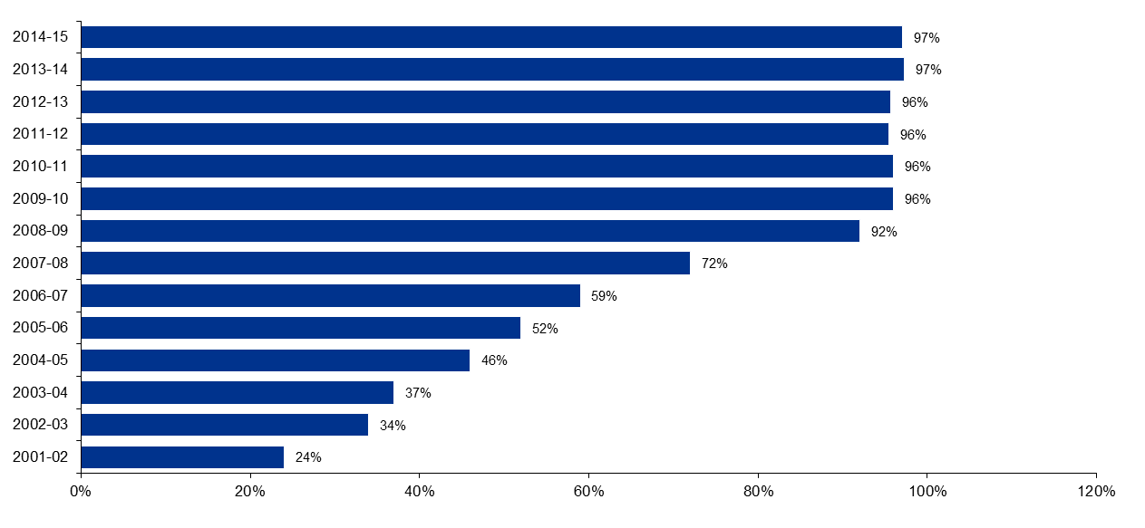
Source: ORIC Yearbook 2015-16 and 2011-12
Awareness of ORIC’s compliance monitoring function is high; 91 per cent of online consultation respondents were aware that ORIC had a compliance monitoring function; 43 per cent agreed that ORIC monitored compliance in a streamlined and coordinated way; and over 30 per cent neither agreed nor disagreed that the approach was streamlined or coordinated.
The online consultation gave respondents the opportunity to comment on whether they thought ORIC’s compliance activities were appropriate given the risks from poor corporate governance. A total of 131 substantive written comments were received and a wide range of issues were covered across the responses. Emerging themes include:
- ORIC’s compliance program is appropriate and/or works well (31 respondents – 24 per cent)
- there is room for earlier detection / more proactive intervention (22 respondents – 17 per cent)
- ORIC is too focused on compliance and there needs to be more emphasis on capacity building and addressing poor governance (20 respondents – 12 per cent)
- there is scope for a more targeted / risk-based approach to compliance activities (20 respondents – 12 per cent)
- ORIC’s compliance activities have contributed to understanding, capacity building or improved governance (18 respondents – 14 per cent)
- ORIC’s compliance activities are resource intensive or burdensome for corporations or poorly timed (10 responses – 13 per cent)
- there is room for better consultation with corporations in relation to compliance activities (eight responses – six per cent).
This indicates that respondents considered that ORIC is largely effective, but highlights that they consider there is room for improvement, particularly in the context of needing to develop and communicate a program of activity that utilises limited resources most effectively. Redefining ORIC’s regulatory strategy and approach (as discussed in sections 3.2.1 and 3.2.4) and consideration and articulation of risk tolerance (as discussed in section 3.2.2) will assist in this regard.

Reporting compliance
According to ORIC internal documents, compliance with reporting requirements contributes to the improved reputation and credibility of Indigenous corporations. It also ensures that stakeholders of Indigenous corporations have access to up-to-date and accurate information on corporations through the public register.
As set out in the table below, reporting requirements under the CATSI Act are tiered according to corporation size and income.
Table 3.2: Reporting requirements
Size and income of corporation | Report required
Small corporations with a consolidated gross operating income of less than $100,000. | 1. General report only
Small corporations with a consolidated gross operating income of $100,000 or more and less than $5 million.  AND  Medium corporations with a consolidated gross operating income of less than $5 million. | 1. General report AND  2. Financial report AND  3. Audit report  OR  1. General report AND  2. Financial report based on reports to government funders
Large corporations or any corporation with a consolidated gross operating income of $5 million or more. | 1. General report AND  2. Financial report AND  3. Audit report AND  4. Directors’ report
Sources: ORIC 2016-17 Reporting Compliance Project Plan; Corporation size and reporting factsheet
ORIC actively supports, monitors and enforces financial reporting compliance. ORIC sends reminders by various means to corporations prior to reports being due. Reports are generated by the system and emailed, posted or taken by ORIC staff for corporations to complete. Once reports are lodged and data entered, the database automatically incorporates the financial information into the corporation’s risk profile, which is updated. Failure to submit annual reports subjects a corporation to prosecution as part of ORIC’s enforcement strategy.
Non-compliant corporations are followed up through compliance visits by regional office staff in their respective regions, and national office staff in other areas early in the new year.

Corporation risk profiling
ORIC risk rates each registered corporation to allow it to prioritise its regulatory activities, including complaints about corporations, allocation of examinations, management of disputes, investigations and other regulatory actions. The procedure ORIC follows to compile risk profiles for the purposes of targeting its annual examination and compliance activities on regulated corporations is outlined in ORIC internal document ISS-060 Annual Returns Receipt and Processing (Risk Rating). The risk of an organisation is assessed on 11 risk factors of which financial or financial-related considerations make up six, and have an aggregate weighting of 53 per cent:
- Corporation size (partially a financial measure, as income and assets are key considerations)
- Audit opinion (Financial statement audit)
- Materiality
- Liquidity
- Net Trading Result
- Nature of Business (which incorporates a re-consideration of corporation size).
The remainder have an aggregate weighting of 47 percent and include:
- Compliance Risk (non-compliance in the last two years)
- Regulatory actions (actions undertaken by the Registrar in the previous three years)
- Critical event (including complaints and other intelligence)
- Number of related Party Subsidiaries
- Timeliness of Annual Reporting.
ORIC’s Deputy Registrar explained the process of monitoring and following-up on extreme risk rated corporations to the Review team as follows: ‘When corporations lodge general reports, audited financial statements and director’s reports, information used in corporation risk ratings, including assets, income, employees and other corporate information is refreshed and the system updates the corporation’s risk rating.’
Organisations are accorded a risk between ‘low’ and ‘extreme’. ORIC’s procedures document defines the approach based upon the following table.
Table 3.3: ORIC compliance model
Risk Level | Regulatory Strategies | Regulatory Instruments
Extreme | Command Regulation Non-Discretionary | Deregistration
High | Command Regulation Discretionary | Audit (with or without penalty)
Medium | Enforced self-regulation | Real time business examinations, Record keeping reviews
Low | Self-regulation | Training, Education, Record Keeping, Service Delivery
Source: Based on “ORIC Compliance model” in ISS-060 Annual Returns Receipt and Processing (Risk Rating)
KPMG did not undertake a full review of the risk rating process as it is currently applied, but the annual risk profiling process appears to place considerable weight upon financial inputs (which are dependent on the quality of audit reports) and the outcomes of recent non-compliance or regulatory actions undertaken by ORIC, as a guide to inform future regulatory actions.
Current figures provided by ORIC show the following distribution of risk ratings (set out in Figure 3.2 below). Notably, nearly half of all corporations are rated as presenting a ‘high’ risk and more than half present either a ‘high’ or ‘extreme’ risk (see figure below). Given ORIC’s limited resources, some further refinement of this risk assessment mechanism, based on the experience of its application since its introduction in 2008, would enable ORIC to better target its resources. Such a refinement might include a re-weighting of risk factors, systematic inclusion of additional information from co-regulators and/or funding agencies, or additional granularity. Review and refinement of risk assessment mechanisms is necessary from time to time to ensure that risk profiling / ratings are meaningful.
Figure 3.2: Risk rating of corporations
Source: risk rating data supplied by ORIC
Corporations with an extreme risk rating are flagged by the system for further assessment by staff. ORIC staff assess the factors contributing to the extreme risk rating and consider appropriate action, for example referral to the regulation section for consideration as to whether grounds exist for an examination, referral to the Complaints team for consideration of further follow-up of identified governance issues, referral to the Investigations team for assessment of whether an investigation is warranted (where fraud or other related issues are identified), referral to regional officers for support with governance issues, or the issue of an extreme risk rating follow-up letter to the corporation. During 2015-16, 45 corporations were issued with extreme risk rating follow-up letters. There are currently 104 corporations that are rated extreme risk.
Funding agency representatives, including from both PM&C and the Department of Communications and the Arts, expressed concern whether, or to what degree, analysis was being applied to financial reports, or whether analysis was resulting in timely intervention where necessary. Given that financial considerations significantly influence the risk rating, this would appear to point to an issue of communication. Confidence in the Registrar and Indigenous corporations could be improved if ORIC were to communicate more clearly how it risk-profiles corporations, analyses and acts on information received in financial reports.
The number of examinations resulting in management letters (no significant findings) has remained comparatively high given how many organisations are rated as ‘extreme risk’ (see Figure 3.3 and section 3.2.2), despite reducing resources (which should drive an imperative to target only the most at-risk organisations). The Review understands that in recent years examinations have not all been targeted at the 104 corporations that are rated as ‘extreme risk’ (that is, those where both the likelihood and consequences of non-compliance is highest) or ‘high risk’, but rather some lower risk corporations are included in the annual examination program. Moreover, if the examinations of some ‘extreme risk’ or ‘high risk’ corporations only result in a management letter then this indicates an opportunity to use this information to refine both the targeting model and the risk rating process.

Figure 3.3: Results of examinations 2007-2016

Source: ORIC Yearbooks 2011-12, 2014-15 and 2015-16

Examinations
Under the CATSI Act, the Registrar has the power to appoint authorised officers to examine the books of an Indigenous corporation and to report to the Registrar on the results of the examination. This is considered to be a ‘special measure’ to advance and protect Aboriginal and Torres Strait Islander people and cultures. Policy Statement 25 outlines the key objectives of examinations, which include to:
- assess whether the corporation is being governed in accordance with the CATSI Act (including the regulations and the applied Corporations Act provisions) and its rule book
- check that a corporation is managing its financial affairs properly
- determine the financial position (viability and solvency) of the corporation
- check that directors, officers and employees are carrying out their duties and exercising powers appropriately
- check that directors have properly disclosed and managed any material personal interests
- check whether related party benefits have been properly managed
- report any fraud or misuse of corporation resources for personal benefit
- identify and report on any specific governance or operational concerns identified by the Registrar.
ORIC commissions examinations of large, essential or publicly funded corporations as part of a rolling program (with the aim of examining each large corporation every five years) and also where matters come to the attention of the Registrar, for example where there is evidence of potential financial or governance issues within a corporation, or where the directors or members of a corporation request an examination.
ORIC’s examinations are comprehensive, without going into the same depth of detail on the financial statements as an external audit of financial statements. Examiners are provided with a standard terms of reference (ToR) of approximately 150 questions (approximately 50 pages) to answer throughout the course of the examination. The questionnaire covers a wide range of topics, including: member registers and management of membership; AGMs and general meetings; directors and officers; directors’ meetings; financial and other records; property and housing operations; staff and reporting lines; subsidiary corporations; trusts; partnerships and significant business relationships; fraud issues; related party benefits; tax obligations; sundry matters; and other specific matters that can be inserted into the ToR. All examinations are conducted onsite and usually take two to three days to complete at a cost of approximately $11,000 (in 2015-16).
Interviewees of the Review, ORIC staff and ORIC contractors deemed examinations to be very effective in identifying breaches and promoting compliance; one examiner described the examination ToR as being ‘very close to perfect’. Often, examinations are undertaken as a precursor to a special administrator being appointed and/or an investigation being launched.
The number of examinations undertaken in recent years has reduced significantly; 81 examinations were undertaken in 2008-09 and only 39 were completed in 2015-16. This appears to be largely due to increasingly limited resources being available and examinations being viewed as one of the Registrar’s discretionary activities.
Despite these resource constraints, ORIC does not employ a tiered approach; for example, ORIC does not undertake reduced scope / targeted examinations or desk-based reviews. Furthermore, ORIC’s targeting of its examinations program based on a proactive assessment of risk could be further refined.
ORIC’s annual program of examinations appears to capture a large proportion of low risk rated corporations. The 2015-16 proposed program of examinations, for example, identified 23 corporations. This included three corporations with extreme or high risk ratings, eight large corporations as part of the rolling program, two corporations recently referred by the Complaints Panel, two corporations referred by the Deputy Registrar, two corporations subject to post special administration check-ups, and one medium sized corporation located in the same remote community as one of those subject to the post administration check-up.
Some of the large corporations captured in the rolling program may be selected for reasons of size, level of funding or criticality of services delivered. These types of corporations in particular could be subject to narrower scope or desk-based reviews, particularly where the service delivery is also regulated or reviewed under other regulatory frameworks.
Other compliance programs that KPMG has observed contain a range of inspection/external examination activity that vary in scope and depth, based upon the risk rating of the subject organisations. This is not to say that ORIC’s comprehensive examination should be moved off-site, but rather that there may be opportunity for additional types of reviews, fitting within the broad term ‘examination’ as described in the Act, and that these could be applied in a risk-based way.
For example, KPMG has a number of internal audit clients, whereby the methodology of audits undertaken as part of the annual internal audit program is selected based on the nature of the risk treatment. This can include, for example, either very thorough forensic audits undertaken onsite, desk-based reviews, something in-between or a mixed methodology.
We note that the organisations targeted for examination are subject to risk profiling; however, this profiling appears to result in a binary decision to undertake an onsite examination or not, rather than selection of a range of examination responses.
The Registrar is of the view that desk-based examinations would not be effective, as it is very difficult to get remote located corporations to send in documents in a timely manner. ORIC staff and contractors also emphasised the importance of examinations being undertaken onsite and involving face-to-face contact between the examiner and directors, also noting that this presented an educative opportunity and can result in increased knowledge and understanding within the corporation subject to the examination.
Noting that there may be some challenges and further consideration required, the Review considers that a range of examination activity, including desk-based reviews, could be a valuable addition to ORIC’s compliance program particularly in relation to those organisations with a lower risk profile, but where their size may currently lead ORIC to wish to continue with some form of examination of them. These larger and more sophisticated organisations are more likely to be able to provide the appropriate information for some form of desk-based examination.

Exemptions
In certain circumstances, corporations can apply to the Registrar for exemptions to reporting and AGM requirements. During the 2015-16 year, 42 exemptions were approved. In addition, 236 AGM extensions were approved, and 190 extensions were approved to medium and large corporations from the requirement to lodge financial reports.
Thirty-eight per cent of online respondents indicated that they have previously sought an exemption from ORIC. Of the 42 people who provided a rating, 39 (93 per cent) rated the exemption process as effective.

Recommendations
Ref. | Recommendation
19 | ORIC should review its risk assessment mechanism to ensure that the risk ratings are meaningful and contribute to the targeted allocation of resources.  This should be linked to the activities outlined in Recommendations 7-9 to work more closely with funding agencies and co-regulators, clarify ORIC’s regulatory approach, and develop a strategic risk management framework. There may be benefit in conducting this review together with other agencies.
20 | ORIC should pilot an expanded examinations/audit program to include different types of examinations, for example, examinations with a narrower scope and/or desk-based reviews.  This should be considered in relation to the development of a risk based regulatory plan, and could draw on the expertise of co-regulators (Recommendation 10).
21 | ORIC should communicate more clearly to interested funding agencies about how it risk-profiles corporations, and analyses and acts on information received in financial reports – this can be done through closer working relationships (Recommendation 7) and a better articulated regulatory approach (Recommendation 8), involving funding agencies in the review and revision of its risk assessment mechanism (Recommendation 19).

Managing complaints of non-compliance
One of the functions of the Registrar as outlined in section 658-1 of the CATSI Act is to assist with complaints involving Aboriginal and Torres Strait Islander corporations. ORIC reports that it currently receives approximately 800 complaints about corporations per year (noting that multiple complaints about a single issue are reported as one complaint) – this is a significant increase from 2007-08 where 239 complaints were resolved (see complaints data over the years in the figure below).
Figure 3.4: Complaints about corporations completed by ORIC
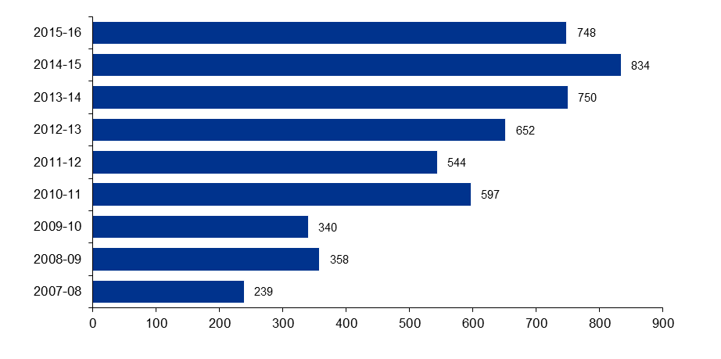
Source: ORIC Yearbooks 2015-16
Complaints statistics are reported annually in the ORIC Yearbook and in detail in six monthly complaints reports. The most recent complaint report for the period 1 January to 30 June 2016 details the following:
- 389 complaints were received (compared to 279 received in the first six months of 2012)
- 400 complaints were finalised (compared to 280 finalised in the first six months of 2012)
- average number of days to finalise complaints by type:
- straightforward – three days (up from two days for the same period in 2012)
- detailed – nine days (same as the first six months of 2012)
- complex – 80 days (a significant increase from 35 days in the first six months of 2012); and
- most complaints were in relation to the conduct of directors and officers (same as in 2012).
By way of comparison, ASIC aims to respond to complaints or reports within 28 days of receiving all relevant information. In 2015-16, ASIC reported that 68 per cent of complaints involving a corporation or an individual were finalised within 28 days. Similarly, ACNC has a key performance indicator (KPI) of providing a substantive response to concerns about charities within 30 business days – in 2015-16, this timeframe was met in 79 per cent of cases.
Of those that responded to KPMG’s online consultation, 38 per cent had been involved in a complaint with ORIC; 15 per cent had made a complaint and 22 per cent were from corporations that had been the subject of a complaint. Of these, 55 per cent rated ORIC as ‘not effective’ in assessing complaints and 47 per cent disagreed that ORIC was open and transparent in dealing with corporations subject to complaints. In contrast, 64 per cent were satisfied with the mediation or dispute resolution services that they received from ORIC.
Written submissions received as part of this Review also raised concerns relating to the transparency and accountability of ORIC’s approach to complaints. Suggestions received via written submissions and online consultation responses included allowing for the subject of a complaint to be more involved in the complaint resolution process and allowing for comments from a corporation’s board or executives in the first instance.

Receiving and responding to complaints/concerns
A complaints handling procedure for individual complaints about corporations is in place with appropriate guidance documented for staff. These state that they were developed to be consistent with Australian Standard AS ISO 10002:2006 ‘Customer Satisfaction – guidelines for complaints handling in organisations’ and the Commonwealth Ombudsman’s ‘Better practice guide to complaints handling‘ (2009). The procedures also refer staff to the Commonwealth Ombudsman’s publication on ‘Managing unreasonable complainant conduct’ (2012).
ORIC has appropriate arrangements for receiving complaints about corporations
Timeframes to respond to complaints are in line with similar complaint management procedures in other public sector legislation
A consistent system is used to record complaints
A critical decision body oversees the management of complex complaints.
ORIC has numerous channels through which it can receive complaints and several policies relating to the receipt of complaints, including:
- PS-02 Complaints involving corporations
- PS-03 Complaints about staff and contractors
- Complaints handing procedures.
Response times for complaints vary upon the assessed complexity, but appear appropriate and in line with similar complaints legislation in the public sector including the Public Interest Disclosure Act 2013.

ORIC does not however, appear to proactively encourage funding agencies, and others to alert it to concerns in order to provide an early warning of potential issues.
The Registrar and ORIC staff detailed a close working relationship between ORIC and auditors of Indigenous corporations; furthermore, many of ORIC’s examiners are also company auditors. Under section 339-90 of the CATSI Act, auditors are required to alert ORIC to situations where the auditor has ‘reasonable grounds to suspect [circumstances that] amount to a contravention of [the CATSI] Act’; however, situations which do not yet meet this threshold may still be valuable intelligence which could factor into proactive targeting measures. Thus, it will be important for ORIC to continue to nurture productive relationships between ORIC and corporation auditors.

Recording complaints
All complaints about corporations received, including reports of concerns from funding agencies, other regulators or external parties such as auditors, are recorded in ERICCA as a ‘critical event’ which links the complaint to the relevant corporation. The complaints handling procedure(s) are generally comprehensive and require complaints to be categorised into three levels of complexity – straightforward, detailed and complex complaints.
A previous review of ORIC in 2012 noted that under the complaints handling procedures, complaints are not always assigned a category until the complaint is closed, highlighting that ORIC may not have oversight regarding the appropriate level of priority required for complaints.
Although current guidelines exist which guide the classification of a complaint into the relevant categories of straightforward, detailed or complex, the guidelines take the form of a list of characteristics rather than a scale or categorisation model. Therefore, there is a risk that without such a Case Categorisation and Prioritisation Model, the ability to address a category of complaints with a consistent decision regarding response, treatment and priority may not be achieved.
In relation to complex complaints, a Corporation Complaints Panel, chaired by the Deputy Registrar, meets fortnightly to assess complex complaints about corporations and to refer these to other sections within ORIC where appropriate, including the Investigations and Prosecutions section. The Complaints Panel also provides advice and mentoring to complaints officers.
This Review notes that recording of complaints within ERICCA has no specific fields, apart from a free text field in ERICCA to capture the type of complaint. Therefore, reports cannot be run on the source of complaints (e.g. funding agency, auditors, private citizen, police, etc.). Consequently, it is not possible to assess the extent to which ORIC is successfully encouraging different stakeholders to raise their concerns and/or provide other intelligence to ORIC, nor to assess the value of these concerns/intelligence to achieve ORIC’s regulatory objectives.

Using complaints and other intelligence
As noted above, policies and procedures relating to the response to complaints, or the referral of complaints to other elements of ORIC, appear appropriate. Appropriate oversight of complaints exists from the Complaints Panel. Responsive uses of complaints to drive activity therefore appear strong.
The current annual risk profiling process, previously discussed in section 3.4.2 includes complaints about corporations as one of the types of Critical Event in ERICCA. Critical Events are a manual category of risk rating reliant upon the ORIC staff member to assign a weighting and risk factor.
The organisational risk assessments are undertaken by ORIC in May each year as part of its business planning cycle. All complaints data is fed into ERICCA for future use, and the data provided forms part of the collection of intelligence which can inform future examinations, complaints and disputes action by ORIC, make referrals to the complaints panel, establish themes or irregularities in director behaviour, which may inform information and education strategies, e.g. themes of newsletters or other guidance.
ORIC could consider the following further enhancements:
- Although complaints about key corporation personnel factor into an individual corporation’s consideration (particularly where a person has been subject to disqualification), where those personnel have been subject to ‘less-than-disqualificatory’ complaints and work across a number of CATSI corporations, the complaint could factor against those other organisations’ risk ratings.
- Complaints about particular organisations in certain industries factor into consideration with regards to other organisations with similar operations in the same industry.
More generally, organisational interrelation is considered in a limited fashion. The ERICCA risk rating considers the number of subsidiaries of an organisation as a relevant factor for the organisation’s risk assessment as a measure of its relative importance, however opportunity exists to consider broader relationships such as relationships with failed or failing organisations whether via key personnel or common ownership structures.

Complaints about ORIC staff
ORIC’s service charter also briefly outlines how complaints about ORIC staff, services or contractors can be made and are handled. Any of these complaints are referred immediately to the General Counsel and are not assessed or processed by ORIC’s complaints officers or entered into the ERICCA database. A quality assurance program is in place which monitors trends in complaints about ORIC to the Ombudsman and ORIC’s General Counsel.
A quality assurance mechanism also exists to ensure monitoring of external complaints about ORIC. We note that complaints about ORIC staff, contractors and services are dealt with by General Counsel. In other organisations, this might be dealt with by the Human Resources function or internal Investigations team as appropriate. Historically however, ORIC states it has only received five of these a year and they have not considered these to be burdensome. ORIC has also stated they believe it is appropriate that they are dealt with only by General Counsel.

Recommendations
Ref. | Recommendation
22 | ORIC should increase its proactive encouragement for funding agencies to provide ongoing intelligence of potential issues, in addition to the more periodic strategic discussions. This intelligence collection may utilise the complaints process. It is acknowledged that intelligence sharing requires the input and participation of organisations outside the control of the Registrar.
23 | ORIC should consider identifying further source data, for example whether complaints are received from funding agencies, police, peak bodies etc., in its complaint recording in order to enable trend analysis.  ORIC should also consider whether the level of analytics skill within ORIC is currently sufficient for undertaking trend analysis and other data analytics. This could be bolstered with appropriately skilled Graduates rotating through ORIC.
24 | ORIC should enhance its proactive approach to regulation through the use of enhanced risk profiling of organisations, including:  - considering the risks presented by key personnel and organisational interrelationships  - consideration of complaints against other similar organisations based on industry or operational similarity.

Case selection and escalation

Selection and escalation
Serious and complex complaints where there is credible evidence of criminal misconduct, misconduct or breaches by directors or other officers, or theft, fraud or misappropriation are referred by the Corporation Complaints Panel to ORIC’s Investigations and Prosecutions team for assessment (a referral). Investigation activities are overseen by a Regulation and Litigation Committee (RaLC), which approves matters for investigation and litigation, and refers matters to a delegate of the Registrar to consider whether to issue a show cause notice or appoint a special administrator.
ORIC has appropriate internal escalations, protocols and oversight committees which, de facto, will drive a consistent approach to categorisation and prioritisation of those complaints which are to be investigated.
Although ORIC does not have a case assessment and prioritisation model to assist it in identifying, prioritising and selecting cases for investigation, the operation of the Complaints Panel and the Regulation and Litigation Committee are designed to achieve consistent decision making.

Where examiners, special administrators or liquidators identify allegations of criminal misconduct that require further investigation, these are also considered by the Corporation Complaints Panel and referred to the Investigations and Prosecutions team as appropriate.
Similar to the categorisation of complaints, ORIC evaluates referrals on a case by case basis but does not employ a formal Case Categorisation and Prioritisation Model (CCPM). This may limit ORIC’s ability to achieve consistent, defensible and repeatable decision making with regards to investigation priority. This may be of significance where too many referrals are on hand and prioritisation decisions need to be made as to which will progress and which will be put on hold. Given the small size of the organisation and involvement of senior staff in the Complaints Panel and the Regulation and Litigation Committee, the risk of mis-allocation of priority is reduced.
In other small investigative functions that KPMG reviewed, a case categorisation and prioritisation model consisted of a graduated scale of severity against the following key questions with each element assessed against a three point scale, leading to a mathematical guide to the relative priority of each referral on hand:
- What is the reliability of the source making the allegation?
- How credible is the information/allegation itself?
- To whom does the allegation relate?
- What malfeasance is alleged and what would be required to prove its existence?
- How severe is the alleged behaviour (what is the financial consequence, what is the impact upon the relevant community)?
- How available is the evidence required to prove the allegation?
- What are the prospects of financial recovery?
- What is the risk of inaction/the deterrent value of action?

Recommendation
Ref. | Recommendation
25 | ORIC should formalise a Case Categorisation and Prioritisation Model to guide a consistent, repeatable range of responses.

Investigations into non-compliance

Undertaking investigations

Structures and governance
ORIC undertakes investigations into serious non-compliance and fraud. As discussed in the previous section, cases to be pursued are decided by the RaLC, which meets fortnightly.
The RaLC is responsible for decisions to proceed, continue, redirect or terminate investigations and approves investigation plans. The oversight of the investigations function by the RaLC enables holistic oversight of the program of investigations and enables the identification of recurring themes and issues.
ORIC’s investigations function structure and governance appear to meet better practice.
Relevant committees and feedback mechanisms exist to enable the identification of systemic issues and trends.
Investigators hold relevant qualifications and are familiar with investigations standards.
No shortage of investigative powers was identified as part of this Review.

We understand from interviews that whilst investigations do not involve the systematic production of a stakeholder feedback report, the Investigation team reports fortnightly to the Senior Management Meeting which allows the identification of systemic issues on a timely basis to be fed back to relevant line management.
The use of an investigations oversight committee meets with better practice standards. This enables ORIC to address which investigations to pursue with a strategic approach.
With regards to performance measurement, although investigators have a KPI for litigation success which is measured and tracked, there are no individual activity measures and no individual completion statistics. ORIC states its Investigations team provides statistical reporting fortnightly to its Senior Managers Meeting, bi-annually for Senate Estimates and annually for the ORIC Yearbook.

Powers
Investigations are undertaken under the CATSI Act which provides a range of compulsive powers. ORIC investigations staff feel that these investigations are generally well supported by the CATSI Act.
The team commented positively on the existence of the compulsive powers to facilitate witnesses speaking with investigators. Particularly, they identified this as a means by which witnesses who were willing to provide evidence, but concerned about community pressure not to provide that evidence, could provide evidence in a manner which protected them from reprisals.
The team did however note that a consequence of the requirement to provide 14 days’ notification to produce documents in section 453-5(3) created a situation where the notification enabled evidence to be destroyed prior to any possibility of securing it for investigative purposes. In similar situations, ASIC is able to provide a forthwith notice under section 87 of the Australian Securities and Investments Commission Act 2001 which requires production of books and records at a place and time that is ‘reasonable in all the circumstances’.
The team also identified a difficulty in prosecuting the relevant accountants and lawyers with the difficulty of the need to prove that the adviser was influencing the decisions of the directors or officers or were officers themselves. No legislative change was suggested.
The Review notes that the scope for undertaking investigations provided by the CATSI Act may be limited. In particular, where corporations establish unreasonable or irregular payments schemes within government structures, it is not currently within the remit of ORIC to undertake an investigative role. This does not however necessarily present a strong impediment to the functional responsibility of ORIC, as ORIC may be able to prevent such governance and potential misconduct by way of a more facilitative process through its outreach and training.

Staffing
The Investigations and Prosecutions team consists of an EL2 Investigations Manager, three EL1 Senior Investigators (one position vacant) and an APS 4 support officer. Three staff, including two investigators are Indigenous.
The ratio of investigators to population of regulated bodies is relatively high, with five investigations function staff, to 2,800 regulated bodies, however the qualified Investigations team is small (four qualified investigators) and has little provision for absences in the team (e.g. unforeseen leave etc.). This is especially significant given the requirement for two investigators to attend witness and suspect interviews as corroborators.
Opportunity may exist to rebalance the staffing profile of the Investigations team within existing budget arrangements by considering the use of more junior staff as corroborating staff. As an illustrative example, the Department of Immigration and Border Protection considers qualified investigators to be APS5 staff, Senior Investigators as APS6 and Investigations Team Leaders as EL1 staff. KPMG notes that the shortage of qualified and experienced investigations staff outside law enforcement bodies is a likely complication to any re-profiling of staffing arrangements.
Although a formal skills audit was not undertaken as part of this Review, staff indicated that they held the mandatory qualifications required by the Australian Government Investigation Standards (AGIS), being a Certificate IV or Diploma Government (Investigations).
ORIC does not maintain an ability to train investigators and relies upon hiring investigative resources who already have the relevant, required, qualifications.

Technology and support
The Investigations team has access to an evidence room, Class C drawers and Class B Cabinets to facilitate the appropriate storage of evidence in a manner which would maintain the chain of custody.
Although the Investigations team has access to a formal, commercial, Case Management System (Jade Investigator), its use has been discontinued with the team relying upon ShareHub as its record system. Critical decisions are stored in relevant file structures. ORIC stated that Jade was implemented in 2010 and decommissioned in or around mid-2011 as the IT group were unable to provide a protected enclave for IPS to save work as Jade was not able to operate with the Department’s electronic filing system.
ORIC maintains a MoU with the Shared Services for specialist investigations services, including computer forensics and handwriting analysis. However, ORIC does not have any formalised existing arrangement which might enable them to access surge capacity, when referrals on hand exceed available investigative resources.

Policies and procedures
The team has an investigations manual which is regularly reviewed and in interviews staff indicated familiarity with AGIS.
The Prosecution Policy of the Commonwealth, which is produced by the Office of the Commonwealth Director of Public Prosecutions (CDPP), provides a set of guidelines for making decisions in the prosecution process.
The Policy sets out a high standard in terms of cases that the CDPP is willing to prosecute; it will not always agree to prosecute potential cases, including for example when the defendant is elderly or deemed vulnerable. These guidelines, and the likelihood of the CDPP agreeing to prosecute, are taken into consideration when ORIC decides whether to pursue an investigation.
No file review was undertaken as part of this Review, and the implementation of the investigations practices has not been assessed.

Recommendations
Ref. | Recommendation
26 | ORIC should consider tracking an activity measure, such as number of investigations completed, for investigators in addition to successful litigation statistics to encourage effective use of investigator time.
27 | The staffing profile of the Investigations team should be re-balanced over time to make greater use of more junior staff as corroborating staff. As an illustrative example, the Department of Immigration and Border Protection considers qualified investigators to be APS5 staff, Senior Investigators as APS6 and Investigations Team Leaders as EL1 staff.

Enforcement actions
ORIC has a range of enforcement actions at its disposal, including:
- issuing compliance notices to require compliance with the CATSI Act
- giving a direction (for example for a corporation’s directors to undertake training)
- putting a corporation under special administration
- intervening in a civil proceeding and applying for civil penalty orders
ORIC has a range of enforcement actions at its disposal.
These include special measures such as examinations and special administrations that are not available under mainstream legislation.
- pursuing criminal prosecution through the Commonwealth Director of Public Prosecutions
- making an application to court for winding up orders
- applying for injunctions
- no action letters advising that no action will be taken at a particular time in regards to a breach.
The range of response actions are detailed in policy statements available on ORIC’s website, including:
- Policy Statement 05: Exercise of the Registrar’s powers to intervene
- Policy Statement 20: Special administrations
- Policy Statement 21: No-action letters
- Policy Statement 26: Compliance notices
These policy statements contain a description of the circumstances in which they might be used; however, the strategy which would inform the reason why one response or another should be preferred is not clearly stated. This need for a coherent and articulated regulatory approach is further identified and discussed in section 3.2.4.

Compliance notices
The Registrar has power under section 439-20 of the CATSI Act to issue compliance notices to corporations. A compliance notice is an instruction to a corporation to take action to rectify a suspected non-compliance with the CATSI Act or the corporation’s rule book or an irregularity in the corporation’s affairs. Compliance notices are often issued where minor non-compliance is identified, for example, through the course of an examination.
Compliance notices provide formal guidance for corporations regarding how to improve their standards of corporate governance and financial management. Because they are public documents, they are also a valuable information source for stakeholders, including members, creditors, funding bodies and the community, about the standards of corporate governance and financial management of a corporation.
Currently, ensuring that compliance notices are being enacted is the responsibility of one officer in ORIC’s Regulation team in Canberra and consumes the majority of their time. ORIC has advised that the Regulation team is attempting to increase the involvement of regional office staff in this activity. The Regulation team also expressed frustration that there are limited remedies to ensure an organisation actions a compliance notice and that they rely upon Special Administration.

Penalty notices
The CATSI Act allows for penalty notices to be issued for prescribed offences; however, no offences or associated penalties have been prescribed in the CATSI Regulations to enable penalty notices to be used by the Registrar as an enforcement tool.
ORIC’s Policy Statement 05 outlines that:
…the legislation recognises that some contraventions might be inadvertent or minor. In such cases, it may be preferable not to prosecute an offender for the offence. As an alternative, the legislation allows for the Registrar to issue a ‘penalty notice’ under section 566-5. A penalty notice operates in the same way as an on-the-spot fine for a parking infringement. A person who receives a penalty notice has at least 21 days to pay the penalty and to do any outstanding act or thing.
The Registrar expressed that in his view, penalty notices are not an effective enforcement tool, but are generally used by other regulators as ‘revenue raising’ tools. No changes to the Regulations are recommended by this Review, but Policy Statement 05 should be updated to acknowledge that penalty notices are not a regulatory tool currently available to the Registrar.

Prosecution

Criminal and civil prosecutions
The Registrar has publicly expressed the view that the effectiveness of a regulator is judged on how they address non-compliance and that successful prosecutions will support and encourage compliance within corporations. The Registrar pursues major prosecutions to address serious cases of poor governance and breaches of duty under the CATSI Act. ORIC successfully prosecuted a combined total, averaging around eight major criminal and civil cases per year between 2012-13 and 2014-15 (see table below). No major criminal or civil prosecutions were finalised in 2015-16, although as at 30 June 2016, one civil matter and two criminal matters were underway.
Table 3.4: Major Criminal and Civil Prosecutions
Prosecutions Finalised by ORIC | Financial Year
 | 2007-08 | 2008-09 | 2009-10 | 2010-11 | 2011-12 | 2012-13 | 2013-14 | 2014-15 | 2015-16
Major Criminal Prosecutions | 0 | 0 | 0 | 0 | 0 | 4 | 2 | 1 | 0
Major Civil Prosecutions | 0 | 0 | 0 | 0 | 0 | 4 | 6 | 6 | 0
Total | 0 | 0 | 0 | 0 | 0 | 8 | 8 | 7 | 0
Source: ORIC website, Prosecution Outcomes page
The Registrar noted that there is a reduced ability and appetite to pursue riskier prosecutions in recent years, since the Indigenous Litigation Fund, which reportedly previously underpinned ORIC’s prosecution activities, was removed.

Annual reporting prosecutions
ORIC identified that the lodgment of annual reports has historically been an area of poor compliance. Corporations that do not lodge their reports by 31 December risk prosecution under the CATSI Act, as do the secretaries of those that are classified as large corporations. Corporations can face a maximum penalty of $22,500 for the offence.
Each year, ORIC conducts a compliance program to identify corporations that do not lodge their annual reports by 31 December. In 2010-11, five corporations were prosecuted for failing to submit their annual reports, this increased to 32 in 2012-13 and 2013-14, and then dropped to 16 for 2014-15 and 2015-16. Penalties imposed have ranged from $250 to more than $10,000, however fines are not always imposed by the courts, with a number of cases that have resulted in a charge “proven but dismissed under s.19B of the Crimes Act 1914”.
Figure 3.5: Annual reporting prosecutions 2010-11 to 2015-16

Source: ORIC website, Prosecution outcomes page
The Registrar points to annual reporting prosecutions as ORIC’s most successful compliance program to date. ORIC resources required to undertake the process are minimal – once staff have confirmed a corporation has not submitted a required report by the deadline, all they need to do is generate and lodge a Certificate of Non-Compliance. Since ORIC began prosecuting corporations for failing to lodge reports, compliance has increased dramatically from just 59 per cent for 2006-07 reports to 97.3 per cent for the 2013-14 reporting period. Importantly, as ORIC’s media releases highlight, this high rate of compliance means that the information in the Public Register of Indigenous Corporations is up to date and can be relied on by interested parties including corporation members and funding agencies.
By way of contrast, the ACNC clearly sets out the action that it will take if charities fail to submit their Annual Information Statement on time which range from sending warning letters, publishing a statement on the ACNC Register, issuing penalty notices (ranging from $170 for a small charity with a report lodged within 28 days of the due date, to $4260 for a large charity and a report that was over 112 days due), through to revoking registration for persistent non-compliance, which is defined as failing to lodge for two successive years.
Opportunity exists to further communicate why such a robust approach to non-compliance (prosecution) is appropriate. An example of such an approach is a recent media release from ASQA following a successful action in the Administrative Appeals Tribunal related to the de-registration of a Registered Training Organisation. The media release highlighted that the action flowed from its audit program, outlined the adverse regulatory outcome it was aiming to address, and linked the outcome to its strategy of targeting a specific group of providers. Along similar lines, ORIC should further promote the other actions that are also undertaken prior to or in lieu of prosecution as part of its annual report compliance program. Moreover, the media releases following these prosecutions could highlight how accurate information on the public register allows ORIC to better target its resources that are deployed to offer hands-on support, training, examinations, and where necessary, consideration of special administrations, and how this is linked to the regulatory outcomes ORIC is seeking to achieve.

Special administrations
One of the more significant and unusual powers of the Registrar is the power to appoint a special administrator to an Indigenous corporation. Similar to the examinations power, it is a special measure that addresses the unique role and circumstances of Indigenous corporations.
ORIC’s Policy Statement 20 on special administrations states that “special administration enables the Registrar to provide early proactive regulatory assistance when a corporation experiences financial or governance difficulties”.
The number of special administrations conducted each year has remained relatively stable despite increasing constraints on resources – see table below.
Table 3.5: Special administrations started
 | Financial Year
 | 2007-08 | 2008-09 | 2009-10 | 2010-11 | 2011-12 | 2012-13 | 2013-14 | 2014-15 | 2015-16
Special administration | 3 | 8 | 12 | 9 | 11 | 6 | 11 | 10 | 10
Source: ORIC Yearbooks 2008-2016
The grounds for placing a corporation into special administration are broad and the Registrar does not have to apply to a court. Usually, special administrators are appointed as a result of an examination, and occasionally directors or members of a corporation also request a special administration.
Before appointing a special administrator, ORIC issues a ‘show cause’ notice giving the corporation 15 days to demonstrate why it should not be put into special administration. This is not strictly necessary under the CATSI Act; however, the process is followed fairly rigorously to ensure that procedural fairness is allowed for and the process is defensible.
Once an administrator has been appointed, special administrations generally go through three key stages:
- Resolve the critical issues that resulted in the special administrator being appointed
- Consolidate and ensure proper procedures and processes are in place
- Prepare to hand back the corporation.
ORIC has set a target of six months for the duration of special administrations and sometimes also appoints them for three months or less. This is reportedly not due to budget constraints, but rather to return community control of the corporation to Indigenous people as quickly as possible. The special administrators interviewed by the Review team expressed that, in some cases, allowing a longer period of external administration would result in better and more sustainable outcomes for the corporation under administration.
One online respondent relayed that a special administrator had been appointed to their corporation for a single day to make amendments to the rule book and re-appoint directors. According to the Registrar, this was done at the request of the corporation when all other alternatives for the corporation to resolve internal governance issues involved court proceedings or were otherwise not practical or cost effective. Other corporations have reportedly since requested single day appointments.
Special administrations were viewed by most interviewees as being highly effective interventions. Special administrators who were interviewed for the Review indicated that the powers available to them are sufficient to be able to achieve their objectives.
ORIC contractors interviewed emphasised the need for special administrators to be appropriately qualified including having experience in insolvency, and an understanding of the Indigenous cultural context for the administrator to be effective. Online respondents also echoed the need for cultural understanding for special administrators to be effective. ORIC staff assert that all of their special administrator panel are qualified accountants and insolvency practitioners, and some are official court liquidators, who have been working for ORIC for years and with Indigenous organisations for decades.
ORIC Regulation team staff and some PM&C staff consulted noted that in the past, there have been instances where special administrators have not been appointed due to ORIC’s budget constraints despite there being a perceived need. The Registrar indicated that this is an inevitable consequence of finite resources, especially in the current fiscal environment where resources are increasingly constrained, however, indicated that there may be opportunity for funding agencies to jointly fund special administrations where there are major concerns that cannot be addressed within current budgets. ORIC reported that, since 2007, no funding agency has provided funding to cover the full or partial costs of a special administration.

Recommendation
Ref. | Recommendation
28 | ORIC should ensure that it clearly articulates the escalation process for non-compliance and how, for example, failure to lodge an annual report can ultimately result in criminal prosecution.  A clear link between ORIC’s public regulatory approach and decisions to prosecute, and the related communications strategy post-court outcome, will highlight how this activity is intended to drive compliance in ORIC’s priority areas of concern, and also potentially contribute to increased compliance.

Capability
The Registrar is a statutory office holder supported by the Office of the Registrar of Indigenous Corporations, which is made up of PM&C staff. The Registrar is appointed by the Minster and has functions and powers as provided for within the CATSI Act. The Registrar may appoint one or more Deputy Registrars under the CATSI Act to assist in carrying out Registrar functions. The Deputy Registrar is engaged under the Public Service Act 1999.
ORIC staff are co-located with PM&C staff in regional offices where possible, and the Canberra office occupies half a floor in Centraplaza. Access to this part of Centraplaza is through an additional set of secure doors, which other PM&C staff do not have access to enter through (necessary due to the investigative function). While the office supporting the Registrar is technically part of PM&C, it is also almost completely separate. There also appears to be a perception that ORIC employees, who are technically PM&C staff, are somewhat isolated and not actively involved in the broader corporate activities of PM&C, particularly in the Canberra office.
The Registrar also detailed that since the machinery of government changes that brought Indigenous affairs (and ORIC) into PM&C, the Registrar and ORIC have been increasingly excluded from broader departmental activities including business planning, senate estimates processes, the PM&C annual report, budget development, departmental risk plans, information exchange, ministerial correspondence, ministerial briefings, senior staff interaction, etc. Active inclusion of the Registrar and ORIC in these broader departmental activities would assist in rebuilding relationships, aligning objectives, undertaking joined up work and information sharing.

Indigenous employment
All positions within ORIC are identified (have criteria relating to understanding and communicating with Indigenous people), and ORIC has a cultural competence framework whereby positions are numbered from 1 to 3 based on level of cultural competency required. The proportion of ORIC staff identifying as Aboriginal or Torres Strait Islander was 47.9 per cent as at 30 June 2016. This represents a significant increase in the proportion of Indigenous staff since 2007-08 when 17 per cent of ORIC staff identified as Indigenous.
By way of comparison, PM&C had 16.1 per cent Indigenous representation at June 2016 and a target of 17 per cent, the Department of Human Services aims to achieve five per cent representation by 2017, and the whole of government target is three per cent by 2018.
Considering the nature of ORIC’s work and its singular focus on Indigenous corporations, it is highly appropriate that it aims for a high proportion of Indigenous staff. Of the online consultation respondents, 22 noted the importance of this staffing profile to ORIC’s work.

ORIC’s resourcing model
The Registrar’s functions as set out under the CATSI Act are provided for reference at Appendix C. ORIC’s structure at the time of writing is outlined for reference at Appendix D.
ORIC staffing has reduced substantially over time from 63.99 FTE in 2010-11 to 46.57 FTE as at 30 June 2016.
In recent years, ORIC has not been successful in applications for PM&C Graduate placements. Graduates and Indigenous Australian Government Development program participants are centrally funded and could present an opportunity for increased capacity at little cost to ORIC. Graduates are also centrally supported to undertake short-term regional office rotations in PM&C.
Two PM&C officers interviewed for the Review suggested that there may be merit in exploring whether PM&C’s regional office capacity could be better leveraged by ORIC. As ORIC is an independent regulator, this approach is not advisable and could further confuse ORIC and PM&C roles and undermine actual and perceived independence. However, there may be scope for ORIC to reduce some administrative burdens associated with procurement if ORIC accessed some of the provider panels available to the remainder of PM&C or other Departments.
A number of ORIC staff interviewed mentioned that they had very little capacity to undertake “proactive” work with current resourcing levels, and the lack in resourcing has contributed to limitations on the work that they can undertake.
KPMG observed ORIC staff to be a passionate, dedicated team with a good understanding of the strategic and operational priorities of the organisation.
The move to having an ORIC regional presence has been welcomed by regulated entities.
Demand for ORIC services has increased and is expected to continue to increase as the expectations of high levels of governance remain, while government and business increasingly procure more goods and services from Indigenous organisations, and as native title entities acquire more assets and revenue streams. The number of new corporations registering under the CATSI Act has increased at a steady rate within recent years, with 170 new corporations registering in 2014-15 and 163 in 2013-14. The increasing number of regulated corporations, coupled with an increased demand for services, continue to present challenges for ORIC.
Continuing to operate with the existing number of staff appears increasingly unsustainable, with more work for a decreasing number of staff. This does not appear to have impacted on activities in some areas due to the dedication and passion of staff, and gained efficiencies; however, it is the view of KPMG that this may not be sustainable in the long term.
There are some indicators that some work and decisions may not be undertaken at the most appropriate staff classification. A workforce capability review against APS work level standards would assist to identify if the resourcing issue extends to challenges with capability, skills, classifications of positions, and delegations as opposed to just the numbers of staff.
There would seem scope, subject to a review of work level standards, that additional staffing resources could be allocated to investigations (junior investigator level) and regional offices, if additional funding was made available. At the time of writing, there were four vacant positions within ORIC (an EL2, two EL1s and an APS5) as well as staff on leave (including long-term maternity leave) that were not being backfilled. If these positions are primarily unfilled because of budget constraints then it would seem feasible to implement a staffing model with a higher mix of lower grades, within ORIC’s share of the Department’s existing Average Staffing Level (ASL) cap.

Key capacity reflections on each functional area

Executive
ORIC’s Executive consists of the Registrar, the Deputy Registrar, an EL2 Governance Branch Manager (vacant and unable to be filled due to funding constraints), an APS5 finance and administration officer (vacant), an APS5 Executive Assistant, and an APS4 Executive Assistant.
The Minister for Indigenous Affairs has publicly stated, and the Registrar confirmed, that a succession strategy is in place to fill the Registrar and Deputy Registrar positions with suitably qualified Indigenous people.

Registration, reporting and project delivery section
This is the largest team in ORIC, comprising one section manager and 15 staff. Seven staff (an EL1, an APS5, three APS4s, two APS3s) work in registrations and reporting, three in complaints (an EL1, an APS5 and an APS2), two in dispute management (an EL1 and an APS6), and three in the project delivery team (an EL1, an APS6 and an APS5).
Main functions of the Registration and Reporting team include registrations, de-registrations, changes to corporation details, rule books, and name changes, corporation reporting and exemptions, simple complaints and general enquiries through ORIC’s call centre, and data entry.
Good results were received in the survey conducted by KPMG on ORIC’s registration services – 60 per cent of those who provided a rating rated ORIC as very effective or better in supporting corporations through the registration process. Call centre advice was rated very highly, with 90 per cent rating advice received through the call centre as useful (63 per cent provided a rating of very useful/extremely useful).
The Complaints team has overall responsibility for handling all complaints, complaints statistics and compliance with the complaints handling procedures. Staff in this team deal mostly with detailed and complex complaints, while simple complaints are generally handled by the Registration and Reporting team or regional officers. Feedback on how ORIC handles complaints was less positive (see section 3.5 on complaints). The APS5 in this team also spends 40 per cent of their time supporting the General Counsel with FOI processing.
The Dispute Management team are involved when difficult complaints point to evidence of a dispute. They also respond to requests for assistance with disputes from corporations, and at times have collaborated with the National Native Title Tribunal.
Staff mentioned that additional qualified staff (EL1s) in the disputes and complaints areas would allow quicker resolution of some of the more complex complaints (which took an average of 80 days to resolve in the period 1 January to 30 June 2016) and additional capacity to undertake proactive work in the disputes space. Additional funding would be required for any increased staffing.
The Project Delivery team functions involve managing key internal and external whole-of-office projects. These include: call centre operations, reporting compliance project, regional operations, ERICCA support and systems administration, online lodgment support including for corporations, management of ORIC recruitment assistance (ORA) and secretariat support for the LawHelp services, and management of ORIC’s quality assurance program.

Investigations and prosecutions section
The staffing profile of the Investigations and Prosecutions Section includes an EL2 section manager, three EL1 senior investigators (one position currently vacant), and one APS4 administrative support officer. ORIC is currently recruiting to fill the vacant EL1 position of legal officer.
The number of investigators is the minimum required, but has little provision for absences in the team (e.g. unforeseen leave etc.) especially given the requirement for two investigators to attend witness and suspect interviews as corroborators. Staff numbers have reduced in recent years; previously, there were six investigators.
ORIC appears to struggle to recruit and retain qualified investigators. Furthermore, there is little capacity to recruit and train junior investigators, which could be a more sustainable approach over the longer-term, but would require some front-loading of investment (additional funding in the short-term). Specialist services, such as handwriting analysis and computer forensics, are accessed from the Shared Services Centre through an MOU, which is considered appropriate. There are currently no agreements in place to access surge capacity of investigators when needed. There may be an opportunity for PM&C to provide support to ORIC in this regard.

Regulation section
The Regulation team is the second largest team located in Canberra with a total of six staff. There is one EL2 level section manager, three staff at the EL1 level (one who was assisting in the Complaints team while another EL1 was on leave at the time of writing), one APS6 and an APS5.
The Regulation section’s main functions include managing examinations, managing special administrations, monitoring liquidations and voluntary administrations, and post-regulatory action, such as compliance notice follow-ups with corporations. In addition, the team (including EL2s and EL1s) contributes to manning the call centre through which they provide more complex regulatory advice and support.
The team mentioned that they are currently trying to involve regional staff more in compliance follow-ups and project managing examinations.
A panel of external contractors for examinations and special administrators is administered by ORIC. There may be potential to leverage ASIC’s or other agencies’ established panels of providers in order to reduce administration within ORIC, noting that ORIC’s panel have extensive experience working with Indigenous organisations which is considered critical to their effectiveness.

General Counsel
The General Counsel is one EL2 level lawyer, with access to 0.4 ASL of an APS5 in one of the other teams. The role of the General Counsel is to minimise legal risk, provide in-house legal counsel and to be involved in legal proceedings including prosecution; however, the General Counsel currently spends most of their time processing FOI requests, which have increased significantly in recent years (from one FOI request in 2007-08 to 66 in 2015-16), and requests for internal review of decisions, most of which are in relation to decisions made about FOI document releases.
The level of dissatisfaction with ORIC’s approach in handling complaints might be feeding into the large number of FOI requests; of 97 respondents who had been involved in ORIC’s assessment of a complaint about an Indigenous corporation, 55 per cent rated ORIC as ‘not effective’ in assessing complaints and 47 per cent disagreed that ORIC was open and transparent in dealing with corporations subject to complaints (see discussion in section 3.5 of this report). There may be an opportunity for ORIC to review its approach to complaints, including communication with interested parties.
The General Counsel also handles complaints about ORIC staff, services and contractors of which there are around five per year. In addition, the General Counsel clears ORIC communications materials including guidance materials to ensure consistency with the CATSI Act.
From KPMG’s point of view, some of these activities, particularly the FOI processing, may not represent good use of the General Counsel’s time. Whilst recognising the complex nature of some of these requests, we consider there may be an opportunity to review and improve FOI business processes within ORIC. ORIC could consider using standard approaches to common types of requests to enable an administrative response undertaken by lower level staff, who could consult the General Counsel only if legal advice is required. Consultation with the Office of the Australian Information Commissioner may assist with uncertainty around the approach to common requests such as for details of people making complaints. Furthermore, ORIC might find it useful to engage with other regulators and funding agencies in order to learn how FOI is being dealt with. There might also be a case for an additional full-time junior lawyer to assist the General Counsel.
In KPMG’s experience in working with other portfolios, departments may have a central FOI unit that provides FOI process guidance and support to its divisions, and to smaller portfolio bodies as well. There may be opportunity for PM&C to explore how it can better support ORIC in terms of FOI processing, noting that this would depend on PM&C having the capacity to provide this support.

Training section
There are three staff in the Training team including an EL2 section manager, an EL1 and an APS6 staff. The Canberra team plans, develops and delivers corporate governance training and manages contractors and regional staff who also assist with training delivery.
Despite a reduced number of staff, the same footprint of training (total number of participants and corporations receiving training) has been maintained. The mix of training has changed, with less places for accredited training, and regional office staff now also undertake an increasing proportion of training delivery in the regions.
It is the role of the regional officers to work face to face with corporations, including follow up after training. Regional office staff also deliver corporation-specific training and non-accredited corporate governance training, in their respective regions.
The number of courses able to be conducted in a year is limited by the funding and the total number of available training team and regional office staff.
Senior staff (EL2s and EL1s) are at times also required to answer training related enquiries from the public through ORIC’s call centre.

Communications section
The Communications team includes the EL2 section manager, two EL1s (one currently vacant) and an APS6. Skills within the team include communications, graphic design and research. Functions include: media liaison, client and corporate communications, publications and product distribution, internet and intranet, policy development, research, trend and data analysis, parliamentary reporting and submissions, annual reporting and maintaining the Independentdirectory, which matches corporations with qualified volunteer independent directors.
The Communications section manager reported that staffing was adequate to achieve the team’s objectives; however, in the past, ORIC has requested assistance from PM&C, for example in maintaining the website, but PM&C has not had capacity to assist. The Review team is of the view that communications and publications, including website maintenance, are areas in which PM&C could consider providing ORIC with more support.

Regional offices
The Registrar has a strategy in place to move Canberra-based positions to regional offices. Over time, the Registrar envisages all ORIC staff being located in regional offices, apart from a small central support team in Canberra. Most ORIC staff interviewed strongly agreed that there is a need for more regional office staff, but that specialist and support functions should remain in Canberra.
There are currently 10 regional office staff located in seven regional offices: Coffs Harbour, Brisbane, Cairns, Darwin, Alice Springs, Broome, and Perth. These staff are generally co-located with other PM&C staff in PM&C regional network offices.
All staff interviewed with the exception of Investigations and Prosecutions, Communications and the General Counsel, viewed regional officers as an extension of their own function. There appears to be many multiple competing demands on regional officers’ time. This is evidenced by the long list of “key responsibilities and duties” of regional officers detailed in ORIC’s Regional Operations Guidelines:
- Setting up and operating a regional office operation from the PM&C regional or state office and, from this location, offering assistance and support to groups and corporations with governance issues.
- Promoting the benefits of registering under the CATSI Act and assisting groups with the registration process. This includes local assistance and support such as attending pre-incorporation meetings, designing rule books, completing paperwork etc.
- Visiting corporations in the region to confirm their continuing existence, update their records on the public register, promote online lodgment of forms and reports, assist with reporting compliance, and assess governance health, and corporate governance needs for future assistance and support.
- Helping corporations with their governance needs and understanding their responsibilities under the CATSI Act and their rule books.
- Attending and assisting corporations with AGMs, general meetings and directors meetings, and assisting in meeting procedural and legislative requirements.
- Assisting groups with specific registration functions, including: rule changes, name changes, completing change forms and applications for exemptions.
- Identifying well-governed organisations and individuals with good governance skills to be an exemplar of better practice in the region.
Regional officers also assist national office with the delivery of specialist services and/or deliver services jointly, including:
- The delivery of Corporation Specific Training and assisting with the delivery of Introduction to Corporate Governance workshops.
- Complaints handling and assistance with disputes: Regional officers assist, support and provide local intelligence to national office about specific corporation complaints in their regions. Regional officers also take responsibility for managing complaints within their regions, and participate in local community dispute management work for each of the disputes handled by the ORIC Disputes team in their region.
- Regulation program: including project management and support tasks associated with examinations, special administrations and monitoring notices.
- Activities associated with Investigation and Prosecution functions: provide investigation teams with local intelligence and local administrative support.
- ORIC’s call centre operation: all regional officers contribute to taking calls at the call centre in accordance with the roster.
- ORA (ORIC recruitment assistance) applications received for the region. Regional officers provide a local on-the-ground support role for ORIC recruitment processes undertaken in their region.
ORIC’s regional presence is highly valued by online consultation respondents (18 substantive comments emphasised the need for an ORIC regional presence) and funding agencies, particularly those agencies that also have a regional presence. However, regional office resources are scarce and the regional office staff member interviewed for the Review expressed that they struggle to deliver the required level of services across their expansive territories.

Recommendations
Ref. | Recommendation
29 | ORIC should undertake review of work level standards of all positions within ORIC to assess capacity and capability of current staff and to ensure that work is undertaken at the commensurate level.  - This should also include consideration of whether delegations are appropriate and decisions are being made at the correct level.  - Such an assessment would inform any case for increased staffing allocation (see Recommendation 37).
30 | ORIC should continue to regionalise client-facing, voluntary compliance support functions where appropriate, while ensuring active management of consistency of advice and guidance for staff and ensuring streamlined communication channels between regional offices and Canberra based staff.
31 | PM&C should ensure that the Registrar and ORIC staff are proactively included and encouraged to participate in broader corporate activities including senior staff interaction, business planning and reporting, development opportunities for staff, social events, information exchange, on relevant email distribution lists, as well as ministerial briefings and correspondence where appropriate.  The Registrar should also actively participate and encourage ORIC staff participation in broader departmental corporate citizenship.
32 | PM&C should ensure that ORIC has access to appropriately skilled resources, including junior staff such as Graduates and Indigenous Australian Government Development Programme participants. ORIC can contribute to this by identifying and communicating to PM&C the types of skills required of such junior staff and opportunities available within ORIC for their development.
33 | ORIC should undertake an internal project to improve freedom of information (FOI) business processes. This should include consideration of:  - The principles behind FOI (open government, greater transparency and greater public participation in decision-making) and how to best integrate these into usual business, including ORIC’s approach to handling complaints.  - Approaching the initial processing and preparation of any routine/common aspect of FOI requests as an administrative, rather than legal, activity seeking legal assistance only where necessary, noting that current staffing levels and workload would not allow for staff taking on additional functions related to FOI.  - Consultation with the Office of the Australian Information Commissioner in relation to handling common requests.

Funding
A range of publications have set out principles that the Review considers could be relevant to the consideration of ORIC’s funding.
The Financial System Inquiry identified a number of principles which underpin a best-case funding model for regulators, including:
- Total funding should be proportionate to the size, complexity and nature of the regulated population. This aligns regulatory funding to changes in the level of risk in the regulated population.
- Regulatory costs should be proportionately borne by those contributing to the need for regulation or benefiting from that regulation. Proportional allocation of regulatory costs promotes the principle of horizontal equity: that market participants should be treated fairly, as outlined in the Australian Government’s guidelines on cost recovery models for regulators.
- Funding should have a high degree of stability and certainty year to year. This promotes long-term planning and increases efficiencies by avoiding unnecessary short-term costs.
- Funding should promote operational independence. This encourages effective and unbiased regulation.
The OECD also outlines the following relevant key principles for funding regulators:

Supporting outcomes efficiently
Funding levels should be adequate to enable the regulator, operating efficiently, to effectively fulfil the objectives set by government. Furthermore, clarity around the regulator’s sources and levels of funding is necessary to protect their independence and objectivity. Therefore, funding processes should be transparent and as simple as possible.
While Government should be able to review an independent regulator’s funding levels from time to time, secure multi-year funding arrangements are advisable. This approach can contribute to the independence of a regulator by protecting it from budget cuts motivated by political reaction to unpopular decisions.
When setting the level of funding for a regulator and its objectives, risk appetite should also be taken into consideration – with what degree of risk is Government comfortable?

Regulatory cost recovery vs budget funding
The merit of fees or charges revenue compared to budget funding depends on the circumstances. The OECD noted that cost recovery through the imposition of fees and charges is most often adopted when government services do not directly benefit all citizens. Fees on regulated providers provide a mechanism by which the costs of regulation are incorporated into the costs of delivering the service.
The Australian Government Charging Framework (2015) sets out the how fees and charges should be applied in the Australian context.
While the CATSI Act allows for fees to be prescribed in the CATSI Regulations, currently no fees are imposed on corporations including for registration, form lodgment, use of services, training etc. In addition, as discussed in section 3.8.2 the CATSI Regulations do not prescribe any offences or penalties to enable the use of penalty notices, which can also present a revenue opportunity for government.
Considering that the average income of the Top 500 Indigenous corporations in 2014-15 was $3.76 million, there may also be a case for ORIC to prescribe fees and charges in certain circumstances.

Funding litigation and enforcement costs
Funding provided to regulators should take into account all necessary enforcement, prosecution and appeal activities likely to arise from its functions. There can be significant and unpredictable costs involved, and there should be a defined process to obtain funding for any major unanticipated court actions in the public interest. The process for obtaining this funding should be consistent with the degree of independence of the regulator.
ORIC advised that when it was part of the former Department of Families, Housing, Community Services and Indigenous Affairs (FaHCSIA), it had access to the $2 million Indigenous Litigation Fund, which could also be accessed by those responsible for legal action relating to funding programs. While ORIC indicated that it typically drew down less than $300,000 annually from the fund, it had access to additional contingency funds if it lost a major case and had substantial costs awarded against it. In the past, ORIC has had cases go as far as the Full Federal Court and the High Court, so it, and the defendants, have incurred very substantial legal costs. Indigenous Litigation Fund appears to have been an internal resource allocation within FaHCSIA, as it was not recorded as a separate item in FAHCSIA’s last two annual reports (2011-12 and 2012-13). Following the machinery of government changes which led to ORIC moving to PM&C, the Indigenous Litigation Fund was not retained.
ORIC described this standalone fund as having some similarities to ASIC’s Enforcement Special Account and the ACCC’s Litigation Contingency Fund which underpins those organisations’ major prosecution activities. These are much larger funds, with more complex legal and financial reporting arrangements, which is appropriate given the level of resources they are allocated.
ORIC advised that since the loss of this access to the Indigenous Litigation Fund, it has had to be more risk-averse, and consequently less likely to proceed with potential high cost, complex proceedings where there was less certainty of success. This seems to be reflected in the decline in the number of major criminal and civil cases that it has successfully prosecuted since 2014-15 (see section 3.8).
Some form of litigation contingency fund would seem to offer substantial benefits, particularly when a regulator is considering undertaking potentially expensive litigation where there is a risk that costs could be awarded against the regulator if it is unsuccessful. If the Government wishes ORIC to take on more of the difficult and complex cases, against well-resourced corporations, then some form of litigation fund, specifically for that purpose, would be desirable. The amount available in the fund would need to be assessed and agreed, ideally based on the costs associated with ORIC’s past litigation of complex criminal and civil cases when it was able to conclude approximately eight matters per year. The legal and administrative form of the funding allocation, and the criteria for ORIC’s access, would need to be settled with PM&C, with the aim of it being used for additional litigation rather than as a means to the more routine criminal and civil cases.

How ORIC is funded
PM&C’s Portfolio Budget Statement FY2016-17 states that Portfolio Budget Statements are not required for the Registrar of Indigenous Corporations (along with a range of portfolio body agencies) as they are not funded through the annual Appropriation Acts, either directly or through the Portfolio department. ORIC’s budget is provided as an allocation within PM&C’s annual departmental budget. The Registrar asserts that there has been little certainty of funding over forward years, and this is impacting on ORIC’s ability to effectively plan its regulatory activities each year.
Other independent regulators are often identified as separate entities or as separate programs under their home Departments for budgetary and reporting purposes and thus have greater funding certainty.
The Australian Charities and Not-for-profits Commission has a different arrangement. It is part of Treasury’s portfolio (and under the Australian Taxation Office (ATO) specifically) is listed as a distinct program in the ATO’s Portfolio Budget Statements but is also funded through a Special Account, which is set out over the forward estimates. This provides transparency around the ACNC’s performance information as well as visibility, and a degree of certainty, of ACNC funding over the forward estimates. Arguably, this approach also contributes to the ACNC’s perceived and actual independence.
However, in contrast, Treasury does not disclose a separate program for the Small Business Commissioner.
The Review considers that to provide greater transparency and certainty of funding, consideration should be given to establishing ORIC as a separate program or sub-program under the PM&C outcome. While one option would be to provide funding to the Registrar through a Special Account, similar to the ACNC, this would require establishment via a determination by the Finance Minister. Establishment of a separate sub-program under the existing PM&C outcome would not require Ministerial or Department of Finance intervention.

Funding challenges
As outlined in section 3.9, demand for ORIC services is expected to continue to increase as the size, complexity and nature of the sector it regulates grows. Meanwhile, funding for ORIC has reduced over time. In 2006-07, ORIC’s budget allocation was $11.014 million. This has reduced to $7.9 million in 2016-17. This decrease represents a nominal reduction of 28 per cent, or 42 per cent in real terms (see figure below which shows ORIC’s funding since 2006-07, and this funding in 2006-07 dollar terms).
Figure 3.6: ORIC funding in nominal terms and real terms ($2007)

Source: ORIC Yearbook 2015-16
Funding per registered corporation in nominal terms has decreased from $4,310 per registered corporation in 2007-08, to $2,840 per registered corporation in 2016-17. This amounts to $2,490 less per corporation in $2007, or a 46.7 per cent reduction in real terms.
ORIC reports some substantial productivity and efficiency increases, for example:
- the processing of registration and reporting jobs has decreased from 61 days to 2.75 days
- the level of training activity has been maintained (at about 900 participants from 200 corporations)
- the number of special administrations has been maintained
- the finalisation of disputes, which previously took 55 days, now averages 12 days
- the external examinations process has reduced on average from 72 to 55 days
- internal examinations process has reduced from 50 days to 25 days.
These efficiencies appear to have minimised the impact of the funding reductions to some degree, while maintaining the quality of services. However, there is also evidence of reduced regulatory activity as a direct result of funding reductions. This includes a reduced number of examinations conducted each year (as outlined in sections 3.2.2 and 3.4.2) and less in the way of substantive research being undertaken in recent years (see section 3.1.1).
ORIC maximises the use of the organisation’s funds and to the extent practicable has a current year workplan
In addition to the reduced departmental allocation, the $2 million Indigenous Litigation Fund, which the Registrar advised that ORIC previously relied upon for more complex prosecution activity, is no longer available. As outlined in section 3.8.3.1, the Registrar noted that while ORIC was able to conclude approximately eight major prosecutions each year between 2012-13 and 2014-15, this level of enforcement activity has not been feasible in recent years. No major prosecutions were concluded in 2015-16, and a small number of cases are underway.
ORIC no longer receives a capital budget for enhancements to its database (reportedly $200,000 every two years), which is also important considering the essential role of data and its use in a risk-based approach to regulation.
The Review considers that there may well be a case for additional funding, but that the Registrar and the Department will need to work together to assess and build this case, outlining what additional activities would be undertaken, and the outcomes that would be achieved, with any proposed increase in funding.

Recommendations
Ref. | Recommendation
34 | PM&C should, subject to the Minster’s approval, reinstate an Indigenous Litigation Fund to ensure accessible funding for major civil and criminal prosecutions, with a review by the Department after five years. The amount of this fund should be based on the analysis of the legal costs associated with the cases that were run in 2012-13 to 2014-15 and taking into account the costs incurred by all parties.
35 | ORIC should continue to be funded under PM&C Outcome 2 but under an explicit program or sub-program for ORIC. This funding approach would provide greater transparency and the opportunity to capture a four year budget profile, therefore providing greater certainty for ORIC. This approach is similar to that adopted for many independent Commonwealth Regulators.  The Registrar should engage PM&C’s chief financial officer directly about how to arrange this.
36 | PM&C should provide one-off funding in 2016-17 for additional discrete, one-off projects identified in this Review with the assistance of PM&C. These should include:  - development of an agreed regulatory approach (Recommendation 8)  - development of a strategic risk management framework (Recommendation 9)  - development of a performance reporting framework (Recommendation 11)  - enhancement of ORIC’s web site (Recommendation 15)  - establishment of a pro bono accounting service in a similar way to LawHelp (Recommendation 16)  - development of a consolidated guidance handbook (Recommendation 17)  - refinement of the regulatory risk model within ERICCA (Recommendation 19)  - reinstating capital funding for database enhancements including for enhancements required as a result of Recommendation 19  - undertaking a work level standards assessment (Recommendation 29).
37 | Following ORIC’s development of the regulatory approach and a new draft strategic plan, the Department and ORIC should work together to assess the case for additional funding, outlining what additional activities and outcomes would be achieved with any proposed increase in funding.  An increase of ORIC’s funding base from 2017-18 is likely to be required to keep abreast of potential increases in demand for services and to enable ORIC to proactively support the prosecution of significant breaches of the Act.

Enhancing ORIC’s role

Reasonableness of employee benefits
The level of benefits that are authorised by the Boards of some Indigenous corporations to some employees is a contentious issue, as it is for some listed companies and charities both in Australia and internationally.
There was widespread recognition by interviewees who were consulted directly during this Review that the Boards of CATSI corporations should be the decision makers on the appropriate nature and level of remuneration. However, there was also recognition that they can need more support to make good decisions, and there needs to be more disclosure to ensure appropriate external oversight by both members and those outside corporations, such as funders, of these decisions.
Almost all of the respondents who participated in the online consultation addressed this issue and noted that there were both advantages and disadvantages in ORIC being involved; 69 per cent supported a role for ORIC in determining the reasonableness of benefits provided to employees (of the 356 respondents to this issue). Suggestions on appropriate involvement included benchmarking of salaries, guidance on creating job descriptions, and provision of legal advice.
Advantages of ORIC being involved in this issue included its knowledge of mandatory reporting, and the scope to improve consistency, accountability, and the possibility of early detection of problems were all raised. Thirty per cent of respondents did not support ORIC having a role, noting that ASIC did not have such a role. Disadvantages cited included ORIC’s lack of resources, lack of relevant knowledge and expertise, and concerns about additional red tape for corporations.
There would seem to be a range of options to address this issue:
- The CATSI Act could be amended to require disclosure of the nature and value of remuneration of the key management personnel in annual reporting of each large (and possibly medium) sized corporation. This would be consistent with the requirements imposed by the Corporations Act on listed companies, but more than is currently required of private companies.
- ORIC could be required to produce benchmarking reports on a regular basis utilising its general information gathering powers, or based on the annual report data if the first option was adopted. These benchmarking reports could only report aggregated data or data for individual corporations.
- The CATSI Act could be amended to require the remuneration report to be put to members at the annual general meeting for a vote. Consistent with the requirements imposed by the Corporations Act, this could be an advisory vote, with the same ‘first strike’ and ‘second strike’ requirements, with ultimate sanction being a spill of the Board and fresh elections, but without any related parties being able to vote.
- ORIC could produce additional guidance for Boards about how to apply appropriate due care and diligence when setting salaries and benefits. This could include model position descriptions and performance reviews as well as the key elements of contracts and how to ensure that they are consistent with reasonable market rates.
- There could also be more of a focus on this issue in corporate governance training materials.
- ORIC could also provide more information on where Boards can access other services such as independent remuneration reviews.
- Funding agencies could include as one of the conditions in funding agreements that corporations include remuneration disclosures in their published annual reports. This option would be low-cost, require no legislative change and would focus the requirement on where the most public risk is, that is publicly funded entities. An additional benefit is that this would capture all funded entities, not just those incorporated under the CATSI Act.

Recommendations and options
Ref. | Recommendation
38 | Commonwealth agencies funding Indigenous organisations should include a requirement in their funding agreements that organisations funded over $500,000 report key management personnel remuneration to their respective regulators as a note to their accounts. This clause should apply to both CATSI and non-CATSI registered funded organisations.
39 | ORIC should explore the potential of including senior executive remuneration in corporation risk profiling through the review of the corporation risk assessment mechanism (Recommendation 19).
40 | The Minister’s statement of expectations should require ORIC to:  - conduct research and annually publish remuneration benchmark information relating to key management personnel of Indigenous corporations  - develop guidance materials for boards explaining their responsibilities in terms of oversight of benefits packages  noting that additional funding may be required in order for ORIC to undertake these activities.
Ref. | Options | Considerations
41 | Introduce requirements for large (or potentially medium) sized corporations to disclose the nature and value of remuneration of key management personnel in annual reporting, consistent with the requirements of all listed companies. | This may be too burdensome and inappropriate for a large proportion of CATSI registered corporations.
42 | Provide members of Indigenous corporations with the same powers relating to approval of remuneration reporting, as is available to shareholders in listed companies under the Corporations Act. | This may be too burdensome and inappropriate for a large proportion of CATSI registered corporations.

Regulation of native title entities

Prescribed Body Corporate requirements
If the Federal Court hands down a determination of native title then the Native Title Act 1993 requires that the court should also determine which corporation is to manage native title on behalf of the native title holders.
The Native Title (Prescribed Bodies Corporate) Regulations 1999 (PBC Regulations) require that corporations be registered under the CATSI Act. These corporations are known as prescribed bodies corporate or PBCs. Once a PBC is entered on the National Native Title Register, it becomes a registered native title body corporate (RNTBC).
As well as the PBC Regulations, a PBC is also required to meet its obligations under the Native Title Act 1993, the CATSI Act and any other relevant Commonwealth, state and territory legislation.
As a CATSI registered organisation, the PBC is required to meets its obligations including conducting annual general meetings, developing and submitting annual reports and lodging other documents with ORIC as determined by the CATSI Act.
The PBC Regulations deal with the functions of the PBC and include:
- Managing native title rights and interest of common law holders
- Holding money received in trust
- Investing or otherwise applying money as directed
- Consulting with common law holders
- Consulting with other persons or bodies
- Entering into agreements
- Exercising procedural rights
- Accepting notices required by any law to the Commonwealth, a State or a Territory
- Performing other function relating to the native title rights and interests as directed by the common law holders.

Findings
During this review, a number of issues in relation to the regulation of PBCs was identified, including:
- ORIC has the responsibility to regulate organisations registered under the CATSI Act, but does not have any powers in relation to the requirements under the PBC Regulations.
- A native title group may establish separate entities to manage the funding and investments including charitable trusts, providing no jurisdiction for ORIC.
- Native title corporations generate high levels of complaints and disputes (particularly around membership), and handling these take up a relatively large proportion of ORIC’s resources.
- As noted in section 2.1.1.1, ORIC suggested amending the CATSI ACT to provide the Registrar with additional powers to amend member registers and to refuse to register or to amend a rule book if its terms are not consistent with a native title determination may assist to reduce these disputes.
- The native title group’s only accountability mechanism for the PBC Regulations is through the courts, which is complex and costly and the capacity of native title group members to navigate the system is low.
- More capacity building, support services and education for PBC directors, corporation members and wider native title group members is required in order to support greater transparency.
- Complexity of group governance arrangements requiring the creation of multiple entity types (tending towards fragmentation of interests). The Minerals Council of Australia and the National Native Title Council have recommended a new form of tax exempt entity be created – the Indigenous Community Development Corporation.
- Many PBCs/RNTBCs are small with no income, assets or staff and must still comply with the onerous obligations under the CATSI Act, its rulebook and the PBC Regulations.
Consultation indicated a preference that the regulation of native title corporations should be tightened, with 37 per cent of online consultation respondents indicating that they would be supportive of ORIC taking an increased role in the support of the governance and regulation of PBCs, a position that ORIC, PM&C and the Attorney-General’s Department also held (see section 2.1.1.1).
Those online respondents who indicated that they would not support an increased role for ORIC (25 per cent) identified that ORIC may not have the capacity and resourcing to take on a larger function such as this or that other bodies were better positioned to undertake this, e.g. Native Title Representative Bodies.
This latter view is consistent with the 2015 Council of Australian Government’s Investigation into Indigenous Land Administration and Use, which found that the “role of ORIC as regulator under the CATSI Act is incompatible with the complex systems of cultural governance and decision‐making in PBCs”. It also recommended that “Native Title Representative Bodies (NTRBs) should have primary responsibility for the regulation of PBCs and are well placed to manage dispute resolution with reference to ethnographic material, decision-making processes and regional context”.
Currently, NTRBs are focused on supporting native title groups’ pre-determination, which their funding model reflects. With a large number of determinations having now been made, there is growing demand to fund NTRBs to provide support services for native title groups post-determination.
It was suggested through the native title ministers meeting process that ORIC is well placed to provide regulatory oversight of the PBC Regulations to improve accountability to the native title group including negotiating agreements and managing benefit allocation models.

Options
KPMG recognises the complexities associated with managing the issues identified during this Review in relation to regulation of native title entities. As such, we have proposed a number of options below that Government should consider, prior to the necessary consultation with affected stakeholders.
Ref. | Option | Considerations
43 | Investigate the option to include reference to relevant PBC Regulations clauses in the CATSI Act so that regulation of these are explicitly within ORIC’s jurisdiction.  Also consider additional powers for the Registrar to amend member registers, and to amend rule books where the rule books are inconsistent with a native title determination as suggested in Recommendation 1. | - Does ORIC have the capacity and capability to take on this function?  - Challenges involved in changing legislation including time and appropriate consultation.  - Would provide oversight over PBC Regulations, potentially strengthening management of native title entities and reduce complaints and issues.  - Would provide a more accessible avenue for dispute resolution.
44 | Investigate the option to provide funding to Native Title Representative Bodies (NTRBs) to provide support and services post determination for members and PBCs/RNTBCs. | - Future funding models and availability for the NTRBs to perform this function.  - Could provide more accessible support services to members and PBCs/RNTBCs.  - Would provide a more accessible avenue for dispute resolution.
45 | Increase PBC/RNTBC specific training and support services, including for members.  Explore options for delivery of this through partnerships between PM&C, ORIC, NTRBs and other stakeholders, and ensure that this is resourced appropriately. | - Capacity for organisations to deliver training.  - Availability of funding to provide support services.
46 | Consider whether a separate part in the CATSI Act or separate legislation specifically dealing with native title corporates allowing for more flexibility in corporate structures would be more appropriate. | - Challenges involved in changing legislation including time and appropriate consultation.  - Could provide a more appropriate structure for native title entities.  - Would require current native title entities to change corporate structures to this model.  - Any broader tax implications.  - If under separate legislation, would need to be regulated by an appropriate body.  - If under the CATSI Act, does ORIC have the capacity and capability to perform the function?
47 | Consider introducing public reporting of native title monies, including the use of register of third party consultants or agents, or explore other measures to further increase transparency and accountability.  For example, regulatory guidance around benefit allocation models, to ensure fiduciary responsibility of trustees where they are the native title holders, or mandate the use of a professional trustee. | - Identify an appropriate mechanism, e.g. legislative amendments to require native title entities to report publicly.  - Ensure the corporate structures that negotiate agreements and manage funding arrangements are covered by a regulator.  - Challenges involved in changing legislation including time and appropriate consultation.  - Any broader tax implications.  - Establish a regulatory function to oversee reporting obligations and managing complaints or disputes.

Other observations
A number of the Review’s interviewees, including ORIC staff, ORIC contractors who work as examiners and special administrators, funding agencies, and a small number of online respondents, highlighted the important role that independent directors can play in enhancing corporate governance. Requiring independent directors, appointed on the basis of skills gaps, is a contentious issue as many would likely be non-Indigenous given the current availability of the required skills and experience.
At this point, there is not sufficient evidence for the introduction of a blanket requirement for members to appoint independent directors for CATSI Act corporations, or even a subset of those corporations. Indeed, such a blanket requirement could have unintended effects if, in meeting the challenge of filling those roles, some of the directors appointed were not suitable. However, it is open to funding bodies/government agencies to require independent directors with suitable skills and experience in corporations to be on the board of corporations to which they provide substantial funds, or those that have shown to have governance and/or financial management gaps. Any introduction of requirements for independent directors should be undertaken as part of a risk-based approach.
However, there may be a case for ensuring that suitable, independent directors can be appointed if the need arises. The rule books of some Indigenous corporations reportedly require all directors to be members of the corporation. This precludes drawing on the skills and experience of other Indigenous or non-Indigenous people as independent directors. There would seem to be a case for not allowing rule books to contain such a restriction, and thereby allowing members to appoint from a broader pool of independent directors if they wish.

- : Online consultation
Below is the full text of the online consultation tool that KPMG used to elicit responses from stakeholders. The web-based tool included skip logic, so that the answers of some questions led to skipping some subsequent but irrelevant questions for that respondent, and also allowed respondents to skip questions they preferred not to answer. Quantitative analysis of the responses is contained in Appendix B. The online consultation was not intended to be a random sample survey and so caution should be exercised in interpreting the aggregated responses.

Q1 As part of the Government’s commitment to supporting Indigenous corporations, KPMG has been commissioned to undertake an independent review into the Office of the Registrar of Indigenous Corporations (ORIC) and the Corporations (Aboriginal and Torres Strait Islander) Act 2006 (the Act).
KPMG is scheduled to report by the end of December 2016 and will seek to establish how, going forward, ORIC can most effectively support the capacity of Indigenous corporations to institute good governance and strong financial management, and intervene using its regulatory powers when necessary.
KPMG is seeking information from a variety of sources. This online consultation tool is one way to tell us your opinion. At the end of the online consultation you will be asked if it is OK for the review team to contact you if we have any questions.
This online consultation tool is open from 25 October 2016 until 4 November 2016.
Please note that you do not need to answer all questions. You may use the “Next” button to skip to the next question if the question is not applicable or if you have no comment on the particular question. Due to the limitations of the online software platform on which this consultation tool is hosted, there are some instances in which you will not be able to go back to a previous page once you click 'next'. We have flagged pages where the back button is not available due to this reason. It is only possible to submit one response to the online consultation tool per mobile or computer. If more than one person from your corporation wishes to complete the online consultation, they will need to do so from a different device. Please note that if you leave the online consultation while you are completing it, you will only be able to revisit it to complete and submit your response if you use the same computer. You will automatically be presented with a complete report of your own responses when you complete the survey within the same browser.
No personal information (names or email addresses) collected as a part of this online consultation will be distributed beyond KPMG without your consent. You can provide your views confidentially, and we will only use responses that identify the views of an individual or corporation with your consent.
If you have any queries regarding this online consultation please contact xxxx xxxxx at xxxx@kpmg.com.au or on (02) 6248 xxxx.
Guidance to complete your Response
By clicking on the "Next" button below you acknowledge that you have read and understood all of the information detailed in this notification, and agree to participate in this online consultation. You will have the option to read the Terms of Reference for the review of ORIC before you start the online consultation.
Approximate time to complete the online consultation is 15 to 25 minutes, depending on the depth of your response.

Q2 Would you like to read the Terms of Reference before you start the online consultation? (Note that you will not be able to access the Terms of Reference at any other point during the online consultation, nor will you be able to return to this front page once you click "Next").
- Yes
- No
Q3 Terms of Reference
The Registrar of Aboriginal and Torres Strait Islander Corporations (the Registrar) is a statutory officeholder established to support and regulate corporations incorporated under the Act. The Office of the Registrar of Indigenous Corporations (ORIC) supports the Registrar in his or her functions under the legislation and is part of the Department of the responsible Minister.
Purpose
This review will seek to establish how the Registrar can most effectively support the capacity of Indigenous corporations to institute good governance and strong financial management, and intervene when necessary under the Act.
The review may assess the effectiveness of:
- the Registrar’s administration of the Act, with reference to the public’s confidence in the administration of the Act;
- ORIC’s staffing profile and current human resources to perform their function;
- the Registrar’s risk-profile in conducting investigations and, in particular, its use of special administrations, examinations and investigations in a way that fulfils the objectives of the Act;
- ORIC’s engagement with, and support for, Indigenous corporations incorporated under the Act and the outreach programmes; and
- ORIC’s dual role as educator and regulator and whether these functions are best performed by a single office.
The review may also look at the following systemic issues:
- whether amendments to the Act are needed to ensure consistency or harmonisation with the other corporate regulation in Australia;
- whether strengthening the prosecutorial and evidence-gathering powers of the Registrar would encourage more effective management of organisations registered under the Act;
- whether individual provisions or structural issues within the Act require strengthening to improve the integrity of the Act and the Registrar’s effectiveness;
- the effectiveness and use of the merits review provisions in Part 15-4 of the Act;
- whether the regulation of native title benefits should be brought within the jurisdiction of the Registrar;
- whether giving the Registrar the power to review the reasonableness of benefits provided to an employee of an organisation registered under the Act in the course of their employment would encourage more appropriate financial management of those organisations; and
- whether the current resourcing of the Registrar is sufficient to support the Registrar’s ability to prosecute potential breaches of the Act and effectively administer the Act.
Indigenous people possess a range of socio-economic and cultural characteristics, which can differ from those of other Australians and may disadvantage them if they were governed by statutes of general incorporation such as the Corporations Act 2001 or the state and territory associations incorporation legislation.
The review may also have regard to the capability review of the Australian Securities and Investments Commission (ASIC) and other relevant measures such as the Australian Taxation Office’s initiative regarding metrics to improve the management of dispute resolution.
The review
The review will be undertaken by KPMG. The systemic aspects of the review relating to the Act will be conducted jointly with the Registrar. A Steering Committee has been established to oversee the review and is chaired by a senior official from the Department of the Prime Minister and Cabinet (PM&C), with other members from PM&C, ASIC and the Department of Health. The review will be supported by PM&C.
Timing
The review commenced in October 2016 and is expected to be completed by December 2016.Click next to begin the online consultation.

Q4 Are you a current or former: [Please tick as many as apply]
- Voting member of an Aboriginal and/or Torres Strait Islander corporation?
- Board or committee member of an Aboriginal and/or Torres Strait Islander corporation?
- Executive or manager in an Aboriginal and/or Torres Strait Islander corporation?
- Staff member in an Aboriginal and/or Torres Strait Islander corporation?
- Volunteer at an Aboriginal and/or Torres Strait Islander corporation?
- Member of the public that uses the services or otherwise engages with an Aboriginal and/or Torres Strait Islander corporation?
- Other, please specify: ____________________
Q5 Do you know if ORIC regulates the corporation with which you are most involved?
- Yes, it is regulated by ORIC
- No, it is not regulated by ORIC
- Don't know
If Yes, it is regulated by ORIC Is Selected, Then Skip To End of Block. If Don't know Is Selected, Then Skip To End of Block
Q6 Is your corporation regulated by:
- ASIC
- State associations regulator [e.g. Queensland Fair Trading, Consumer Protection WA]
- Other, please specify: ____________________
- Don’t know
If Don’t know Is Selected, Then Skip To End of Block
Q7 Do you know why your corporation has chosen to be regulated by ASIC or a state regulator?
Q8 Were you involved in the initial registration of your corporation with ORIC?
- Yes
- No
If No is Selected, Then Skip To End of Block
Q9 Approximately what year was this?
Q10 How effective was ORIC’s support while your corporation was going through this process?
- Not effective at all
- Not very effective
- Moderately effective
- Very effective
- Extremely effective
Q11 Can you please explain your response?

Q12 ORIC can provide an exemption to an Indigenous corporation from some requirements of the Act, for example, from the requirements to have more than five members, or related to reporting. Did your corporation seek an exemption from ORIC?
- Yes
- No
Answer If ORIC can provide an exemption to a corporation from some requirements of the Act, for example, if Yes Is Selected
Q13 How effective was ORIC’s support while your corporation was going through the exemption process?
- Not effective at all
- Not very effective
- Moderately effective
- Very effective
- Extremely effective
Q14 Do you think ORIC could provide better support in relation to the initial registration of, and in providing exemptions to, Indigenous corporations in the future? If so, how?
Q15 Has ORIC helped your corporation to improve its governance and/or financial management functions?
- Yes
- No
Answer If Has ORIC helped your organisation to improve your corporation’s governance and/or financial management. If No Is Selected
Q16 Did you know that ORIC offers a number of services to assist Indigenous corporations in complying with regulatory requirements?
- Yes
- No
Q17 If applicable, please select which of the following services offered by ORIC your corporation has used: [Please tick as many as apply]
- ORIC’s call centre: ORIC offers a call centre which provides advice from ORIC staff.
- ORIC’s LawHelp: ORIC offers a free legal service for not-for-profit corporations.
- ORIC corporate governance education materials and guides: ORIC provides information on how to start and run an Indigenous corporation on its website and through printed publications.
- ORIC corporate governance training: ORIC's delivers training programs to increase corporate governance knowledge, skills, efficiency and accountability within corporations.
- ORIC recruitment assistance: ORIC offers ‘Corporation jobs’ and ‘ORIC Recruitment Assistance’ (ORA) to help select the right candidate and provide a tailored employment contract.
- ORIC’s mediation and dispute resolution services: ORIC helps parties work through problems which might affect the viability of an Indigenous corporation and bring together disputing parties.
- My corporation has not used any of these services. If so, why not?

Q18 You told us that you had used ORIC’s call centre services. How useful did you find the call centre advice?
- Not useful at all
- Not very useful
- Moderately useful
- Very useful
- Extremely useful
Q19 Can you please tell us why?
Q20 How do you think ORIC could provide better call centre advice services in the future?
Q21 You told us that you had used ORIC’s LawHelp advice services. How useful did you find the LawHelp advice?
- Not useful at all
- Not very useful
- Moderately useful
- Very useful
- Extremely useful
Q22 Can you please tell us why?
Q23 How do you think ORIC could provide better legal advice services in the future?
Q24 You told us that you had used ORIC education materials and guides. How useful did you find the ORIC corporate governance education materials and guides in supporting you to improve the running of your corporation?
- Not useful at all
- Not very useful
- Moderately useful
- Very useful
- Extremely useful
Q25 Can you please tell us why?
Q26 How do you think ORIC’s guides could be made more useful in the future?
Q27 You told us that you had used ORIC's corporate governance training. How useful did you find ORIC’s corporate governance training in supporting you to improve your compliance with ORIC’s requirements and the running of your corporation?
- Not useful at all
- Not very useful
- Moderately useful
- Very useful
- Extremely useful
Q28 Can you please tell us why?
Q29 How do you think ORIC could make its training programs better in the future?
Q35 You told us that you had used ORIC’s recruitment assistance. Were you:
- Applying for a job?
- Trying to find someone to work in your corporation?
- Other. Please explain: ____________________

Q36 In your view, how do you think these services contribute to ORIC’s role of supporting improvements in governance or financial management?
Q38 How do you think ORIC could improve its recruitment role in the future?
Q39 ORIC has staff that can work through problems which might affect the viability of an Indigenous corporation and bring together disputing parties. Their aim is to stop small matters grow into big ones. How satisfied were you with the ORIC mediation and dispute resolution services?
- Very unsatisfied
- Unsatisfied
- Neither unsatisfied nor satisfied
- Satisfied
- Very satisfied
Q40 Can you please explain why?
Q41 How do you think ORIC could make its mediation and dispute resolution services better in the future?
Q42 Are there any other services that you think ORIC should provide? If yes, please list them.
Q30 What do you see as the advantages of ORIC being both the educator on governance and financial management, and the corporate regulator?
Q93 What do you see as the disadvantages of ORIC being both the educator on governance and financial management, and the corporate regulator?
Q31 Have you attended any other training programs (not provided by ORIC) to help you meet corporate governance requirements, and the running of your corporation?
- Yes. Which training did you attend?
- No
If No is Selected, then Skip to overall, to what extent do you agree.
Q32 Why did you attend this training?
Q33 Which training program would you recommend to others and why?
- ORIC training program. Please explain.
- The other training program you attended. Please explain.
- Both. Please explain.
Q34 Overall, to what extent do you agree or disagree that ORIC’s communication with those it regulates is:
 | Strongly disagree | Disagree | Neither agree nor disagree | Agree | Strongly agree
Clear
Targeted
Effective

Q43 Are ORIC’s financial reporting rules for Indigenous corporations easy to apply?
- Yes
- No. What would make these easier to apply?
- Don’t know
Q44 Did you know that ORIC has a compliance function (e.g. monitoring reports, assessing complaints, undertaking examinations and investigating allegations of breaches)?
- Yes
- No
If No is Selected, then skip to end of block
Q45 Please let us know what you think of how ORIC goes about monitoring compliance.
Q46 To what extent do you agree or disagree that the way in which ORIC monitors compliance is?
 | Strongly disagree | Disagree | Neither agree nor disagree | Agree | Strongly agree
Streamlined
Coordinated
Q90 Please let us know what you think about whether ORIC’s compliance activities (e.g. monitoring reports, assessing complaints, undertaking examinations and investigating allegations of breaches) are appropriate given the risks from poor corporate governance?
Q48 Every year, ORIC receives about 700 to 800 complaints about corporations. Some of these are what ORIC considers as straightforward, others require more detailed assessments and yet others are considered complex. Have you been involved in ORIC’s assessment of a complaint about an Indigenous corporation?
- Yes, I made a complaint
- Yes, I was part of a corporation that was subject to a complaint
- No
If No is selected, then skip to end of block
Q49 How effective would you describe ORIC’s performance in assessing the complaint?
- Extremely effective
- Very effective
- Moderately effective
- Not very effective
- Not effective at all
Q50 To what extent do you agree or disagree that ORIC was open and transparent when dealing with the Indigenous corporation that was subject to the complaint?
- Strongly disagree
- Disagree
- Neither agree nor disagree
- Agree
- Strongly agree
Q89 How do you think ORIC could improve its assessment of complaints in the future?

Q51 ORIC undertakes investigations of potential breaches of the law, which can lead to prosecutions to address serious cases of poor governance and breaches of duty under the Act. Have you or your corporation been investigated by ORIC?
- Yes
- No
- Don't know
If No is selected, then skip to end of block.
If Don't know is selected, then skip to end of block.
Q52 Please describe your views on how ORIC undertook this investigation of a potential breach of the law.
Q53 How do you think ORIC could improve its investigations in the future?
Q54 Do you think ORIC should conduct more, less or the same amount of investigations in the future?
- More
- Less
- The same amount
Q55 From time to time, problems with the management of a corporation have led ORIC to appoint a suitably qualified, external, independent person as a special administrator to run a corporation on behalf of its members. This regulatory function is referred to as ‘special administration’. Have you or your corporation been subject to special administration by ORIC?
- Yes
- No
If No is selected, then skip to end of block
Q56 Why was your corporation placed under special administration?
- The board sought assistance
- ORIC initiated action
- Other, please specify.
Q57 Do you have any comments on how well ORIC has supported a special administration?
Q58 How do you think ORIC could improve its support of special administrations in the future?
Q59 Do you think ORIC should appoint more, less or the same amount of special administrations in the future?
- More
- Less
- The same amount
Q60 Those affected by regulatory decisions made by ORIC can seek an internal merits review by the Registrar. Did you know of the availability of internal merits review, and if so how to access it?
- Yes, I knew about internal merits review and how to access it
- Yes, I knew about internal merits review, but not how to access it
- No, I didn’t know about internal merits review
If No is selected, then skip to end of block
Q61 Have you or your corporation been involved in any internal merits reviews by ORIC?
- Yes
- No
If No is selected, then Skip to end of block

Q62 How would you describe that process?
Q63 How do you think ORIC could improve its internal merits review process in the future?
Q64 ORIC currently does not have any formal role in reviewing the reasonableness of salaries and benefits of employees of Indigenous corporations, and only intervenes when someone is found to have received payments that have not been formally approved by a corporation’s board or are inconsistent with a corporation’s rules. However, issues with payments of excessive salaries and benefits within some corporations have been of concern to the community. What role, if any, should ORIC play regarding the salaries and benefits of employees of corporations registered with ORIC?
Q65 What do you think are the advantages of ORIC having the power to review the reasonableness of benefits provided to an employee of an Indigenous corporation registered with ORIC?
Q94 What do you think are the disadvantages of ORIC having the power to review the reasonableness of benefits provided to an employee of an Indigenous corporation registered with ORIC?
Q66 The Native Title Act 1993 requires all Prescribed Bodies Corporate (PBCs) to be incorporated under the Act, and as a result ORIC is their corporate regulator. ORIC’s mandate only applies to the CATSI Act – it does not extend to native title related legislation. For example, ORIC does not monitor compliance with the native title regulations. ORIC’s dispute resolution services does not extend to disputes between a PBC and someone who is not a member of that PBC. In these circumstances, native title holders will generally be required to enforce their native title interests through the courts. How can ORIC best support native title PBCs?
Q67 Should ORIC play a larger role in supporting the development of governance structures within PBCs, in addition to its current regulatory role?
Q108 If yes, please tell us more about what kind of role you think ORIC should play?
Q109 If not, please tell us why not?
Q68 Regulators often have structured programs to engage with those they regulate and other stakeholders with an interest in making the regulation operate effectively. How well does ORIC engage with Indigenous corporations and others in the community to understand the environment in which corporations operate and their challenges?
Q69 To what extent do you agree or disagree that "ORIC understands the environment in which Indigenous corporations operate and their challenges"?
- Strongly disagree
- Disagree
- Neither agree nor disagree
- Agree
- Strongly agree
- Don’t know
Q70 How do you think ORIC could improve its engagement with and understanding of the challenges faced by Indigenous corporations in the future, and changes in its regulatory approach?
Q71 Taking everything into account, overall, how would you rate the current performance of ORIC in its role as the corporate regulator of Indigenous corporations?
- Excellent
- Good
- Fair
- Poor
- Very Poor
- Don’t know

Q72 Can you please tell us why?
Q112 Please outline any aspects of the CATSI Act that you consider makes it difficult for Indigenous corporations to achieve their goals.
Q113 Please outline any aspects of the CATSI Act that you consider makes it difficult for Indigenous corporations to hold directors accountable for their decisions and/or to ensure money is well handled by the corporation.
Q95 Do you think that any specific aspect of ORIC’s Act needs amendment to ensure consistency or harmonisation with other corporate regulation in Australia, and if so, what changes?
Q73 Is there anything else you would like to say about how ORIC undertakes its role, and/or how it could improve its contribution to improving corporate governance in the future?
Q74 The following questions have been designed to enable us to understand more about your corporation.
Q75 In what sector/s does your corporation operate? [Please tick all that apply]
- Health
- Housing
- Children’s services
- Employment services
- Training
- Retail/Store
- Construction
- Native Title
- Tourism
- Other. Please specify.
Q76 What is the size of your corporation?
- Small
- Medium
- Large
Q77 Definitions
A small corporation will have at least TWO of the following in a financial year:
- income of less than $100,000
- assets valued at less than $100,000
- less than five employees.

A medium corporation will typically have at least TWO of the following in a financial year:
- income between $100,000 and $5 million
- assets between $100,000 and $2.5 million
- between five and 24 employees.

A large corporation will have at least TWO of the following in a financial year:
- income of $5 million or more
- assets valued at $2.5 million or more
- more than 24 employees.

Q78 Please enter the postcode for your corporation’s main office if known.
Q79 In what state is the main office of your corporation?
- New South Wales
- Queensland
- Victoria
- Western Australia
- Northern Territory
- South Australia
- ACT
- Tasmania
Q80 Which language do you mostly speak at home?
- English
- Aboriginal and/or Torres Strait Island Language
- Another language
If English is selected, then skip to end block.
Answer if Aboriginal or Torres Strait Island Language is selected or Another language is selected
Q96 Which language(s) do you speak?
Q81 If you have not selected English, to what degree has this impacted upon your ability to access ORIC’s information about your regulatory obligations?
- Not at all
- To a small degree
- A moderate degree
- To a large degree
- To a very large degree
Q82 Are you:
- Male
- Female
- Rather not say
Q83 How old are you?
- 15-24
- 25-34
- 35-44
- 45-54
- 55-64
- 65+
- Rather not say

Q84 How did you hear about this consultation? [Please tick all that apply]
- From an email from ORIC
- From my corporation
- From an Indigenous advocacy organisation. Which one?
- From the Department of the Prime Minister and Cabinet
- From the Australian Government’s Department of Health
- Social media (e.g. Facebook, twitter, other)
- Word of mouth
- Other, please specify.
Q85 Are you happy to be contacted by the KPMG review team if we have any follow up questions?
- Yes
- No
Answer if Yes is selected

Q86 Please enter your details:
First name
Last name
Phone
Email address
Q87 Your response to this online consultation will be included in our analysis and provided in our report to Government. However, we will not share your name against your information unless you provide your consent here. Please select your preference below:
- I prefer to remain completely anonymous in the report by KPMG
- I consent to having the name of my corporation shared in the report by KPMG
Q88 Thank you for participating in this online consultation, your input will be used as part of the Review of the Office of the Registrar of Indigenous Corporations. Please click on the button below to ensure your response is counted. If you have any queries regarding this consultation, please contact Naomi Stenning at nstenning@kpmg.com.au or on (02) 6248 1144.

- : Online responses
Table B.1: Respondents n=328
Figure B.2: Corporation size n=122
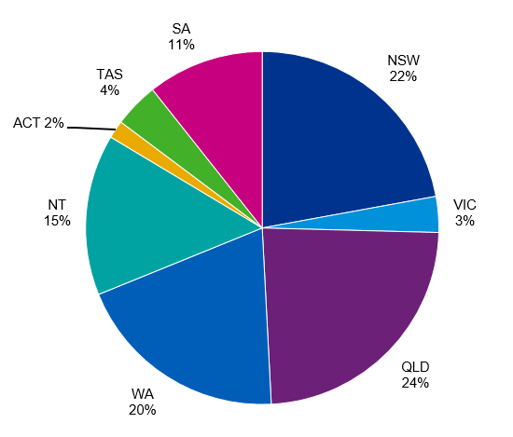
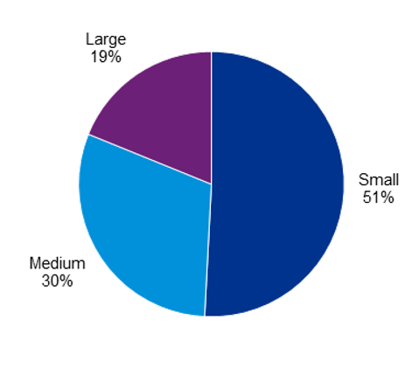
Figure B.3: Location n=122
Respondents
Position | Count | Percent
Voting member | 125 | 38%
Board or committee member | 127 | 39%
Executive or manager | 162 | 49%
Staff member | 64 | 20%
Volunteer | 47 | 14%
Member of the public that uses services or otherwise engages | 37 | 11%
Other | 40 | 12%
Total 381 responses including partially finished
244 responses completed to end of online consultation
70% heard about the online consultation from ORIC’s email

*Other: 37% community org, 17% land management, 17% cultural heritage, 14% family, 5% legal, 5% sport & rec, 3% advocacy, 2% media

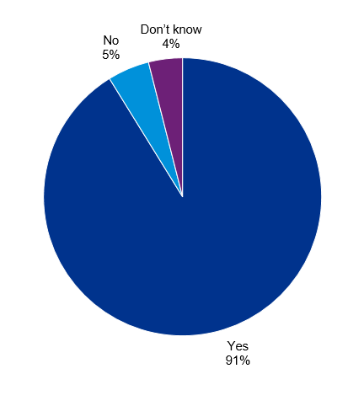
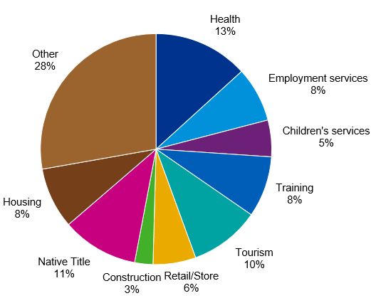
Figure B.1: Regulated by ORIC? n=229
Figure B.4: Sector n=122
*Other: community organisation 37%, land management 17%, cultural heritage 17%, family 14%, legal 5%, sport and recreation 5%, advocacy 3%, media 2%

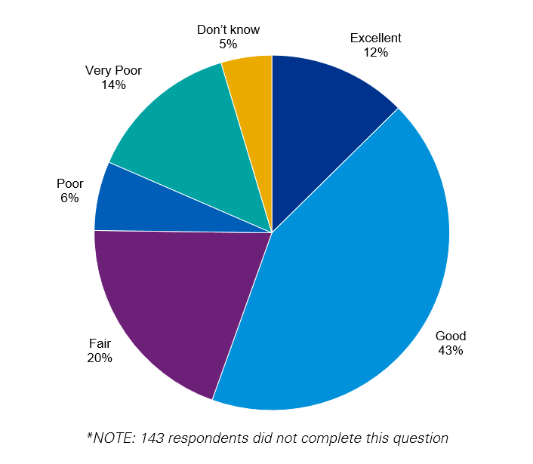
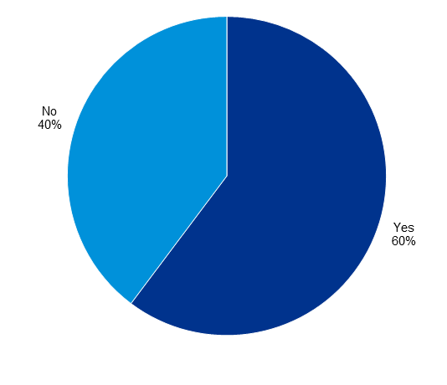
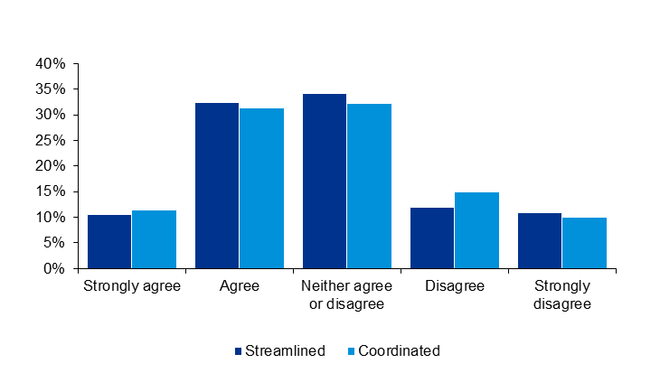
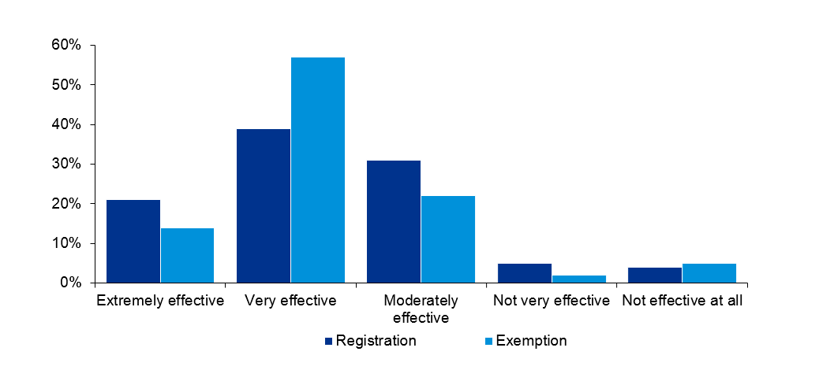
Streamlined n=219
Coordinated n=220
Registrations n=113
Exemptions n=42
Figure B.6: Has ORIC helped improve corporation’s governance and financial management? n=312
Figure B.5: Rating of ORIC’s overall performance n=238
Figure B.8: Method of monitoring compliance
Figure B.7: Effectiveness of support for registrations / exemptions
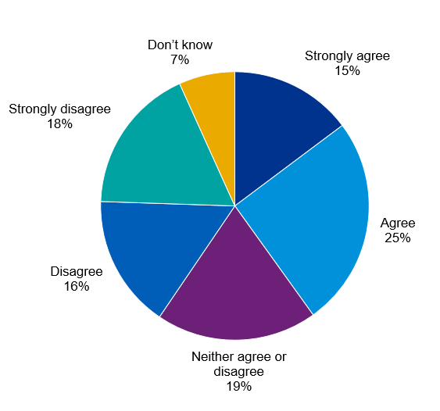
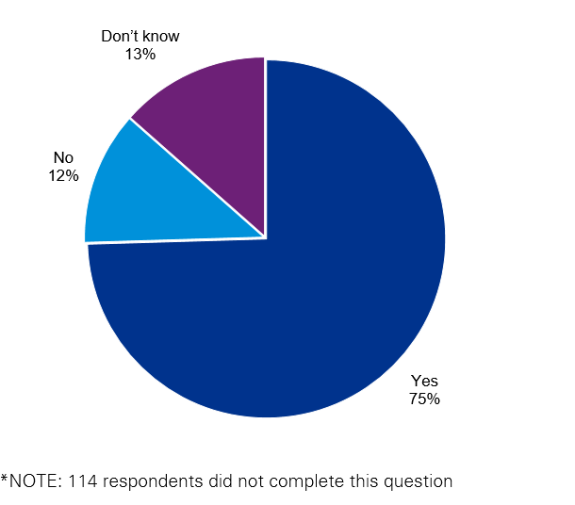
Clear n=265
Targeted n=258
Effective n=263
Figure B.11: Communication
Figure B.10: ORIC understands the environment in which Indigenous corporations operate and their challenges n=237
Figure B.9: Financial reporting rules are easy to apply n=267
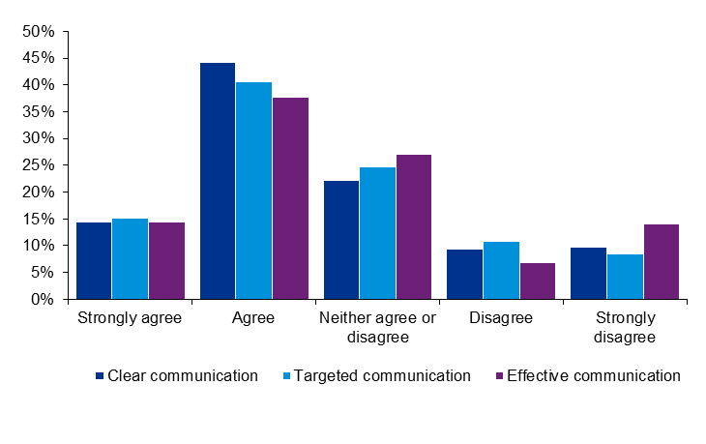

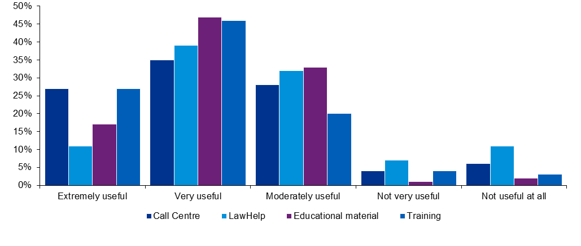
Call centre n=99
LawHelp n=54
Materials n=166
Training n=148
Figure B.12: Usefulness of support services
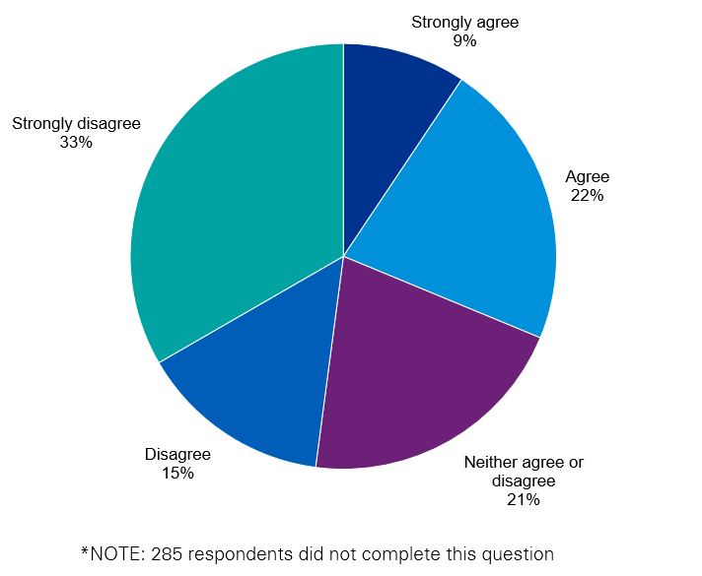
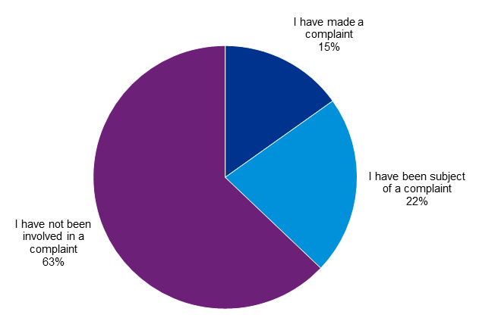
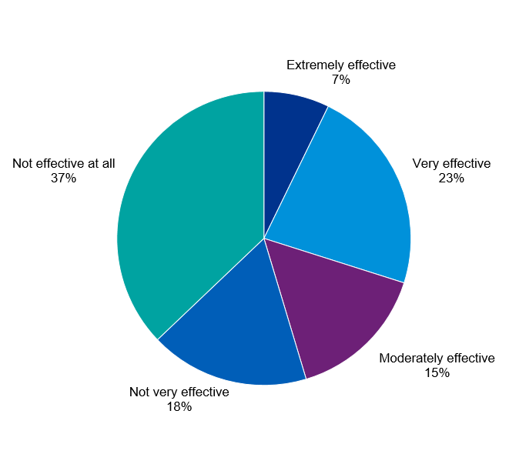
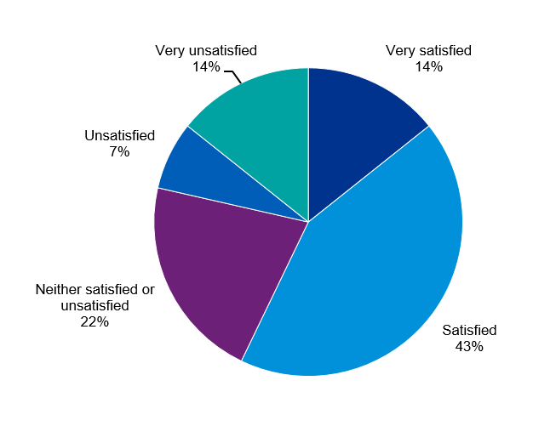
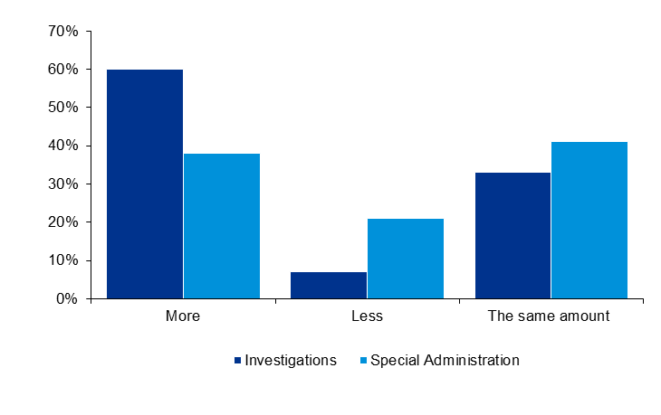
Figure B.17: Investigations and Special Administrations in the future
Investigations n=56
Special administrations n=39
Figure B.16: ORIC is open and transparent in dealing with corporations subject to complaint n=96
Figure B.15: Involvement in complaints n=264
Figure B.14: Effectiveness of assessing complaints n=97
Figure B.13: Satisfaction of mediation and dispute resolution process n=28
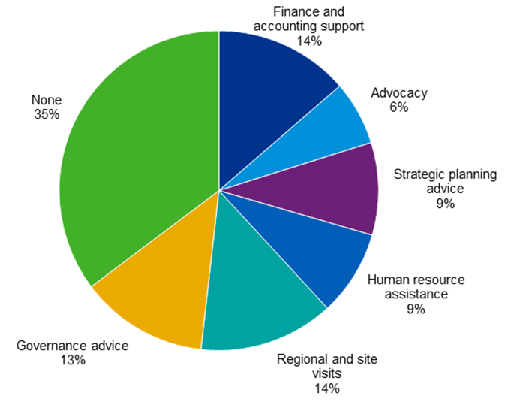
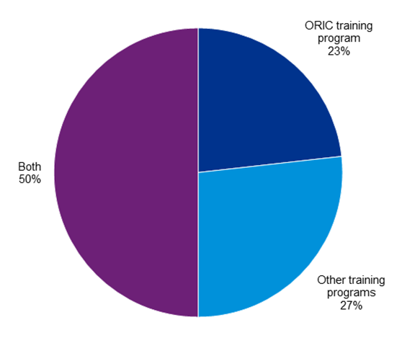
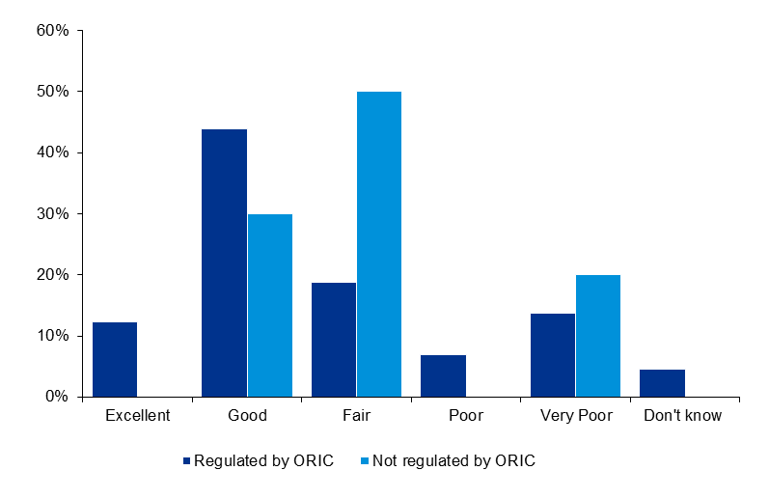
Regulated by ORIC n=226
Not regulated by ORIC n=10

Figure B.19: No. of respondents who had accessed support services
Figure B.20: Other services ORIC could provide n=139
Figure B.21: Training programs recommended (ORIC or others) n=112
Figure B.18: Performance rating given by corporations regulated by ORIC or another regulator
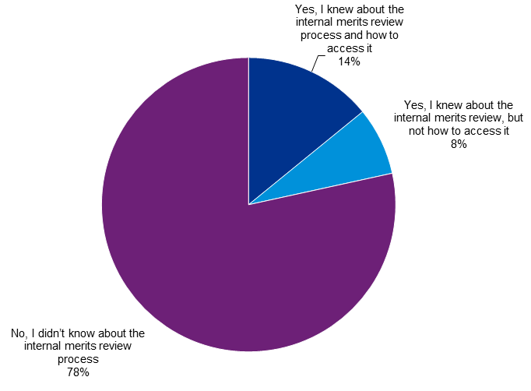
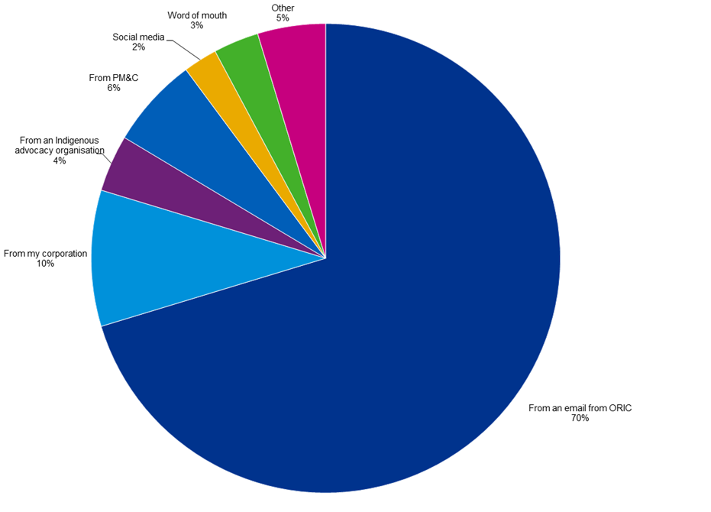
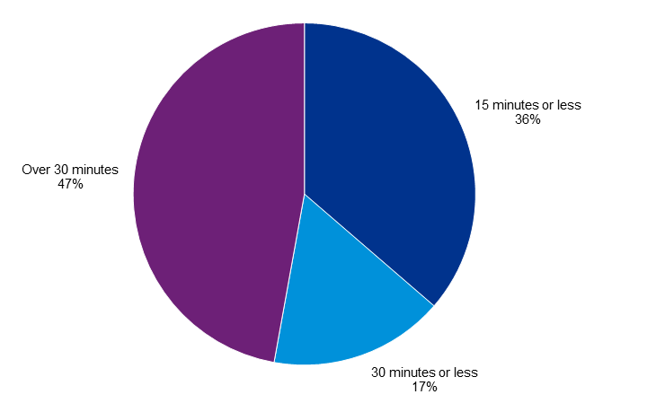
Figure B.24: Time taken to complete online consultation n=381
Figure B.23: How respondents heard about the online consultation n=256
Figure B.22: Knowledge of internal review process n=255
- : Registrar’s Functions

The Registrar’s functions are detailed in section 658-1 of the CATSI Act, which is presented below.
658-1 Functions of the Registrar
(1) The Registrar has the following functions:
(a) to administer this Act;
(b) to maintain such registers as the Registrar thinks appropriate;
(c) to make available to the public information about the registration of Aboriginal and Torres Strait Islander corporations and the administration of this Act;
(d) to provide advice to persons about:
(i) the registration of a particular Aboriginal and Torres Strait Islander corporation; and
(ii) the rules governing the internal management of the corporation; and
(iii) the operation of the corporation;
(e) to conduct public education programs on the operation of the Act and on the governance of Aboriginal and Torres Strait Islander corporations;
(f) to assist with the resolution of disputes:
(i) internal to the operation of an Aboriginal and Torres Strait Islander corporation; or
(ii) between an Aboriginal and Torres Strait Islander corporation and others;
(g) to assist with complaints under this Act:
(i) about the internal operation of an Aboriginal and Torres Strait Islander corporation; or
(ii) involving Aboriginal and Torres Strait Islander corporations;
(h) to conduct research in relation to matters affecting Aboriginal and Torres Strait Islander corporations;
(i) to develop policy proposals about Aboriginal and Torres Strait Islander corporations;
(j) such other functions as are conferred on the Registrar under another law of the Commonwealth;
(k) such other functions as are prescribed.

- : ORIC’s Structure

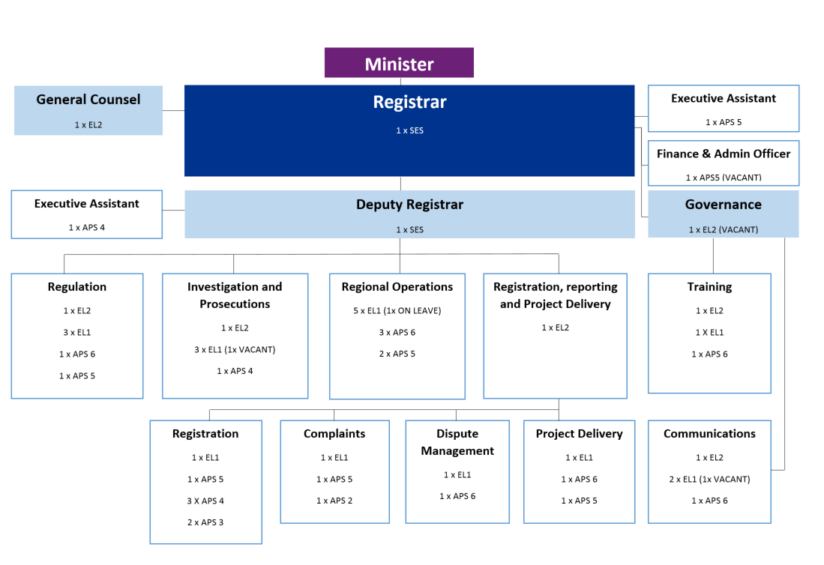

Contact us

Christa Gordon
Partner
+ 61 (0) 2 6248 1210
cgordon@kpmg.com.au

Simon Corden
Director
+ 61 (0) 3 9288 6183
scorden@kpmg.com.au

kpmg.com.au

Inevitably stakeholder input into a public review such as this cannot be assumed to represent an unbiased sample. This should be taken into account when considering the reported responses. However, in this case, the Review received a high level of responses, with a diverse range of views, thereby providing a solid basis for understanding the experiences and views of participants.
OECD 2014, OECD Best Practice Principles for Regulatory Policy: The Governance of Regulators, p.14
Australian Human Rights Commission 2007, Native Title Report 2007
Australian National Audit Office 2012, Capacity Development for Indigenous Service Delivery, Audit Report No.26 2011–12
http://asic.gov.au/for-business/running-a-company/members-of-a-company/
ORIC 2009, The CATSI Act and the Corporations Act — some differences
ORIC advised that it believes the majority of Indigenous organisations are registered under State and Territory acts or the Corporations Act.
Australian Government 2015, Strengthening Organisational Governance: new incorporation requirements
For example, Smith Family 2015, Financial Report for the Year Ended 30 June 2015, Oxfam Australia 2015, Annual Financial Report for the Year Ended 30 June 2015
ASIC undated, ASIC’s compulsory information gathering powers <http://asic.gov.au/about-asic/asic-investigations-and-enforcement/asic-s-compulsory-information-gathering-powers/> accessed 8 December 2016
The Corporations Act provides explicitly for a qualified privilege for auditors. See ASIC 2013, Auditor’s obligations: Reporting to ASIC, Regulatory Guide 34
ORIC advised that most of the requests for an extension were for less than 30 days, and were due to a death in the community, natural disaster, cultural activity, or a delay in the audit.
Susan Bell Research 2015, Comparing the view’s of ASIC leadership team with the views of external organisational stakeholders, p. 5
ORIC 2015, ORIC yearbook 2014–15, p. 47
Coglianese 2015, Listening, Learning, Leading: A Framework for Regulatory Excellence, Penn Program on Regulation, p. 22
In early 2015, the current Minister sent a proposed Statement of Expectations (SOE) to the Registrar. The SOE and the Registrar’s Statement of Intent (SOI) in response did not proceed pending the outcome of the current review. (ORIC 2016, pers. com. 13 December 2016)
This would have a cost, and the ACNC reported in its 2015-16 annual report that the operation of its advisory board in that year cost $160,000 (p. 104).
Corman 2014, Smaller and More Rational Government Agenda
Frydenberg 2014, Smaller and More Rational Government Agenda
Susan Bell Research 2015, Comparing the views of ASIC leadership team with the views of external organisational stakeholders, p. 8
The ASIC Annual Report 2015–16 reported that 9,848 companies entered external administration that year, out of 2.37 million registered companies (p. 86).
ORIC, pers. Com. 7 December 2016
Guidance on this process is contained in the Department of Finance’s publication at https://www.finance.gov.au/sites/default/files/commonwealth-risk-management-policy.pdf
The current Minister’s proposed 2015 Statement of Expectations noted that he expected the Registrar to “adopt a risk-based approach in relation to compliance obligations and enforcement responses, specifically targeting ‘high risk’ Registered Corporations where the consequences of non-compliance is likely to be significant”. (PM&C pers. com. 12 December 2015)
ASQA describe the risks it identifies as either systemic risk which it defines as any risk likely to exist across the sector or in a concerning proportion of providers, and operational or provider risk, which it defines as individual providers who are exhibiting behaviours that pose significant risk to quality training and assessment (Australian Skills Quality Authority 2016, Corporate Plan 2016-20).
ORIC 2015, ORIC yearbook 2014–15, p. 20
ANAO 2014, Administering Regulation (second edition)
These policies are found at <http://www.oric.gov.au/resources/policy-statements>
OECD 2014, The Governance of Regulators: OECD Best Practice Principles for Regulatory Policy, p. 107
ASIC commissioned stakeholder surveys in 2010 and 2013, and a survey was commissioned in 2015 for the external capability review.
CATSI Act, 658-1
The research examined 93 cases of corporate failure within Indigenous corporations incorporated under the CATSI Act between April 1996 and July 2008 (Swansson 2010, Analysing key characteristics in Indigenous corporate failure, Australian New Zealand School of Government’s Institute for Governance).
This involves providing: 1. A copy of the reports given to the funding bodies, together with any relevant auditor’s report; 2. An income and expenditure statement and a balance sheet disclosing any income, expenditure, assets and liabilities that have not been included in the funding reports; and 3. A director’s declaration that there are reasonable grounds to believe that the corporation will be able to pay its debts when they become due and payable.
ORIC, pers. com. 28 November 2016
Section 453-1 examination of books
See analysis on the proportion of examinations that detect non-compliance in Section 3.2.2 and 3.4.2
ORIC Minute dated 18 May 2015, 2015-16 Year – Proposed examination program
Australian Securities and Investments Commission Annual Report 2015-16
Known by various names, a stakeholder feedback report would ordinarily provide advice to the appropriate line area on systemic issues identified by the investigation (if any) and control weaknesses for remediation. Such reports are completed at the finalisation of an investigation and are not released externally.
Office of the Registrar for Indigenous Corporations Yearbook 2014-15
Office of the Registrar for Indigenous Corporations Yearbook 2014-15
ASQA 2016, “ASQA’s decision to cancel Cornerstone Investment (Aust) Pty Ltd registration stands: Media Release”, 21 November
PM&C, Indigenous Representation in the Commonwealth Public Sector
DHS, Reconciliation Action Plan 2015-2017
APSC, Commonwealth Aboriginal and Torres Strait Islander Employment Strategy
Corporations (Aboriginal and Torres Strait Islander) Act, section 658 - 1 (1)
This would involve careful assessment of the work undertaken in each position against the APSC’s work level standards. The outcome of the assessment might include recommendations for a re-profiling of the levels within teams.
Commonwealth of Australia 2014, Financial System Inquiry Interim Report, Canberra, pp. 3-110 to 3-111
OECD 2014, OECD Best Practice Principles for Regulatory Policy: The Governance of Regulators, pp. 97-104
Kelley, E. and Tenenbaum, B. 2004, “Funding of Energy Regulatory Commissions”, Energy Working Notes, World Bank in OECD 2014
ORIC 2015, The Top 500 Aboriginal and Torres Strait Islander Corporations 2014-15
PM&C 2016, Portfolio Budget Statements 2016-17, p. 8
Treasury, ATO
PGPA Act – section 78
Snapshot of ORIC as at 30 June 2016
The requirement for unlisted companies to prepare remuneration reports was removed in 19 March 2015 by the Corporations Legislation Amendment (Deregulatory and Other Measures) Act 2014. This was presented as a red tape reduction measure. This change meant that companies which are disclosing entities by virtue of having a wide base of shareholders, but which are not listed, would no longer be required by the Corporations Act to report on the remuneration of their key management personnel.
Information sheet for PBCs – Office of Registrar of Indigenous Corporations

