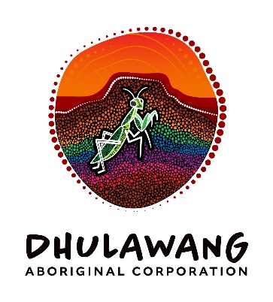

# Dhulawang Aboriginal Corporation

# Job Advertisement

**Independent Director (Finance)**

**Location:** Flexible (Remote or On-Country engagement options available)  
**Term:** Part-time, fixed-term (initial 12 months, with potential for extension)  
**Remuneration:** Negotiable  
**Reports to:** Chairperson, Dhulawang Aboriginal Corporation

**About Dhulawang Aboriginal Corporation**

Dhulawang Aboriginal Corporation is a First Nations-led organisation committed to empowering Aboriginal families in Kempsey and on the Mid-North Coast of NSW. As a Dunghutti-led entity, Dhulawang champions self-determination, community-led governance, and long-term prosperity for families in need. The three key streams of our business include Family Dispute Resolution, Domestic Violence and NDIS.

**Role Overview**

We are seeking an experienced Independent Director with a strong financebackground to join our Board and support Dhulawang in strengthening governance, financial oversight, and strategic decision-making. This role is critical to ensuring the Corporation’s financial sustainability, compliance, and alignment with best practice governance standards.

**Key Responsibilities**

* Provide independent oversight and strategic advice on financial matters, including budgeting, reporting, risk management, and investment.
* Support the Board in developing and implementing robust financial governance frameworks.
* Assist in interpreting financial reports and ensuring compliance with regulatory obligations.
* Contribute to board discussions with a focus on financial sustainability and accountability.
* Mentor and build financial literacy within the Board and executive team.
* Uphold the values and cultural integrity of Dhulawang Aboriginal Corporation.

**Essential Criteria**

* Proven experience as a board director or senior executive in finance, accounting, or audit.
* Professional qualifications in finance, accounting, or a related discipline (e.g., CPA, CA).
* Demonstrated understanding of governance principles and fiduciary duties.
* Experience working with Aboriginal organisations or in culturally safe environments.
* Strong analytical, communication, and interpersonal skills.
* Commitment to ethical leadership and community empowerment.

**Desirable**

* Knowledge of Indigenous governance models and community-controlled organisations.
* Experience in not-for-profit or social enterprise sectors.
* Familiarity with funding bodies, grant management, and financial reporting in the Aboriginal sector.

**How to Apply**

Please submit your CV and a cover letter outlining your interest and suitability for the role to Laura Curtin, General Manager at operations@dhulawang.com.au