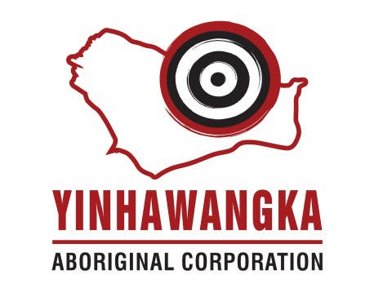

Chief Executive Officer-Yinhawangka Aboriginal Corporation

Paraburdoo based role in the further establishment and growth of the corporation including member and expanding Ranger services and building program.

Yinhawangka Aboriginal Corporation (YAC)
Yinhawangka Aboriginal Corporation (YAC) was established as a corporate entity for the three Yinhawangka ancestor family groups – Minatangunha, Jardhunha and Thurantajinha & Wilga (MJT&W). The Yinhawangka people have traditional rights to an area based around Paraburdoo in the Pilbara region of Western Australia. Paraburdoo lies within the Shire of Ashburton and is surrounded by spectacular natural scenery.
The Corporation will be pivotal in progressing the broader interests of approximately 300 Yinhawangka adults, plus associated children who reside in the majority of the broader Pilbara region, and in representing the Yinhawangka people in their dealings with Government and private industry in general.
YAC very recently achieved Prescribed Body Corporate (PBC) status to hold native title for the benefit of the Yinhawangka people.
The position.
We are seeking a passionate and outcomes driven CEO to join YAC at a pivotal time in its growth and further establishment. This includes the expanding Ranger unit and the construction of a substantial YAC office in the new year. The longer term ambition of the community is to develop their own people towards self determination and roles in management and leadership. Teaching, coaching and sharing knowledge is part of the incoming CEO's role.
The role is a 2 year term, with 2 year extension possible by agreement and will include:
- Providing strategic direction, leadership and management of YAC in order to maximise the realisation of the ancestor family groups vision, values and strategic goals.
- Leading a small but focussed team of professional managers and staff, characterised by its constructive, collaborative and innovative culture. Current direct reports include Operations Manager, Office Manager and soon to be added Ranger Unit anticipated to be 12 staff in total across all of YAC.
- Being the ultimate responsible person for the commercial, occupational health and safety aspects of YAC as well as the legal obligations associated with being a PBC.
- Overseeing the construction of the $4M office to commence mid 2018.
- Securing and managing the MJT&W people's native title rights and interests and the Corporation's human, physical and financial resources, and ensuring that the MJT&W peoples' culture and heritage are recorded, protected and shared in the community.
- Providing advice to the respective Boards of Directors on strategic positioning, economic development opportunities and managing the Prescribed Body Corporate.
- Engaging with MJT&W community and all other stakeholders.
- Negotiating and representing YAC with all stakeholders whilst maintaining strong long term positive relationships.
- Implement recent trust review recommendations.
The Ideal Candidate:
- Previous indigenous working experience as a leader, stakeholder or community member.
- Previous history of guiding a PBC from determination to visible and concrete benefits for the community.
- An advanced leadership and influencing style to accommodate different cultures, personalities and context which ensure interpersonal relationships are positive and long term focused.
- Advanced communication skills to match context and audience.
- Learns, understands and respects MJT&W people's Lore and Culture.
- Tertiary qualifications appropriate to the role.
- Advanced financial literacy as well as the ability to translate and add meaning for those without the same level of financial literacy.
- Commercial acumen.
- Demonstrate a history of making sound decisions and have strong skills in strategic, operational and financial management to identify, plan and execute strategic activities.
- Demonstrates a history of creating strategy and implementation via an engaging and compelling leadership style.
- Skilled in mediation, conflict resolution and negotiation.
Closing date for applications is COB Thursday 14th September, however we would encourage interested candidates to express interest prior to this date.
A competitive remuneration package including housing, motor vehicle, will be negotiated with the successful candidate.
Your application.
Meelup Management is partnering with the YAC Board to conduct the selection process and can ensure privacy and confidentiality to all enquiries from local, interstate and overseas candidates.
Please click APPLY NOW and send your résumé and cover letter outlining your specific qualifications, relevant experience and why you believe you are ideally suited to this opportunity. Alternatively you can email your resume to chris@meelup.com.au or call +61(0)418 914 862 for a confidential discussion and suitability for this role.

