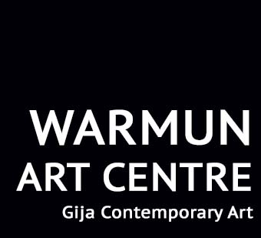

Warmun Art Centre is calling for applications for Manager
Salary package range is $87,000 - $102,000
Warmun Art Centre is one of Australia’s leading Aboriginal arts and culture organisations. Located in Gija Country, in the East Kimberley region of Western Australia, Warmun Art Centre is 200km south of Kununurra on the Great Northern Highway. Warmun Art Aboriginal Corporation is wholly Gija owned with a board comprising artists and leaders from Warmun community.
Warmun Art Centre represents internationally renowned contemporary artists including Lena Nyadbi, Mabel Juli, Rusty Peters, Patrick Mung Mung, Rammey Ramsey, Shirley Purdie and many other senior artists, as well as a large number of young and emerging contemporary artists. In addition to the successful painting studio and gallery program, the Art Centre also operates a digital media lab, language and culture programs, and a community collection and archive.
Manager
This is the peak role within the organisation, overseeing 12 Aboriginal and non-Aboriginal staff. The Manager is responsible for three main areas of management: financial, governance and human resources. The position will be focus on building on the Art Centre’s past successes whilst developing new economic opportunities and revenue diversification, funding and philanthropic support and other initiatives that build organisational capacity.
We need an experienced, highly organised and focussed individual with a proven record of successful financial and human resource management and a track record of enabling strong governance. We need someone who is resourceful, strategic and practical to lead by example and practice. It is an excellent opportunity for someone who has demonstrated experience achieving both positive economic and social impact to take one of Australia’s most successful Aboriginal arts organisations to the next chapter of its story.
The position is full time with a two-year contract being offered and the opportunity to extend.
Relevant background checks will apply.
Benefits Include:
- Salary sacrifice arrangements available
- House and electricity supplied
- 5 weeks annual leave after one year
- Reasonable relocation expenses
Application process
Applications closing date is 5:00 pm on 16 January 2017.
Contact and applications via contact@creativeeconomy.com.au

