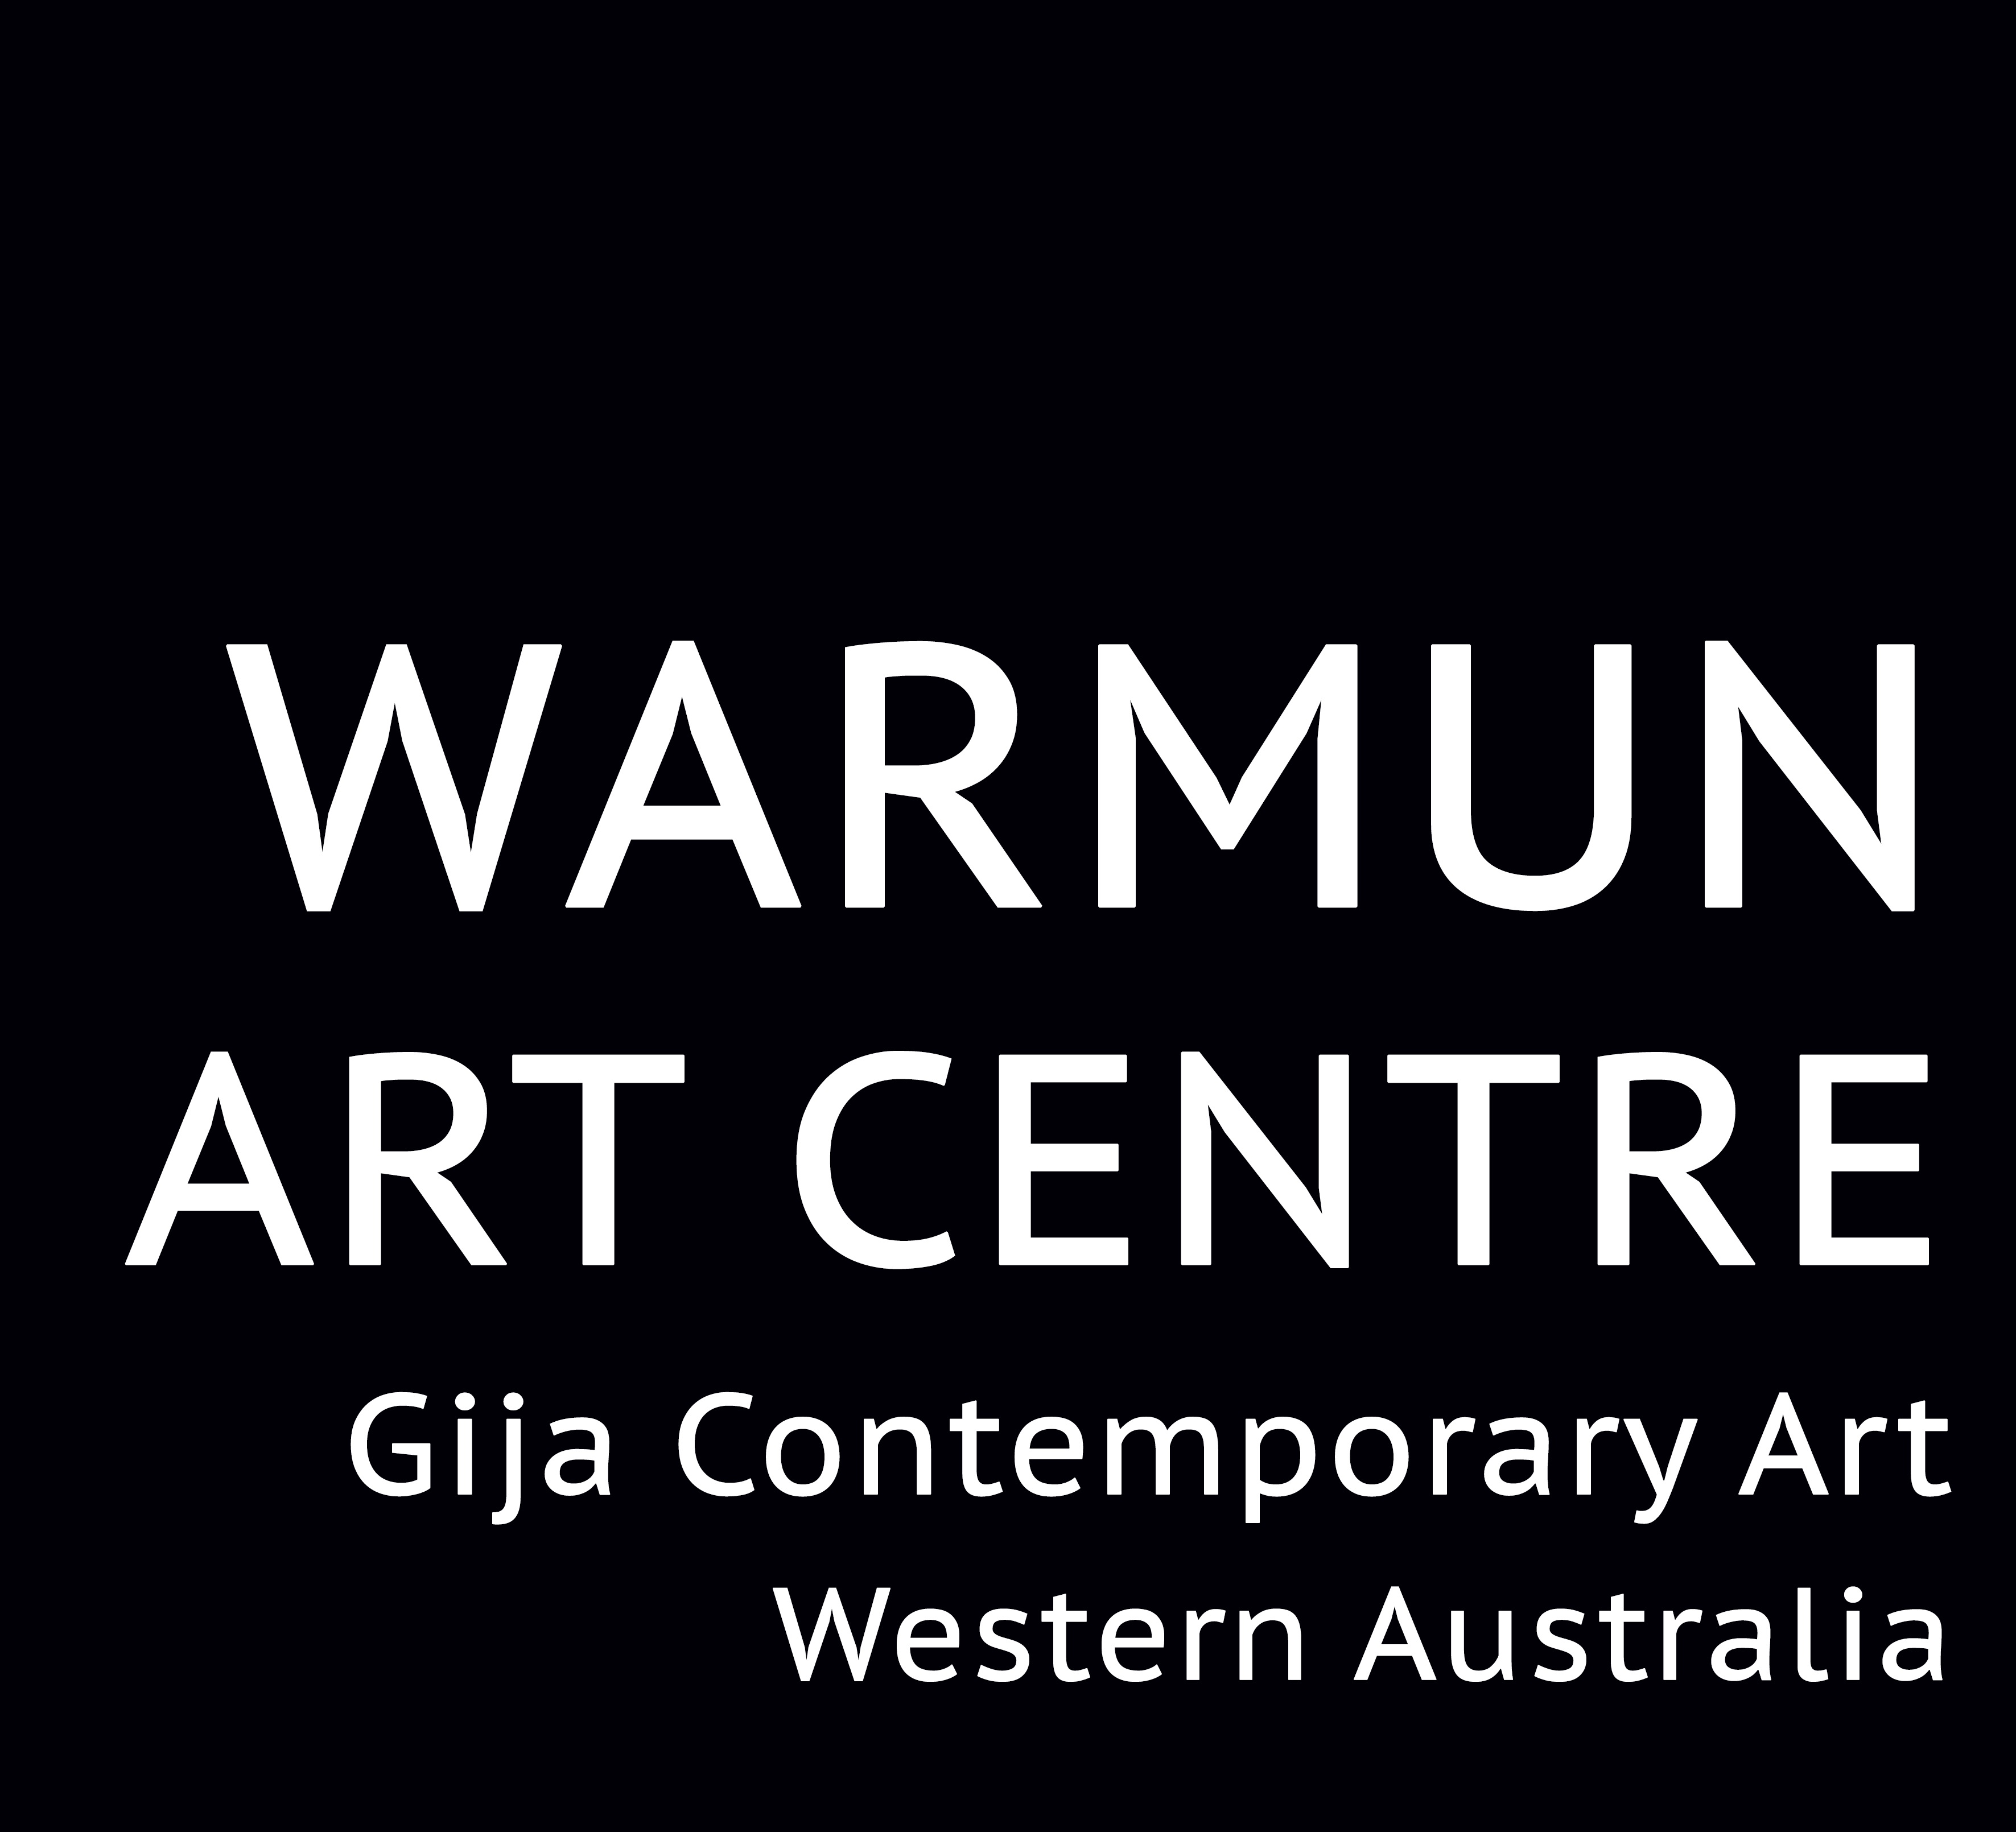

JOB OPPORTUNITY: Gallery Coordinator, Warmun Art Aboriginal Corporation

Salary Package Range is $73,000 - $82,000

Warmun Art Centre is one of Australia’s leading Aboriginal arts and culture organisations. Located in Gija Country, in the East Kimberley region of Western Australia, Warmun Art Centre is 200km south of Kununurra on the Great Northern Highway. Warmun Art Aboriginal Corporation is wholly Gija owned with a board comprising artists and leaders from Warmun community.

Warmun Art Centre represents internationally renowned contemporary artists including Lena Nyadbi, Mabel Juli, Rusty Peters, Patrick Mung Mung, Rammey Ramsey, Shirley Purdie and many other senior artists, as well as a large number of young and emerging contemporary artists. In addition to the successful painting studio and gallery program, the Art Centre also operates a digital media lab, language and culture programs, and a community collection and archive.

Gallery Coordinator
We are currently looking for a Gallery Coordinator to join our team. The position is for a two-year contract with options to extend. The role of Gallery Coordinator carries many challenges and also offers great rewards. The position is an outstanding opportunity to be part of a growing enterprise that is looking to build on its successes and establish new markets in Australia and overseas, and at the same time increase its visibility, potential and operations in the local market. The role carries many exciting professional development opportunities for the successful applicant.

The Gallery Coordinator plays a key role in the running of the organisation, being responsible for revenue and sales relating to the Centre’s art gallery and its associated programs, including touring exhibitions, publications, merchandising, copyright, financial record-keeping and Gija staff training. Although the position of Gallery Coordinator will largely be based in the gallery, cross over into other program areas may be required from time to time. In this regard, as part of a talented and flexible team, it is desirable that applicants also have some experience of Indigenous culture and cultural programs and experience with social media.

Benefits Include:
- Salary sacrifice arrangements available
- Housing and electricity supplied
- 5 weeks annual leave after one year
- Reasonable relocation expenses

The position is full time with a two-year contract being offered and the opportunity to extend.

Relevant background checks will apply.

Application process
Applications closing date is 5:00 pm on 16 January 2017.
Contact and applications via contact@creativeeconomy.com.au

