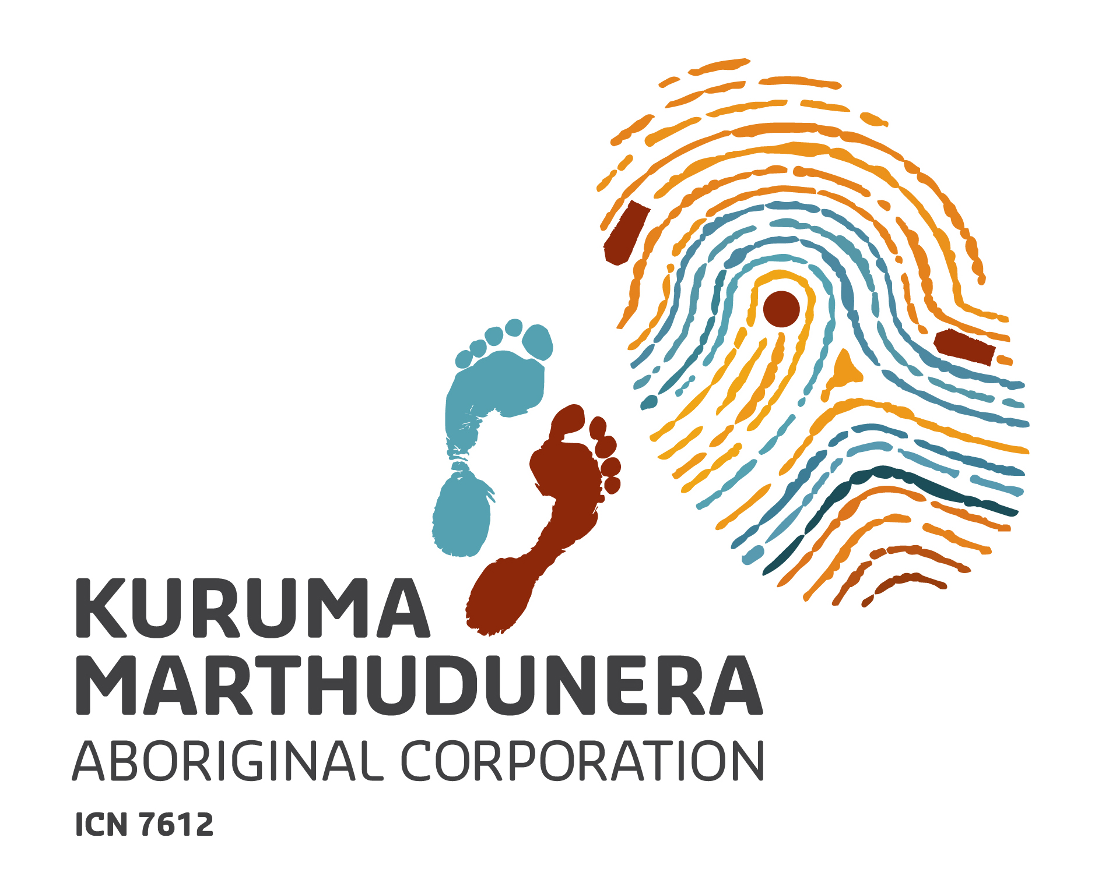

Job Description

Title: Cultural Heritage Manager
Basis of Employment: 2 year contract
Reports to: Chief Executive Officer

Purpose of the Role
The Kuruma Marthudunera Aboriginal Corporation (KMAC) was established as a corporate entity for the Kuruma and Marthudunera people (K&M). The K&M people have traditional rights to an area covering about 15,759 square kilometres in the Pilbara region of Western Australia. The K&M traditional lands lie within the Shires of Ashburton and Roebourne and comprise part of the Fortescue River and the complete river system of the Robe River, in the most westerly part of the Hamersley Range. The Corporation is pivotal in progressing the broader interests of approximately 200 K&M people and in representing the K&M people in their dealings with governments and private sector.

Under the direction of the CEO, the Cultural Heritage Manager will lead and manage KMAC’s Cultural Heritage business unit and other cultural heritage related matters as they arise. This includes, but is not limited to, the development and implementation of appropriate processes and documentation to manage the Cultural Heritage business; identification, training and oversight of those carrying out cultural heritage works; the establishment of beneficial stakeholder relationships; and project coordination and delivery of related strategic projects.

The essential duties of the Manager Cultural Heritage will be to:

- Lead and manage KMAC’s Cultural Heritage business unit;
- Manage processes and documentation for the efficient delivery of heritage surveys;
- Facilitate the development and manage the implementation of tailored cultural awareness training programs to meet the needs of clients; and
- Oversee the management of a roster of K&M people engaged in the delivery of cultural heritage work.

Key Responsibilities and accountabilities

- Conducting and facilitating heritage surveys
- Develop policies and processes that support the efficient management of the KMAC Cultural Heritage business unit and supportive working environment;
- Coordinate surveys in accordance with industry best practice and associated native title and heritage agreements and relevant legislation;
- Oversee the development and efficient management of a roster of K&M people to work on heritage surveys;
- Coordinate, document and report on field work involving heritage protection;
- Prepare correspondence and documents relating to heritage surveys;
- Liaise with mining companies, government and consultants as necessary;
- Ensure that draft heritage survey reports are provided in a timely manner;
- Undertake effective, culturally sensitive and timely communications on heritage matters with K&M people and survey participants;
- Develop strategies and initiatives to assist K&M people to identify and protect areas of cultural significance; and
- Manage and report to the CEO on the KMAC’s Cultural Heritage business, including the administration and development of heritage survey business.

- Facilitate the development of cultural awareness training programs
- Facilitate and coordinate the development of KMAC’s cultural awareness training programs;
- Implement KMAC’s cultural awareness training programs;
- Build constructive commercial relationships with mining companies, government agencies and departments and third party service providers so that KMAC’s cultural awareness training program becomes recognised as the industry leader in the provision of cultural awareness training;
- Lead, manage and mentor staff and K&M people who deliver cultural awareness training programs;
- Research, evaluate and continuously seek improvements in the delivery of KMAC’s cultural awareness training programs so that KMAC becomes and remains industry leader; and
- Manage and report to the CEO on the KMAC’s Cultural Heritage business, including the administration and development of cultural awareness training business.

- Managerial and other duties
- Lead and manage KMAC’s Cultural Heritage business unit;
- Lead, manage and mentor staff in the Cultural Heritage business unit;
- Develop annual budget and business plan for the Cultural Heritage business unit and report on a monthly basis to the CEO against budget and plan;
- Actively promote KMAC’s Cultural Heritage business unit to K&M people and clients;
- Manage KMAC’s Cultural Business records management system, including:
  - Maintaining files (paper and electronic) from creation through to archiving in a way that allows the tracking of all correspondence and documents.
  - Understanding and maintaining electronic heritage database “The Keeping Place”.
- Conduct other duties as are required to maintain the efficient operation of KMAC Cultural Heritage Business Unit; and
- Any other duties that may be assigned by the CEO from time to time.

Selection Criteria

Essential
- Demonstrated experience and record of achievement in one or more of the following fields: natural resource management, cultural heritage, business development, project management and policy development.
- Specialist expertise in cultural heritage and stakeholder management.
- Strategic land and resource planning: - demonstrated ability to conduct cultural heritage audits and develop plans that secure social, cultural, environmental and economic benefits.
- Working knowledge of Aboriginal community aspirations and cultural resource management industry.
- Planning and organisational skills: - implementing processes, tasks and resources required to achieve goals and find effective ways to deal with anticipated and unexpected barriers.
- Influence and negotiation experience: - experiencing using well developed communication and interpersonal skills to develop and implement business strategies to build commercial relationships with and support from key internal and external stakeholders and partners.
- Staff and workload management: - managing staff, consultants and meeting time critical deadlines.
- Information Technology: - experience using computer software, in particular Microsoft Office, GIS software, internet and email, publisher and project management databases.
- Experience: - a minimum of 5 years’ experience in a similar role and managing a small team of dedicated and committed individuals.

Qualifications

Essential: A degree (honours or above) in Anthropology or Archaeology from a recognised tertiary institution.
A current Western Australian Driver’s Licence (manual).

Desirable: A degree or significant experience in business management or marketing.

Essential Personal Values and Qualities

- High ethical standards, personal integrity and good judgment.
- Genuine appreciation and respect for Aboriginal people and their culture.
- Commitment to Aboriginal self-determination and self-management and strong and decisive leadership skills.
- High degree of self-motivation, energetic, resourceful and innovative with a proven track record of achievements.
- Willingness to work in a demanding environment that may require work outside of normal hours.
- High level of communication, negotiation, business acumen and interpersonal skills.
- Successful candidate may be required to build the capacity of potential K&M staff to support their personal development.

Location

The position will be based in Karratha and regular travel within the region may be required. KMAC is prepared to consider alternative arrangements to secure the ideal candidate.

Salary

An attractive remuneration package will be negotiated (including possible salary sacrifice) with the successful applicant.

