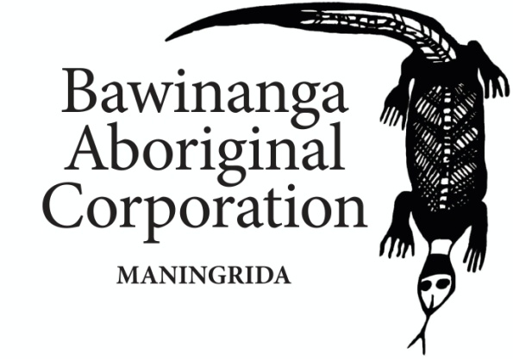
Position Description

Position Title: Chief Executive Officer
Classification: Senior Executive Appointment
Reporting to: Executive Committee

Governance
Bawinanga Aboriginal Corporation (BAC) is a not for profit Aboriginal corporation, directed by an Executive Committee (The Board) elected annually by the members at the Corporation annual general meeting. Policies formulated at the executive level are enacted by BAC through the leadership of the Chief Executive Officer (CEO) and the Management team representing each program area.
Organisational Objectives
- Promote the management of language, culture and traditional practice
- Promote the management and sustainable use of traditional lands
- Promote community development
- Promote the welfare of outstation residents
- Provide or assist in the provision of and maintenance of education, training, employment, housing, health, communications and other services.
- Foster business opportunities and promote economic independence
- Promote, in all of its endeavours, the common good and mutual benefits of its members through fair, equitable and representative action and enterprise.
BAC Operational Responsibilities
BAC is a large and complex regional community development organisation providing services to 35 outstations, administering more than 50 grants and managing a suite of businesses, including:
Housing, Construction, Earth Moving/Roads/Roads, Outstation Services, Women’s Centre including, Textiles Workshop and Cleaning Services, Djelk Rangers, Barlmarrk Supermarket and Outdoor Supplies, BAC Fuel Supplies, Mechanical Workshop, Maningrida Arts and Culture, Djomi Museum, Tourism, Aged Care, Training, Good Food Kitchen, Night Patrol, Job Services and Money Management Services.

Purpose of the Position
Operating under the direction of the Executive Directors and in accordance with Bawinanga Aboriginal Corporations (BAC) corporate plans, policies, relevant legislation and funding requirements, the CEO is responsible for:

- Provide leadership, motivation and direction to the staff of the Corporation Promoting the collective interests of the members of the Corporation in accordance with the Constitution
- Remaining up to date with all aspects of Indigenous affairs; particularly political, social and economic matters that affect the Corporation
- Provide quality reports, advice and assistance to the Executive
- Provided oversight for the management of all Corporation activities
- Be available as the main point of contact including: the media, government and other organisations
- Maintaining good communications and reporting within BAC
- Facilitating strategic planning and policy development
- Attending meetings, functions and cultural activities as required to represent the Corporation’s interests
- Engaging with the three tiers of Government to best advantage BAC, and adapt to any changes in Government policy
- Maintaining links with Northern Land Council and ensure compliance with the Aboriginal Land Rights Act
- Attending all General, Special and Executive Meetings of the Corporation
- Liaising with other Community organisations to facilitate positive relationships
- Identify funding sources and prepare grant applications and ensure proper acquittal procedures are in place and adhered to
- Evaluating Financial reports and informing the Board Finance sub-Committee
- Ensuring that grant income is properly spent, reported and acquitted
- Producing reports, including Annual Report, and submissions as required in relation to Corporation activities and structure
- Investigating (facilitating appropriate research and assessments) and reporting to the Board about the future needs of the Corporation
- Ensuring that BAC complies with all relevant laws and regulations within the purview of its operations, and particularly the BAC Code of Conduct
- Developing staffing structure, undertaking recruitment and setting remuneration of key staff
- Ensure BAC Enterprise Bargaining Agreement (EBA) is renewed and lead negotiations as required
- Undertaking prescribed roles in accordance with the EBA including redundancy, disciplining of staff as required, and dismissals subject to Board approval
- Ensure that staff contracts are maintained, monitored and reviewed as necessary
- Perform all other reasonable duties as required and within professional levels of competency.

Reporting Relationships

The CEO reports directly to the Executive Board.

Key Accountabilities
- Coordinate the development, implementation and timely review of BAC

- Coordinate and be accountable for the financial operations in relation to
Agreements BAC has entered into and compliance with all corporate (ORIC) and other reporting requirements with the Financial Controller.

- Coordinate network stakeholders across the Maningrida region, manage stakeholder relationships and build capacity through a whole of government approach.

- Coordinate the recruitment of all staff, in partnership with the Human Resources Manager, and the EBA.

- Provide and coordinate the professional support, induction, training and development of all BAC staff, and establish/maintain a good professional support network.

- Establish and administer the timely and effective collection of information on Outstation community needs, levels of satisfaction and industry best practice levels in relation to all BAC programs and services.

- Assist with the development of a regional strategic and operational plan which sets targets and includes work plans for BAC and develop appropriate reporting tools.

- Maintain safety and ensure that Work Health and Safety Regulations are adhered to.

- Provide regular reports to the BAC Board Members as required.

- Ensure an effective, efficient and courteous service is provided to all service users and the community.

Continuous improvement
Understand and support continuous quality improvement in the delivery of Services to all BAC Outstation Communities.

Corporate & social responsibility
Adhere to the BAC By-Laws and Code of Conduct

Stakeholder relationships
Be proactive in the area of relationship management with and between all BAC staff, and develop sound working relationships through delivering appropriate and honest support and/or feedback
Ensure communications are appropriate to BAC outstation communities, BAC and the entities within which the CEO role operates.

Integrity & Ethical Behavior
Act with integrity at all times and ensure that areas of responsibility operate in an open, transparent and accountable manner. Always seek credible and professional support when in any doubt.

Selection Criteria
Applicants must be able to demonstrate the possession of the following skills, knowledge and experience.
Essential

- Experience working with Aboriginal corporations and people, and detailed contemporary knowledge of Aboriginal culture and communities and their operation

- Demonstrated experience with the delivery of a complex Senior Management environment, and successfully running a senior management team

- Demonstrated experience in the completion of government funding access and reporting requirements; and demonstrated experience in developing and managing program budgets.

- Highly developed and demonstrable experience in successfully working with people in a cross cultural setting, and in a remote setting

- Experience in establishing and maintaining successful relationships with an Australian Indigenous corporation membership and associated stakeholders.

- Demonstrated understanding of community development principles.

- Demonstrated interpersonal, written and oral communication skills to communicate effectively and produce confidential written reports of quality and relevance.

- Experience in coordinating, training and motivating staff.

- Sound decision making skills including an analytical approach to problem solving.

- Knowledge of WH&S principles and the ability to promote them in the workplace.

- Current Driver’s Licence and willingness to live in a remote community and to travel to remote communities.

- Police check and ability to acquire an NT Ochre Card.

Desirable
- Experience in and understanding of the use of computer-based Financial Management Systems and Client Information Management Systems.
- Experience in working for not-for-profit organisations.

- Experience in driving a 4WD vehicle in off road conditions.

- Hold a current first aid certificate or the ability to attain one.

