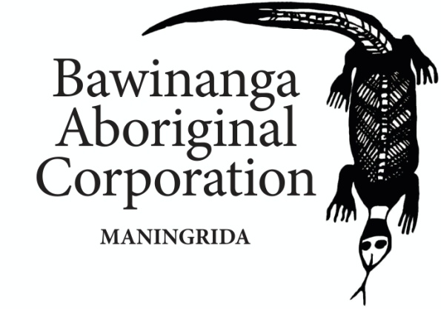

Chief Executive Officer
The Bawinanga Aboriginal Corporation is seeking to employ a suitably qualified Chief Executive Officer to actively pursue the objectives of the Corporation under the direction of the Bawinanga Board.
The Chief Executive Officer will have outstanding leadership, cross cultural, governance, financial, operational and people management skills in order to direct and facilitate the achievement of Bawinanga’s objectives.
Bawinanga is a large and complex remotely based not for profit outstation resource, support and development organisation. Bawinanga operations include the iconic Maningrida Aboriginal Arts and Culture, and Djelk Rangers.
Bawinanga also operates retail and fuel outlets, building, construction and mechanical services, road maintenance, tourism, community development programme activities and money management services.
The position requires a person with both vision and practical skills who can work effectively with the Board so they can together pursue and achieve the core business objectives of Bawinanga.

Contact Bawinanga Human Resources Manager tammy.russell@bawinanga.com or Executive Support Officer shona.duffill@bawinanga.com telephone 08 8979 6556 or 08 8979 6560 for an information package and position details.

Closing date for Applications: 25th September 2015

