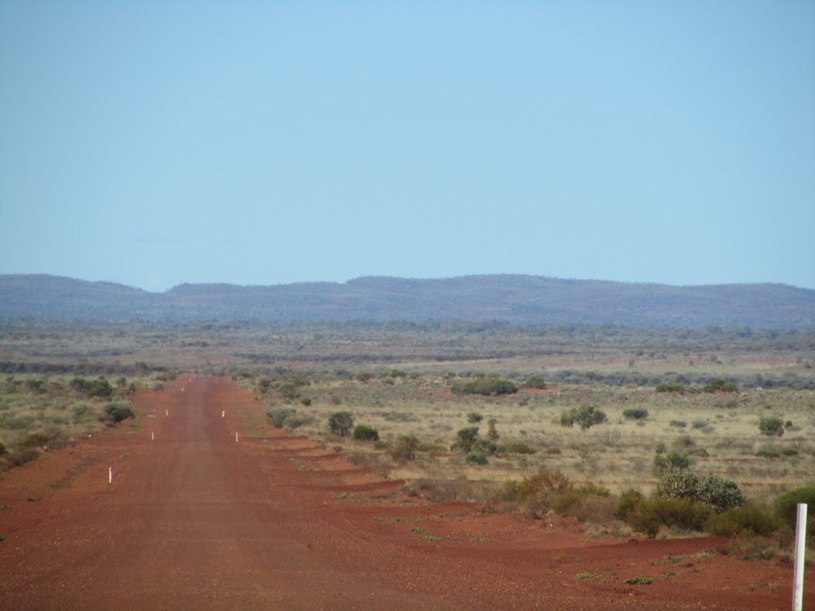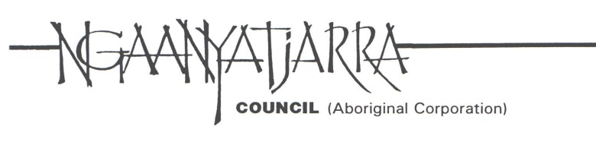

**Coordinator, Community Development Programme**

* **Exciting opportunity**
* **Highly respected Aboriginal Corporation**
* **Make a genuine difference**

Ngaanyatjarra Council is a dynamic non-profit organisation representing the interests of approx. 2000 Ngaanyatjarra, Pintupi and Pitjantjatjara people living in 12 Communities located in the Central Desert region of Western Australia.

This is an exciting opportunity for an enthusiastic and motivated employment services specialist with a strong interest in remote communities to make a real difference to the lives of Aboriginal people. As part of a dynamic team you will be responsible for the operational management of the Community Development Programme (CDP) across the Ngaanyatjarra region.

This will require you to coordinate CDP service delivery and oversee the development and implementation of engaging Work for the Dole projects that meet individual and community needs. You will also be responsible for providing management oversight of all compliance aspects of Ngaanyatjarra Councils CDP contract.

You will have senior experience in employment services provision and possess relevant tertiary qualifications in business, social services or community development. Your high-level communication skills, systems thinking and proactive approach will be key to your success in this role.

Previous experience working with remote Aboriginal Communities and the ability to develop and sustain strong relationships with government and community stakeholders will be highly regarded.

The position is based in Warburton Community with regular travel to the other Ngaanyatjarra Communities as required.

This is an outstanding opportunity to advance your career in a unique and beautiful part of Australia in an exciting and varied role.

For your enthusiasm, skill and commitment, you will be well rewarded with a base salary of $100,000 per annum plus superannuation, 8 weeks leave, PBI salary packaging, $4,333 remote allowance, annual airfare, free accommodation and a fully maintain vehicle for work purposes.

For a detailed position description please contact:

Linda Robertson

Human Resources Manager

**Ph 08 8950 1719 Fax 08 8950 1728**

**linda.robertson@ngcouncil.org.au**

**Applications close 15 November 2015**