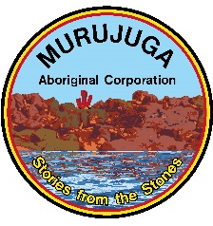

DEPUTY CHIEF EXECUTIVE OFFICER (CEO ELECT)

Murujuga Aboriginal Corporation is a progressive organisation situated in Karratha. The Corporation runs the Murujuga National Park by means of the Murujuga Land and Sea Unit, holds real estate investments and invests in local business. It is currently going through a fast expansion phase.

The Board of Directors is seeking a dynamic and capable person to fill the role of Deputy Chief Executive Officer with view for the orderly succession of our incumbent CEO.
The ideal candidate for this important role will have:
- Previous experience in high level management of an Aboriginal Corporation
- An extensive management and leadership background:
- Extensive knowledge of Government policies and negotiations.
- A track record in governance and financial management:
- Business and enterprise development experience, and
- Staff and performance management experience.

The Deputy CEO of the Corporation will work alongside the current CEO and the Board of Directors to establish, implement and evaluate strategic plans and operational systems that effectively capture and deploy resources to build the human, cultural, social, environmental and economic values and opportunities of the Corporation members.
A competitive salary and benefits package is on offer for the successful candidate. Indigenous candidates are encouraged to apply.
All applications are to be addressed and emailed to: ceo@murujuga.org.au

If you would like further information regarding the position please contact Ron Critchley on (08) 9144 4112
Applications close 5.00PM, 30 April 2015.

